Agent connection problems

Agent doesn't appear in Agent list in the primary server

Problem
- After setting primary server url in the agent configuration, the agent is not detected by the primary server.
- The agent is configured to be “Agent only”, Primary server option is disabled.

Possible causes

Certificate issue
- If the server url is using https, you must register the server certificate in the agent
- In agent instance, got to Settings->Admin configuration->HTTPS and use the import button
- Restart the agent.

Linux: local host DNS issue
- Get the server logs of the agent and look for below exception:
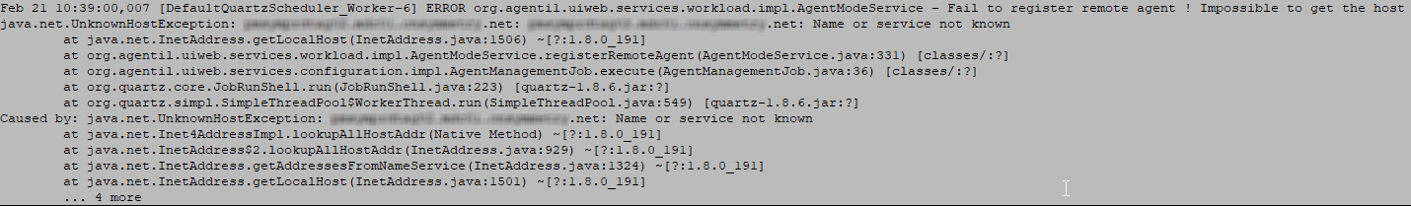
If you can find it, you need to edit the file /etc/hosts and register the FQDN hostname of the local host with 127.0.0.1

