Victora metrics Connector

Purpose
- Victoria metrics is a time series database used to store the metrics of each tenant.
- It is extremely efficient for consuming millions of data points
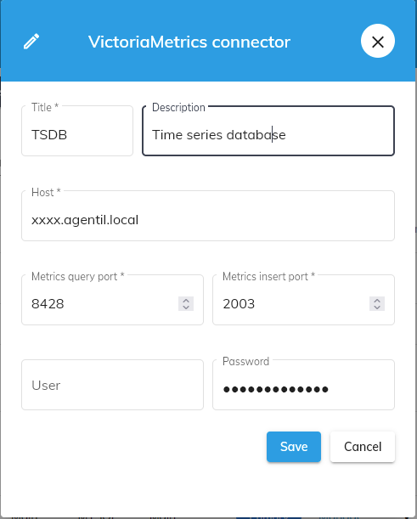

Configuration
- Title: : The display name of Victoria metrics
- Description: Description of Victoria metrics
- Host: : The hostname or IP address of Victora metrics
- Query and insert port: The ports used by Victora metrics
- Database name: Database used by the Victoria metrics
- User/Password: Credentials to access the Victoria metrics (not set by default)

