Keystore Management
- This page allows administrators to manage the keystore used by the application.
- It provides features to download and install certificates, generate self-signed certificates, and inspect the content of the application keystore.
- The page is divided into two main tabs:
  - Install and download certificates
  - Keystore
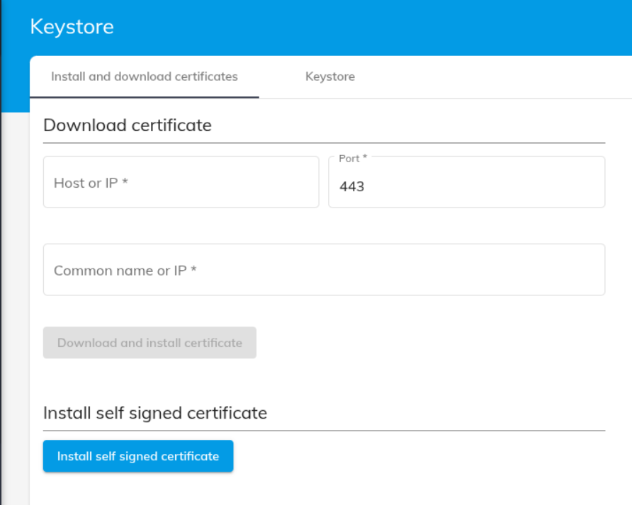

Install and Download Certificates

Download Certificate
This section allows you to retrieve an SSL/TLS certificate from a remote server and install it into the application keystore.

Form Fields
- Host or IP: The hostname or IP address of the remote server providing the certificate (do not include HTTP or HTTPS schema).
- Port: Network port used by the remote server (typically 443 for HTTPS).
- Common Name or IP: Expected Common Name (CN) or IP address that must match the certificate identity.
After the certificate is downloaded and installed, an application restart is required for the changes to take effect.>

Install a Self-Signed Certificate
This section allows the application to generate and install a self-signed certificate.
- Click the Install self-signed certificate button.
- Enter the Common Name (CN).
- Once confirmed, a self-signed certificate is generated and added to the keystore.
After installing a self-signed certificate, the application must be restarted for the new certificate to be used.

Keystore
The Keystore tab provides a read-only view of the application keystore.
This tab displays a table containing all entries stored in the keystore, including:
- Certificate aliases
- Certificate type (trusted certificate, key entry, etc.)
- Validity period
- Additional metadata depending on the certificate type
- And other related information

