Logs

UI
- The Logs section shows a table of the existing logs file.
- It allows the following actions:
  - download a log file
  - Delete/bulk delete log files
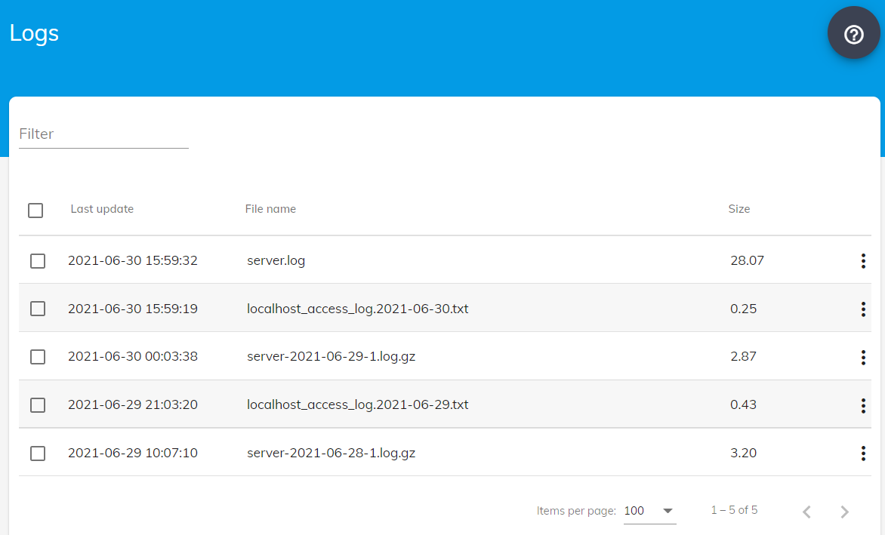

Download/Bulk download
- You can downlod a log file or a group of log files by either using the table action menu or the Download selection button.

Delete/Bulk delete
- You can delete a single log file or a group of log files by either using the table action menu or the Delete selection button.

