Health statistics
This section displays meaningful information about the performance and problems detected in the Redpeaks instance.

Incoming data
Performance problems can be caused by an influx of incoming data. Use the dashboards to detect any unusual situation.
- Displays the amount of data comming from the collectors:
  - Alarms
  - Metrics
  - Metadata
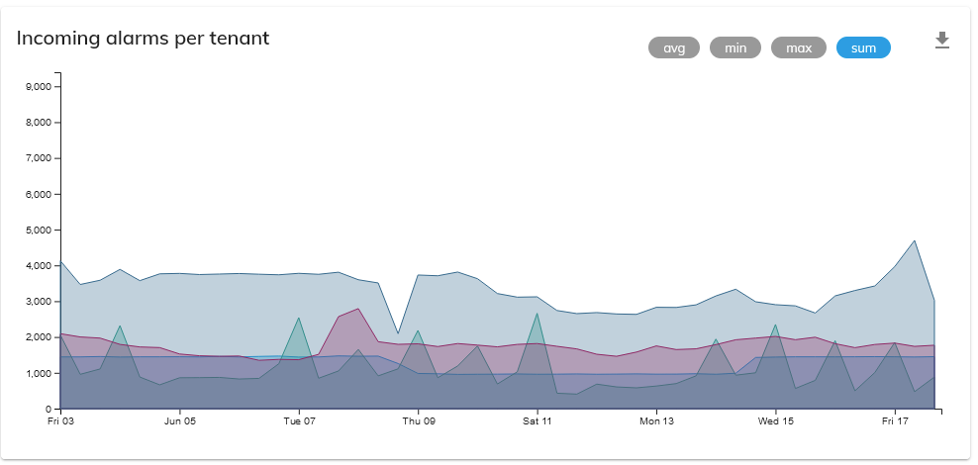

Log errors
To monitor errors in logs can be useful for investigating problems or checking the current situation.
- From this tab you can easily track errors in the server log file.
  - Last errors within the current period of time
  - The most frequent errors per class
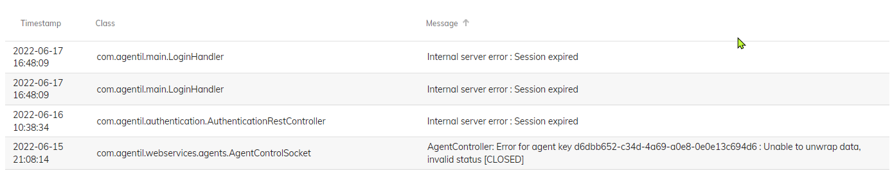

DB Requests
The database is often at the center of performance issues. This section will help to analyse database usage made by the application, and identify slow requests
- Dasboards displays the following information for config and metric databases:
  - The number of requests by type and by tenant
  - The average request time by type and by tenant
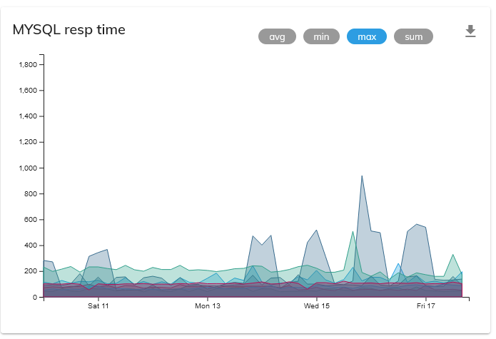

Slow Requests
This section will display database statistics and list the slowest requests.


