Super user

Purpose
- The super user is the user with the most permissions and can be used to manage the application's tenants.

Tenants UI
- The super user settings shows a form with the super user credentials.
- It allows the following actions:
  - Edit super user credentials
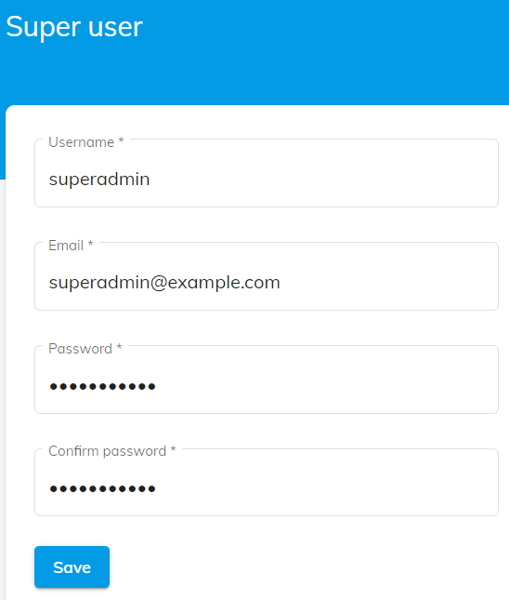

Edit
- Set the super user parameters
  - Username
  - Email
  - Password
  - Confirm password
- Press Save to save the changes

