Applications
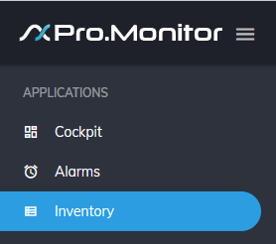
- Those are the current available applications:
Application | Description
Cockpit | Overview of your system's health and performance
Alarm console | An alarm console to manage all incoming alarms
Inventory | An inventory application to list and see groups, systems, hosts, etc...

