Dashboard editor
Redpeaks Cockpit's Dashboard Editor offers users access to pre-configured and customizable dashboards,
streamlining the organization and analysis of system data.
Users can design and explore bespoke dashboards tailored to their specific needs,
fostering seamless navigation through collected data and the generation of personalized insights.

Overview
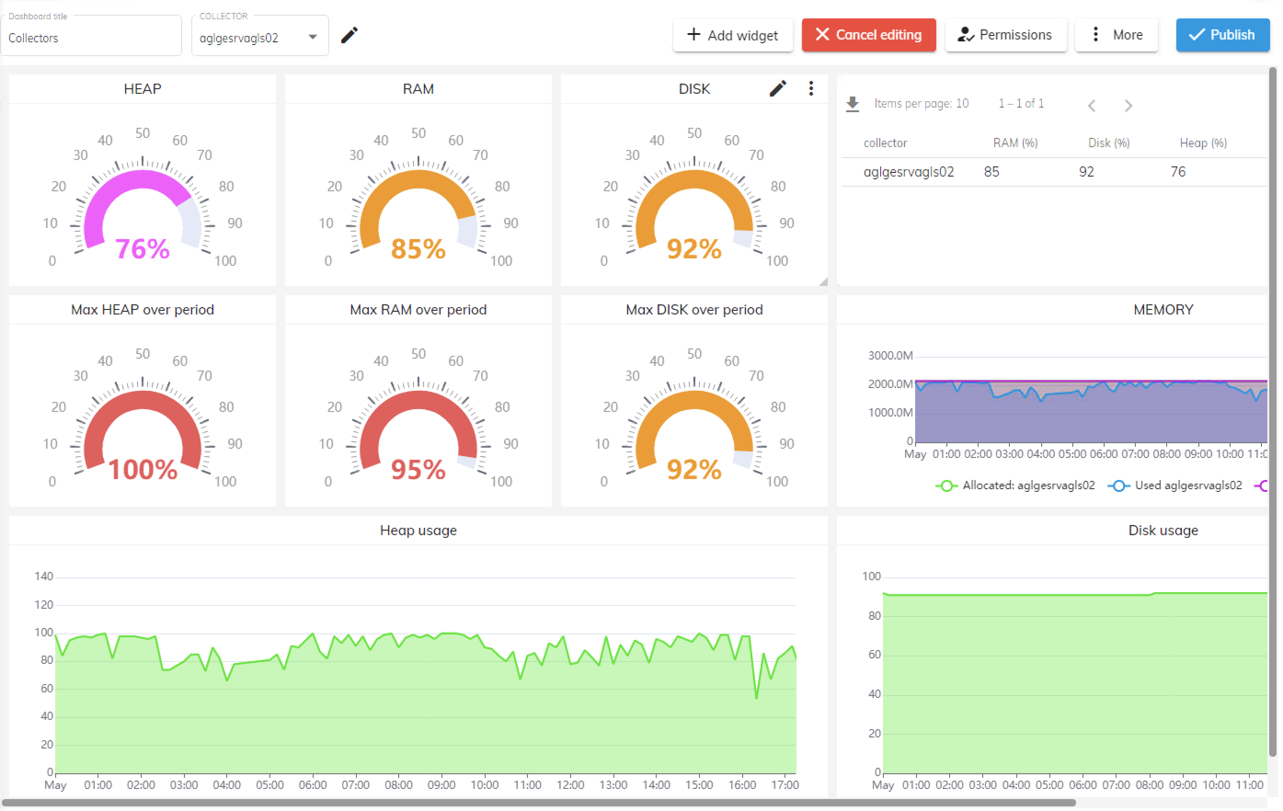
- Controls overview
- Edition
- Permissions
- Import/Export
- Variables

Controls
The following controls are available from the dashboard editor:
- Edit/Add variables
- Add widget
- Cancel edition
- Permissions
- More ->
  - Import
  - Export
  - Versions
- Publish
- Edit/Add Variables: Modify or adjust metric variables within the selected dashboard.
- Add Widget: Insert a new widget from the dropdown list of available widgets onto the dashboard. Click “Add widget” to access the dropdown list of widget options, such as text widgets, chart widgets, and metric table widgets.
- Cancel Editing: Discard any changes made during the editing process and return to the previous state in the dashboard viewer.
- Permissions: Manage and set access rights for users regarding the dashboard.
- More->: Access additional options or settings related to the dashboard.
  - Import: Quickly import dashboard configurations with ease.
  - Export: Effortlessly share dashboard data using the Export option.
- Versions: View or manage different versions of the dashboard and switch between them.
- Publish: Save and publish the dashboard configuration after completing edits.

Edition
- Creating a Dashboard:
- Work Area: Utilize the dashboard editor provided as your workspace for designing and configuring dashboards.
- Adding Widgets: Incorporate various widgets such as charts, tables, metric tables, graphs, etc. to visualize data effectively.
- Customization: Tailor the layout, appearance, and behavior of widgets to your specific monitoring requirements.
- Data Integration: Seamlessly integrate data from different sources to provide comprehensive insights within the dashboard.
- Interaction: Enhance usability and facilitate data exploration with filters, parameters, and interactive features.
- Preview and Testing: Ensure dashboard functionality meets your needs before deployment with preview and testing functionalities.
- Saving and Publishing: Make completed dashboards accessible for real-time monitoring and analysis by relevant users.

Permissions
- Dashboard permissions allows to control who can see and edit a dashboard.
- There are 3 levels of permissions, RESTRICTED is applied by default.
- This allows everyone the right to view a dashboard, but only owner to edit.
- Permissions can be customized via authorization profiles.
- Read Dashboard permissions details for a complete overview

Exporting
- Exporting as PDF: This method allows you to generate a PDF document containing the entire dashboard layout and visualizations.
- Exporting as JSON or Clipboard: With this option, you can export the dashboard configuration and underlying data in JSON format. Additionally, you have the flexibility to copy the JSON data directly to the clipboard.

Importing
- Paste Copied JSON: This feature allows you to import dashboard configurations by pasting the copied JSON data directly into the import interface. By simply pasting the JSON code, you can quickly recreate dashboard layouts and configurations.
- Import JSON File: Alternatively, you can import dashboard configurations by uploading a JSON file containing the desired dashboard setup.

Widgets
- Widgets are the building blocks of a dashboard
- Widget's purpose is to collect and display data, according to the selected time period.
- Insert and size widgets as you need within the dashboard panel
- See below the available widgets
Type | Purpose
Text box | Displaying a custom text
Chart | Displaying timeseries in a chart
Query value | Displaying value from a queried metric data
Table | Displaying timeseries data in a table format
Metric table | Displays timeseries data in a concise tabular format, facilitating easy analysis and comparison of metrics over time.
Gauge | Visualizes single data points or metrics within a specified range, providing an instant overview of current values.
System status | Provides an immediate snapshot of the current state of a system, presenting key indicators or metrics in a concise format for quick assessment and monitoring.

Dashboard variables
Empowers users to dynamically select metrics for display or data analysis, allowing for customized visualization and deeper insights into the dashboard's content. This feature enhances dashboard flexibility, enabling users to adapt their analysis in real-time based on evolving needs or priorities. Read Dashboard variables details for a complete overview

