Dashboard variables
The dynamic metric selection feature empowers users to tailor the visualization of data within the dashboard to suit their specific needs and preferences.
By enabling users to choose which metrics to display or analyze, this feature enhances the flexibility and adaptability of the dashboard, ensuring that users can derive meaningful insights and make informed decisions based on real-time data.

Overview
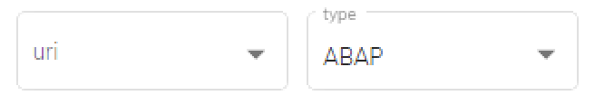
The Dashboard Variable feature in Redpeaks empowers users to filter data on the dashboard dynamically, enhancing data exploration and analysis within the SAP monitoring system. Users can utilize single or multi-select variables, which are fully editable and customizable. Multiple variables can be applied to a single dashboard, providing granular control over the displayed data.

General Instruction of Use:
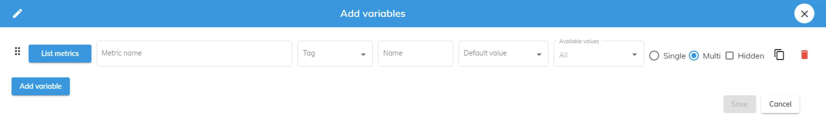
1. Adding Variables:
- Navigate to Dahboard editor.
- Locate the option to add a new variable and click on it to open the variables modal.
- Specify the type of variable (single select or multi-select) and provide a name/description for clarity.
- Define the variable options or values based on the filtering criteria relevant to the SAP monitoring system.
2. Editing Variables:
- Navigate to Dahboard editor.
- Locate the edit icon at the top left close to the existing variables and click on it.
- Update the variable type, name, description, or options as needed.
- Save the changes to apply the updated variable settings.
3. Applying Variables:
- On the dashboard interface, locate the variable selection control (e.g., dropdown menu).
- Choose the desired variable value(s) from the available options.
- The dashboard will automatically refresh to display data filtered according to the selected variable(s).
4. Managing Multiple Variables:
- Repeat the above steps to add additional variables to the dashboard if needed.
- Each variable can be independently selected and applied, allowing for complex data filtering scenarios.
- Users can combine multiple variables to refine data analysis and gain deeper insights into SAP system performance and status.

