Dashboard viewer
Redpeaks Cockpit's Dashboard Viewer provides users with access to pre-configured dashboards,
facilitating efficient organization and analysis of system data.
Users can explore custom dashboards designed to their specifications,
enabling seamless navigation through collected data and personalized insights generation.
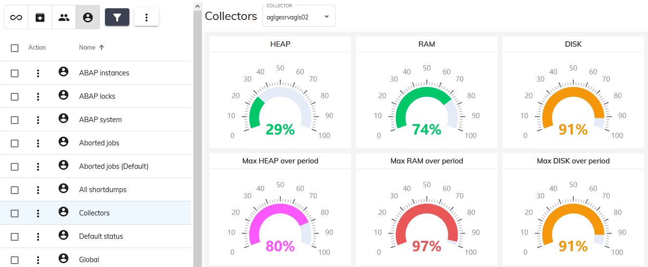

Overview
The dashboard view primarily consists of the following components:
- Dashboard Table
- Controls Overview
- Filter functions
- Variables
- Dashboard Table
  - This table presents a clear overview of the available dashboards, offering sorting functionality to facilitate effortless navigation.
- Controls Overview:
  - Hide Dashboard: Click 'Hide Dashboard' to toggle the visibility of the dashboard list table, providing a clearer and expanded view for enhanced data visibility and clarity.
  - Expand/Contract: Utilize the 'Expand/Contract' icon button to switch between expanding and contracting the view, allowing you to control the level of detail displayed for better clarity or compactness.
  - Period Selector: Utilize the period selector to define the time frame or interval for data exploration and analysis. Simply click on the dropdown menu, then choose the desired period, or specify a custom range by selecting 'Custom'. Adjust the start and end dates accordingly for your analysis needs.
  - Create new: Click the “Create new” button to create a new custom dashboard
  - Filters: Explore and apply customizable filter options to refine your dashboard view based on specific criteria.
  - Bulk Import: Quickly import multiple dashboards at once with the bulk import feature, streamlining your workflow and saving time.
  - Bulk Export: Easily export multiple dashboards simultaneously with the bulk export feature, simplifying the process and allowing for efficient data management.
  - Edit: Transition to edit mode by clicking the 'Edit' button, enabling modifications to the selected dashboard.
  - Export: Select either PDF (Click “Export to PDF”) or JSON (Click “More -> Export”) export options, with the added convenience of copying to clipboard.
- Filter functions:
  - Enhance your dashboard viewing experience with a variety of filter options, including “Default dashboards,” “Non-default dashboards,” and “Current User’s Dashboards.” These filters allow you to refine the displayed dashboard list, focusing on specific information or insights that matter most to you.
  - Toggle the “Text Filter” by clicking on the filter icon and inputting specific text to search for and filter the dashboard list accordingly. This feature provides a quick and efficient way to find the dashboards you need based on your search criteria.
- Variables
  - Utilize the “Variables Selector” to customize your dashboard view by selecting specific variables of interest.
  - This feature allows you to tailor your dashboard display to focus on the variables that are most relevant to your analysis or monitoring needs.

