Chart widget
Use chart widget to display timeseries in a chart in the dashboard
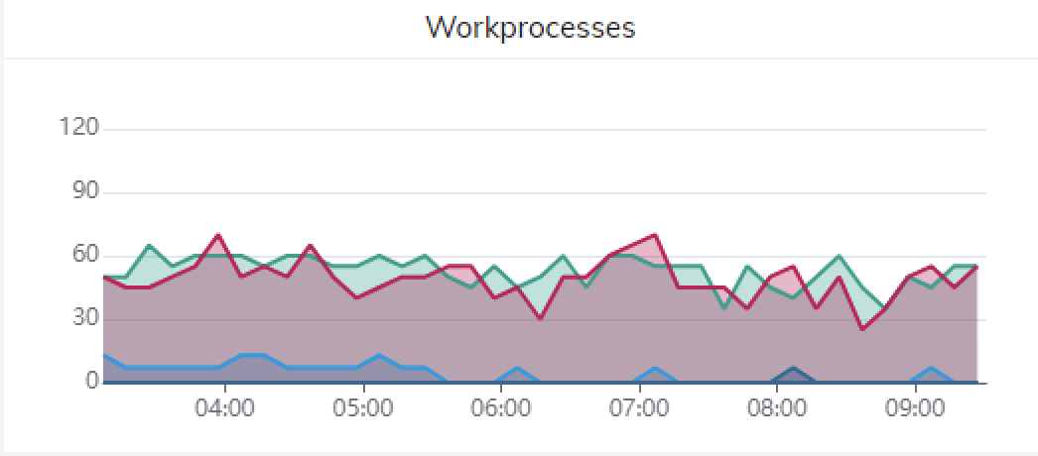

Overview
- Graphically represents timeseries data on the dashboard.
- Provides insight into trends and patterns over time.
- Mouse interaction enables instant visualization of metrics data.
- Zoom functionality available for focusing on specific time periods.
- Click once to hide the tooltip; click down and brush over desired period to reload data.
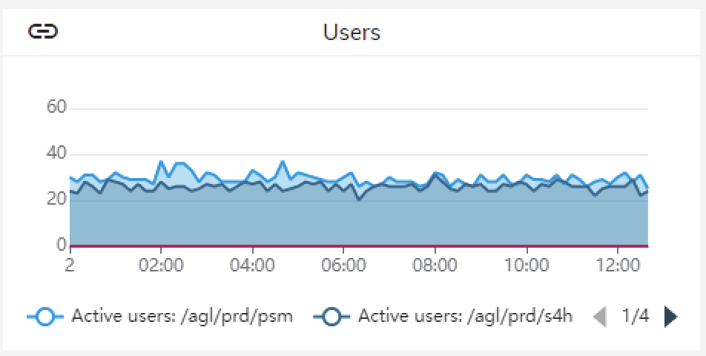

Examples
- System Performance Metrics: Track CPU, memory, and response times to monitor SAP system performance.
- Transaction Monitoring: Monitor transaction throughput and response times for critical business processes.
- Database Monitoring: Analyze database performance metrics for optimal SAP system operation.
- Job Monitoring: Track background job execution times and success rates for timely completion.
- User Activity: Monitor user logins and session durations to enforce security and optimize resources.

