Metric table widget
Use Table widget to display timeseries data in a concise tabular format,
facilitating easy analysis and comparison of metrics over time in the dashboard

Overview
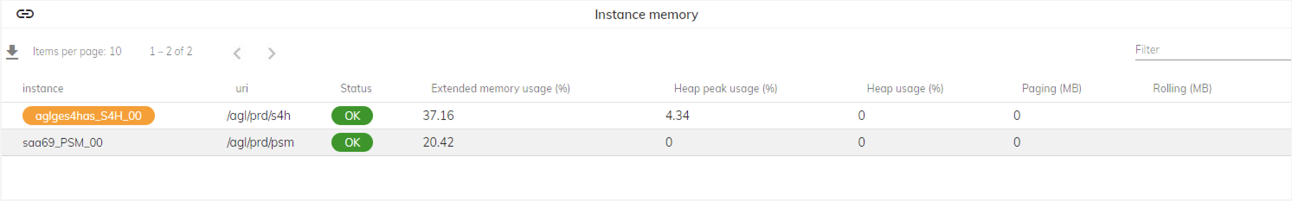
- Displays timeseries data in a concise tabular format
- Shows metrics title and unit when available
- If a variable is attached to the widget, clicking on the widget will load its data.
- Additionally, the widget can carry a link for redirection upon click.
- Copy widget data to clipboard
- Export widget as PDF
- Download widget data as CSV

Examples
- The Metric table widget presents organized data, such as system metrics or transaction details.
- Enables quick analysis and monitoring within the SAP system.
- Provides a concise overview of relevant information for decision-making.

