Query value widget
Use query value widget to display value from a queried metric data in the dashboard
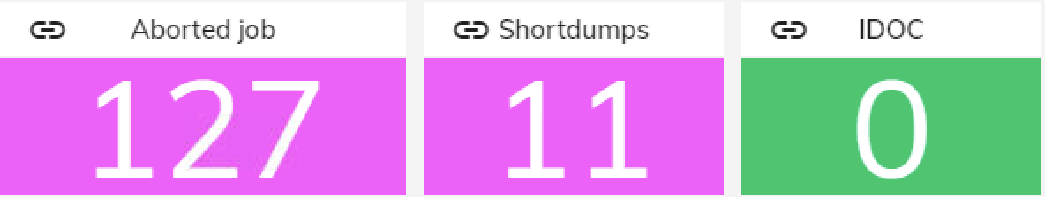

Overview
- Displays the current value of a given metric
- Shows metrics title and unit when available
- If a variable is attached to the widget, clicking on the widget will load its data.
- Additionally, the widget can carry a link for redirection upon click.

Examples
- Real-Time CPU Utilization: Display current CPU usage for quick system performance assessment.
- Error Count Monitoring: Track critical error counts for prompt issue identification and resolution.
- Transaction Throughput: Monitor current transaction rates to gauge system workload.
- Database Connection Pool Usage: Keep track of database connection pool utilization for optimal resource allocation.
- System Uptime: Display current system uptime to track system reliability and downtime events

