System status widget
Use System status widget to get an immediate snapshot of the current state of a system,
presenting key indicators or metrics in a concise format for quick assessment and monitoring in the dashboard

Overview
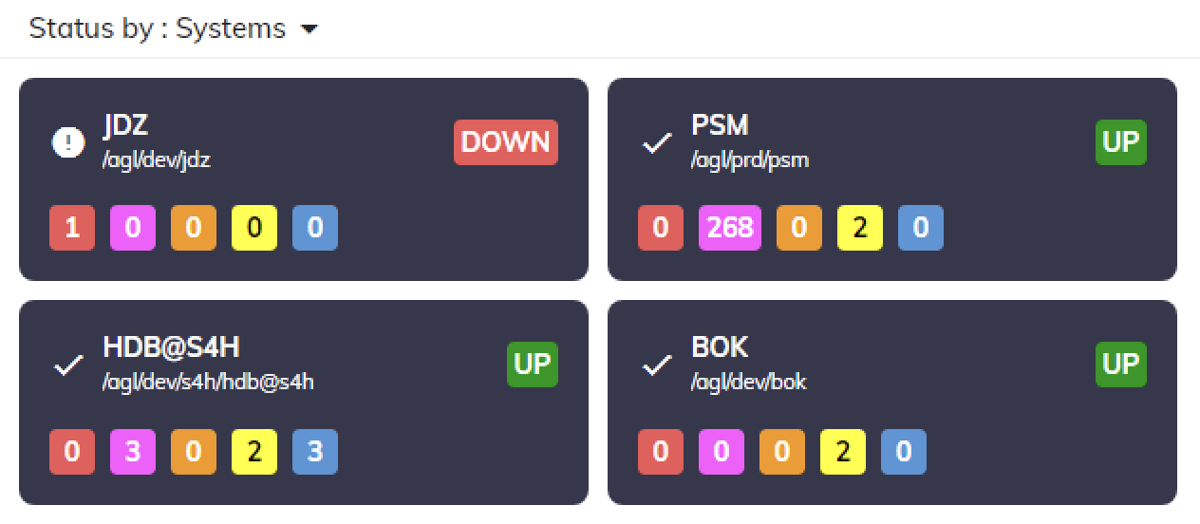
- Provides an immediate snapshot of the current state of a system, presenting key indicators or metrics in a concise format for quick assessment and monitoring.
- Shows metrics title when available
- If a variable is attached to the widget, clicking on the widget will load its data.
- Copy widget data to clipboard
- Export widget as PDF

Examples
- Server Health Monitoring: System Status widget displays key server metrics like CPU, memory, and disk usage for quick health assessment.
- Service Availability: System Status widget indicates operational status of critical SAP services for ensuring service availability.
- Database Performance: System Status widget provides insights into SAP database performance metrics for optimizing database operations.

