Table widget
Use Table widget to display timeseries data in a table format in the dashboard

Overview
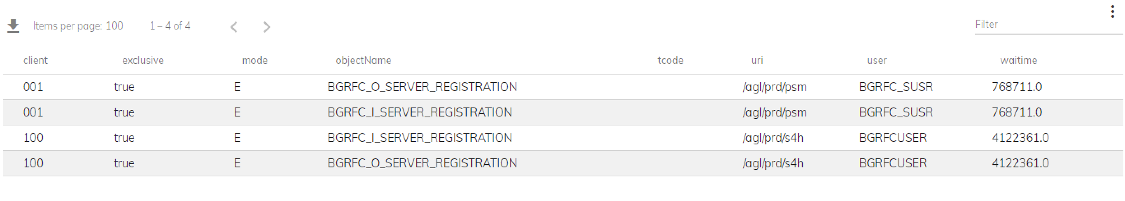
- Displays timeseries data in a table format
- Shows metrics title and unit when available
- Copy widget data to clipboard
- Export widget as PDF
- Download widget data as CSV

Examples
- The Table widget presents organized data, such as system metrics or transaction details.
- Enables quick analysis and monitoring within the SAP system.
- Provides a concise overview of relevant information for decision-making.

