Device Dashboards
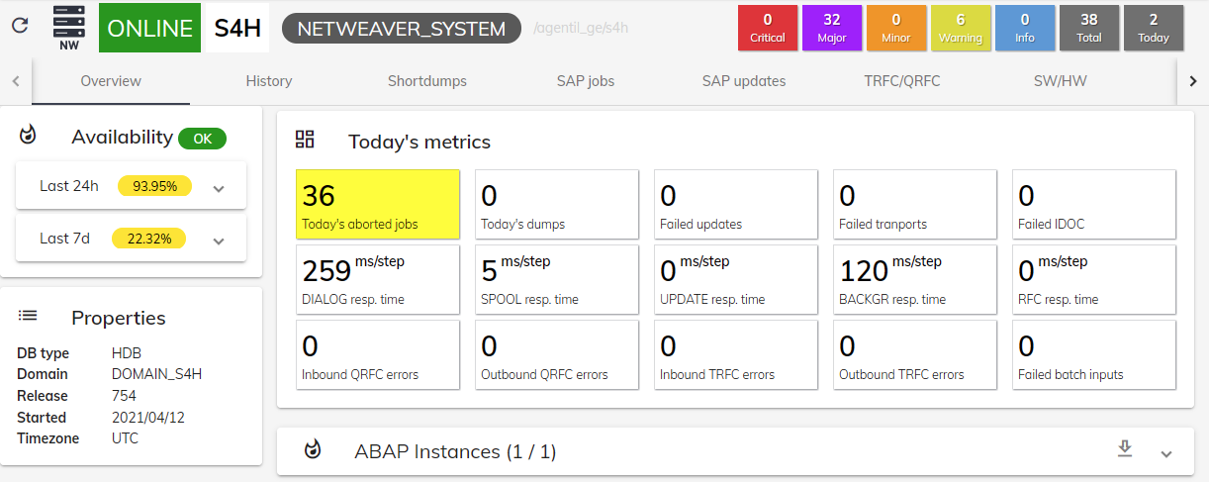

Purpose
- Each type of device has its predefined dashboard
- A dashboard will show general information about the device as well as very detailed information about its health, performance and historical data.

Dashboard types
Type | Description
Netweaver | Dashboard for Netweaver systems and associated instances like ABAP or JAVA
HANA | Dashboard for HANA DB tenant

Dashboard widgets
- Device information will be displayed via dedicated widgets, such as graphs or tables
- Those widgets will behave in the same way across dashboards and are described below

Header
Dashboard header helps to quickly identify the device and its current status:
- Type icon
- Current state
- Device name
- Device type
- Device URI
----

Alarms overview
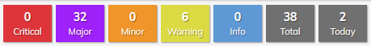
- The alarm overview shows the number of current alarms associated to the device, by severity.
- You can also see the grand total and the number of alarms received today
- You can click on the widget to be redirected to the alarm application, filtering on the current device

Dashboads tabs
- Dashboards have tabs to organize the information in an appropriate way.
- It often starts by an Overview tab showing a summary of the device information
- A given tab usually adresses a particular module or type of data from a given device
- It is often possible to be redirected to a specific tab via a single metric panel in the cockpit or in the dashboard

Availability
- This describes the current connectivity state of the system and its availability rate in the last 24h/7d
- You can expand the panel to see state changes

Properties
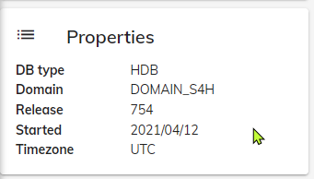
- Depending on its type and configuration, each system will have a different set of properties
- Some properties can be discovered from devices, (Version, ...) and some others can be set manualy (Localization,...)

Single metrics
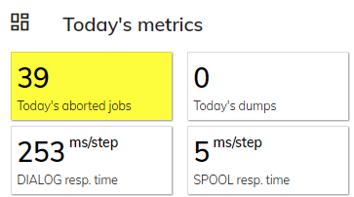
- Displays the current value of a given metric
- Shows metrics name, description and unit when available
- Panel background can arbitrarily change color based on metric value or based on current alarms
- If a dedicated tab is available in the dashboard, to click on the metric will open the tab and load its data.

Information tables
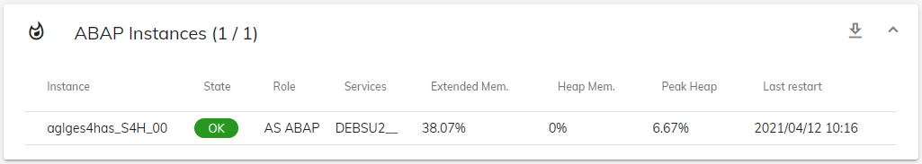
- Tables are used to display metadata of various kinds, such as list of components with their associated health or performance metrics, list of items, etc...
- A header describes table content and contextual information
- Tables can often be expanded or collapsed
- When enabled, a filter field allows to search for specific information
- An export button allows to download the content of the table in a CSV format
- The content of a table will often depend on the selected period

Graphs
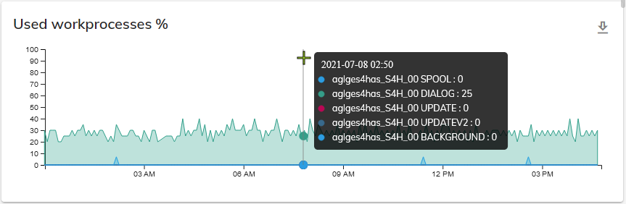
- Graphs display metrics data across a period of time.
- Move the mouse over the graph to visualize instant metrics data
- On some graph, you can zoom in using the mouse:
  - Click once to hide the tooltip (Click again to unhide the tooltip)
  - Click down and brush over the desired period
  - This will automatically reload the data for the selected period across all dashboard tabs
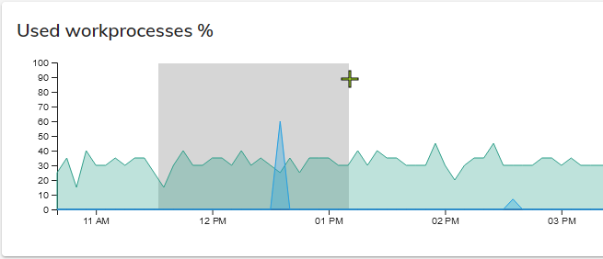

Period picker
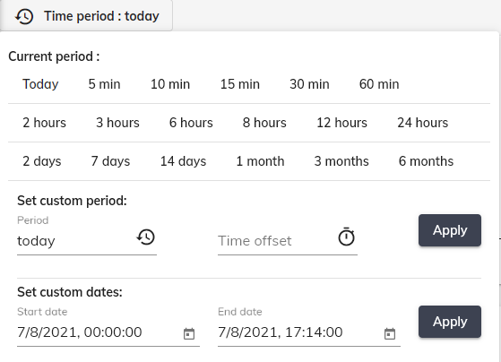
- The period picker allows to select the period of time to use to display device data
- To change the period within a tab will also change the period of other tabs
- You can select predefined periods, or set your own custom period via the custom period form or the date picker.
- Custom period form and date picker allows to select a period with an offset versus current time
  - Example: Period: 24h Offset: 7d : Displays 24 hours of data from 7 days ago
Time units to use in custom period form:
Unit | Description
s | seconds
m | minutes
h | hours
d | days
w | week
y | year
- Examples:
  - 24h: 24 hours
  - 30d: 30 days

