Inventory

Purpose
- The inventory gives an overview of all the discovered devices with their relationships and properties
- Use the filters to quickly find any device and access all its information within the table

Inventory UI
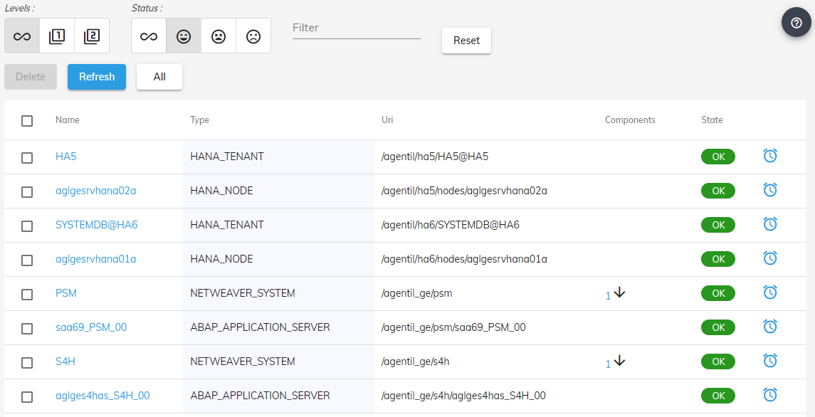

Filters
Levels: The level filter allows to define the levels of hierarchy to display:
- Infinite: Displays all levels
- 1: Displays only the first level (Groups only)
- 2: Displays only the two first levels
Status: Filters the devices based on their current state:
- Infinite: All devices
- Happy: Offline states
- Moderate: Unknown states
- Unhappy: Offline states
Filter: Filters the devices based on your entry, on the following properties:
- Name
- Type
- URI
- State

Table
- The device table will list all discovered devices according to the defined filters
Name | Device name
Type | Device type
Uri | URI identifier
Components | Number of childs devices
State | State of the device connectivity
- Click on the device name to access to its dashboard.
- Click on the components column to see only the childs of the devices.
- Click on the alarm icon will redirect to the alarms application with a filter on the device.

Dashboard
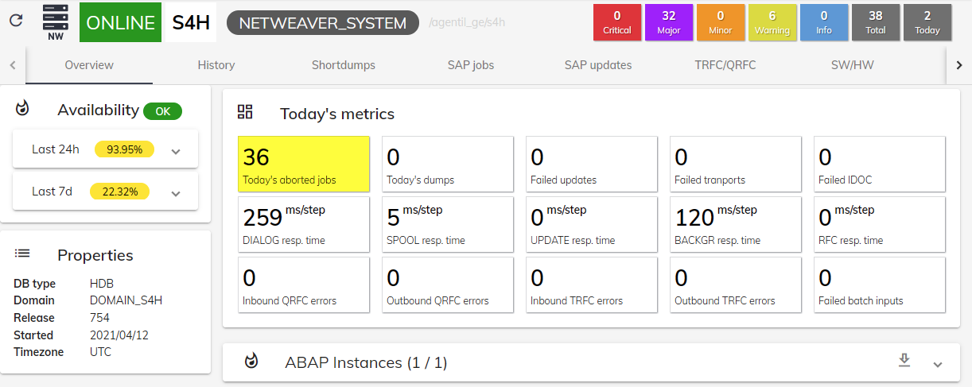
- The inventory application leads to device dashboards by clicking on a device name.
 You can bookmark device dashboard url to quickly access to the dashboard of a given system

