Reports

Purpose
- The Reports enables users to manage and access all generated reports
- Reports are collected from all configured collectors and can be downloaded, viewed, or resent via email
- If SMTP settings are configured in the Cockpit and a collector didn't have SMTP, reports will be sent through the Cockpit

Report Definition
A report is a generated file that provides detailed system information, status, or monitoring data:
Parameter | Description
Timestamp | The time the report was received by the Cockpit
Name | The unique name of the report, often reflecting its type and generation date
Type | The format of the report (e.g., HTML, ZIP)
Size | The size of the report file
Status | The current state of the report (e.g., Sent)
Recipients | The email recipients who received the report, if applicable

Reports UI
- Download: Click the download icon to save the report locally.
- View: Click the eye icon to preview the report directly in the interface.
- Delete: Use the menu (three-dot icon) to delete individual reports.
- Filter: Utilize the filter bar to search for specific reports based on name or parameters.
- Resend Reports: If SMTP is configured, reports can be resent to the defined recipients via email.
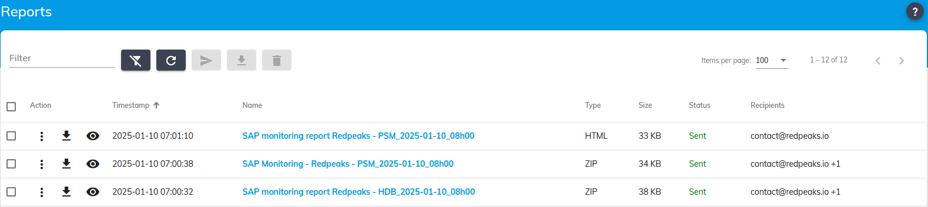

SMTP Integration
The Cockpit can handles email report sending seamlessly using its SMTP configuration when needed
- When “Send report via email” is enabled in the report settings:
  - The Cockpit uses its SMTP configuration if the collector's SMTP is disabled
  - Reports are sent to the specified recipients automatically
  - Hover over the Recipients column to display the list of email recipients for each report

Notes
- Reports are generated by collectors and synchronized with the Cockpit
- Bulk actions such as downloading multiple reports or deleting selected reports are supported
- Hover mouse on “Not Sent” in the Status column to view details about the issue

