Overview

What is Redpeaks Cockpit ?
- Redpeaks cockpit is a monitoring and integration solution primarily focused on SAP technologies and the associated databases and environments
- Its purpose is to monitor the health and performance of these applications to ensure the highest quality of service and facilitate operations and maintenance.
- We named it Cockpit because it will provide visibility and control over large and complex environments, via various applications such as Alarm console, Overview cockpit or Dashboards
- Redpeaks cockpit works with Collectors which are dedicated to specific technologies, such as SAP.
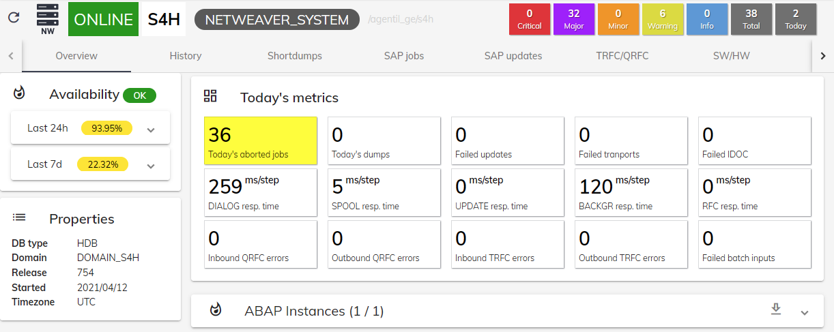

Main features
- Applications: Redpeaks cockpit can be seen as an application platform. Each application will help to manage device landscapes
  - Cockpit overview: Visualize your entire landscape in a single page
  - Alarm console: Manage all the problems detected on the devices
  - Inventory: Manage all you device properties and connectivity
  - Device dashboard: In depth visibility of a particular dashboard.
  - More applications will appear as we go.
- Monitoring:
  - A whole section is dedicated to the definition and control of the monitored environments
  - This is where you will define the structure of the environment and the connection parameters
  - You will also define and control how those environments will be monitored
  - Predefined monitoring profiles are available for each type of system
- Administration
  - Manage teams and users: Users can be grouped by teams to facilitate the control over what a user can see and do
  - Manage authorization profiles allowings to finely control which applications a user can use and which devices he can control.
  - Business rules: Create rules to define actions based on some incoming events
  - Plugins: Easily connect Redpeaks cockpit with external third parties
  - Monitoring library: A preconfigured set of monitors based on monitoring best practices and designed to be efficient and simple to use.
  - Collectors: Agents that remotely connect to the systems, collect, analyze data and generate monitoring information such as alarms, metrics and reports.
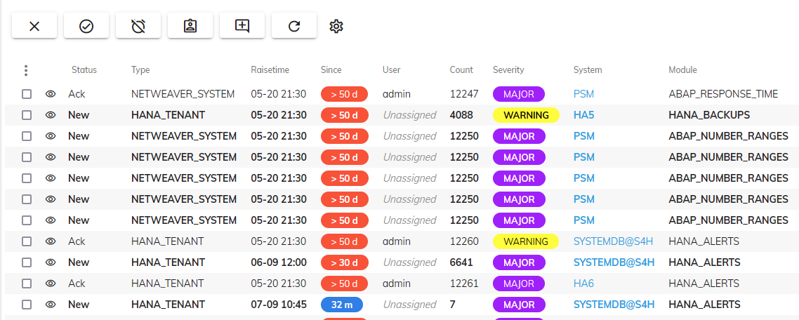

Monitored technologies
Redpeaks cockpit is a generic platform that can cope with any kind of devices.
The provided SAP collector can monitor the following applications:
- SAP NetWeaver ABAP/Java
- SAP S/4HANA
- SAP HANA
- SAP Business Objects
- SAP ASE database (Sybase ASE)
- Oracle database
- MSSQL database

Architecture
- The Redpeaks cockpit application relies on the following components:
  - A central instance hosting most key components such as UI, databases and agents control.
  - Collectors responsible for collecting information on the target systems.
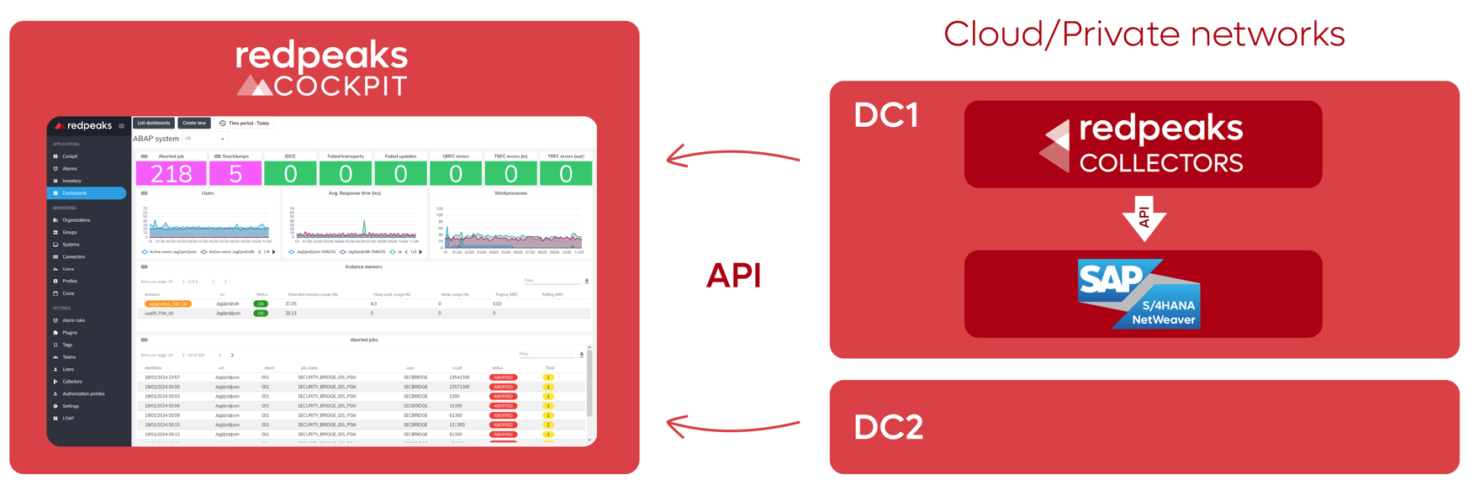
Central Instance:
- The central instance provides the main application services:
  - A REST API to consume Agent's data and provide a WEB user interface.
  - Databases to store configuration, metrics, reports, metadata and all generated information.
  - A central control bus to manage remote agents.
- The central instance can be hosted on premise or via SAAS.
Collectors:
- Collectors are agents that will locally collect and analyse information from the devices
- Then consolidated information is sent back to the central instance
- Collectors are a very efficient way of monitoring systems within isolated environments without exposing them.

