Monitoring
The monitoring section allows to define the monitored environments and their structure,
as well as all the necessary parameters to connect.
This is also where you can configure and customize the way each environment will be monitored.
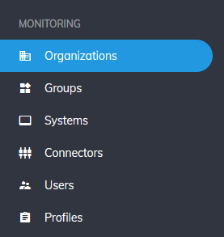

Overview

Organizations and groups
- They are folders and sub folders helping to organize the monitored environments
- Use organizations to identify different companies/entities (customer A, B, etc...)
- Use groups to identify a common aspect of your environments (like roles: Production, etc...)
- Groups will also reflect to a zone where all underlying systems will be reachable.
- Each group must be associated to a remote collector which will have the capacity to connect to the systems.
- Organization and groups will be later used to set user authorizations and control visibility and actions upon underlying environments
- So it is important to consider the future user authorizations when defining your organizations & groups, because environements within the same group will have the same authorizations
- At least one organization and one group must exist in your configuration.

Systems, connectors, users
- A system identifies a logical component in your environement, such as a NetWeaver system or a Database.
- Connectors are used to define a connection mean to a system
- A system can have multiple connectors when access to system's components requires different means, such as RFC, HTTP, SOAP, etc...
- Users define user credentials to be used by connectors.

Profiles
- Profiles are a flexible way to define and control how your environments are monitored.
- A profile is a template that defines what is monitored and how.
- It contains a list of monitors, which essentially defines the monitoring tasks.
- Associate profiles with connectors to define how a system will be monitored.
- A profile has a type and can only be associated with compatible connectors:
  - Example: An ABAP profile can only be associated with ABAP connectors.

Monitoring sections
Type | Description
Organizations | Organization owning the monitored environments
Groups | Use group to segregate the diffente type of systems
Systems | Defines your SAP systems
Connectors | Defines system remote connection means
Users | Define user credentials to use in connectors
Profiles | Defines the monitoring profiles used to monitor the systems
Crons | Define the schedules used by the monitors

