Profiles
A profile is a set of customized monitors, defining how to monitor a given type of system
You can create your first profiles from a predefined list, or build it from scratch by using Redpeaks's monitoring library
Profiles are then associated to connectors, defining the data to collect and the checks to perform.

Purpose
- Define global monitoring settings
- Customize and fine tune monitoring
- Centralized control of large landscape monitoring
- To create several monitoring templates relevant for the various types and roles of monitored systems

Definition
- A profile is defined by:
Parameter | Description
Name | The display name of the profile
Type | The type of connector to associate with
Description | An optional description
Monitors | The list of monitors to include in the profile

Profile table
The profile table allows to:
- Assign a profile to connectors with Assign action
- Add new monitors in the profile with Assign monitors action
- Clone a profile
- Bulk delete profiles
- Open profile configuration by clicking on profile name
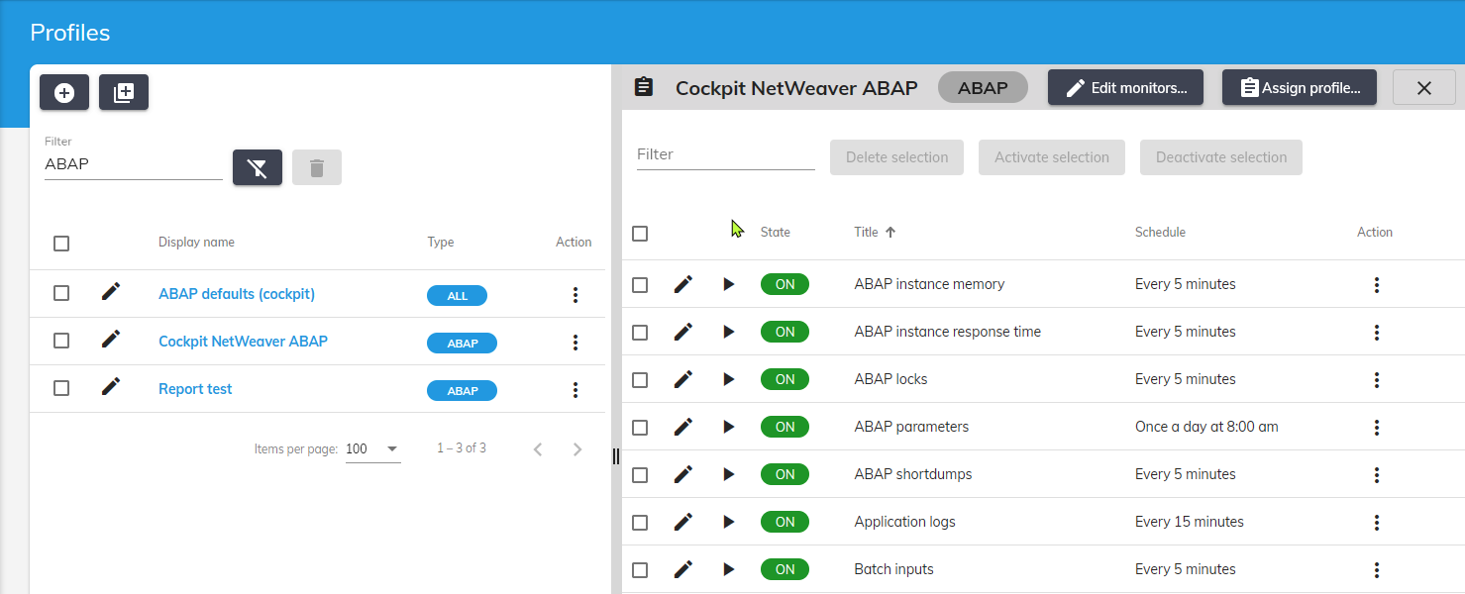

Profile monitors
- The profile monitor list displays the associated monitors
- You can bulk change monitor states and edit each individual monitor from table actions
- To click on a monitor name will open its configuration
 When you customize and save a monitor, the changes will be immediately used by all associated connectors
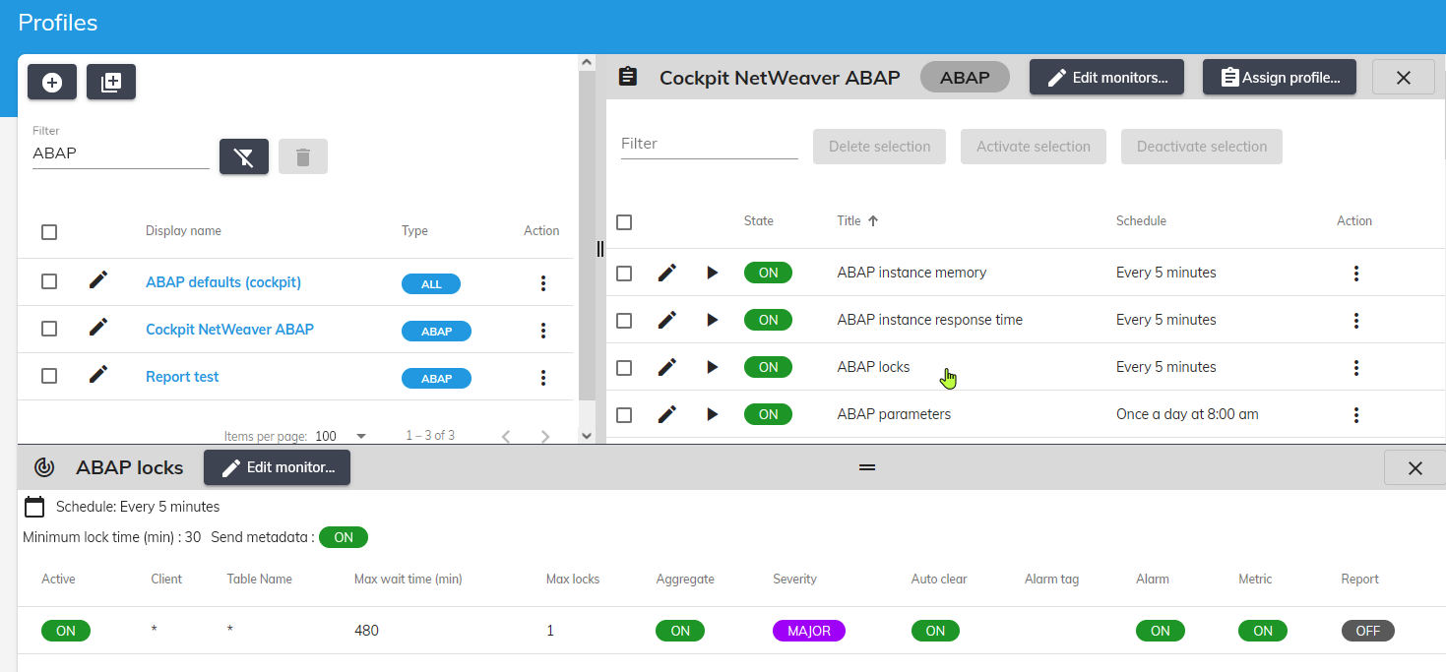

Master profiles
- Master profiles have been created to control the content and customization of multiple other profiles.
- Those profiles are called Supervised, they inherit from one master.
- All changes applied to a master profile will be propagated to each supervised profiles:
  - Adding/Removing monitors
  - Customization of monitors
- This allows enforcing a monitoring standard across several other (supervised) profiles, while allowing customizing
- A Master profile is a template meant to create supervised templates.
- It strictly defines the monitors that each derived supervised profile can have
- It cannot be assigned directly to a connector
- Adding or removing monitors from a master profile will be applied on all its supervised profiles too.

