Collectors

Purpose
A collector is a remote service that acts as a proxy between the Redpeaks Cockpit and SAP systems.
It provides the means to control the monitoring configuration of remote SAP systems and to collect monitoring data.
By using multiple collectors, you can centrally monitor several isolated environments.
Simply assign groups of systems to a collector for starting to control remote target SAP systems.

Configuration
- Collectors will be automatically displayed in the collectors table as soon as the connection is configured and established with the remote collector service.
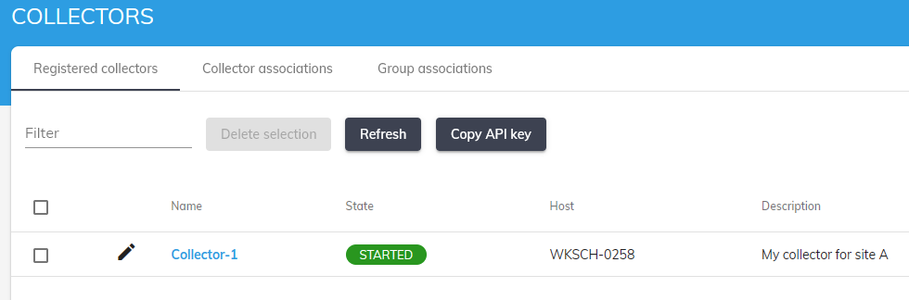
Menu | Description
Registered collectors | Lists collectors currently and previously discovered
Collector associations | To associate a collector with one or several groups
Group associations | To associate a group with one or several collectors
Collector profiles | Define settings templates to use across multiple collectors
API Keys | List and define the API keys used by collectors
Drivers | Centrally manage and distribute drivers to collectors
Statistics | Display collector statistics
Monitoring | Define collector monitoring settings

Assign groups
- To start using a collector, use the Collector associations or the Group associations tabs to assign groups to collectors.
- Once assigned, the monitoring configuration set for each system will be transfered to the collector and the monitoring will take place as configured.
- Any change in the monitoring configuration will be automatically detected and transfered within the next 30 seconds.

Collector settings
- Pressing the edit button will open the collector settings.
- You can update collector name and description as well as collector settings:
  - Log level of the collector
  - DEBUG level expiration: (To prevent DEBUG log to run forever)
  - Collector memory: You can define the maximum memory to assign to a collector
  - Collector threads: You can define the number of concurrent threads to allocate to the collector
NOTES
- Collector memory and threads should only be changed in case a collector is configured to monitor more than 100 systems
- Log level should be set to INFO during normal operations

