Drivers manager
Drivers Manager lets you centrally manage and distribute connection drivers
to all registered collectors. Collectors require drivers to connect to target environments
such as databases and enterprise systems. Keeping the right driver versions aligned
across a large number of collectors can quickly become difficult and time-consuming.
With Driver Manager, drivers are stored and maintained in one place, then distributed to
collectors from a central point. You can also assign specific drivers to specific collectors
when needed (for example, to support different system versions or special requirements).

Configuration
- You need first to upload drivers.
- When uploading a driver, you must assign a type and a version
- You need to select the assign mode of each driver:
  - Assign to Some: force the driver to be assigned to a given set of collectors
  - Assign to All: Will be assigned to any collector, unless specific assignment.
- Types and version will not be auto-detected, you must set them with care
  - To set versions, we recommend using numbers and dots only:
    - Good: 12.25.9
    - Bad: V12 rel25_patch9
Example:
- Driver file name: ojdbc8-23.9.0.25.07.jar (Oracle)
- Type should be Oracle
- Version should be 8.23.9.0.25.07
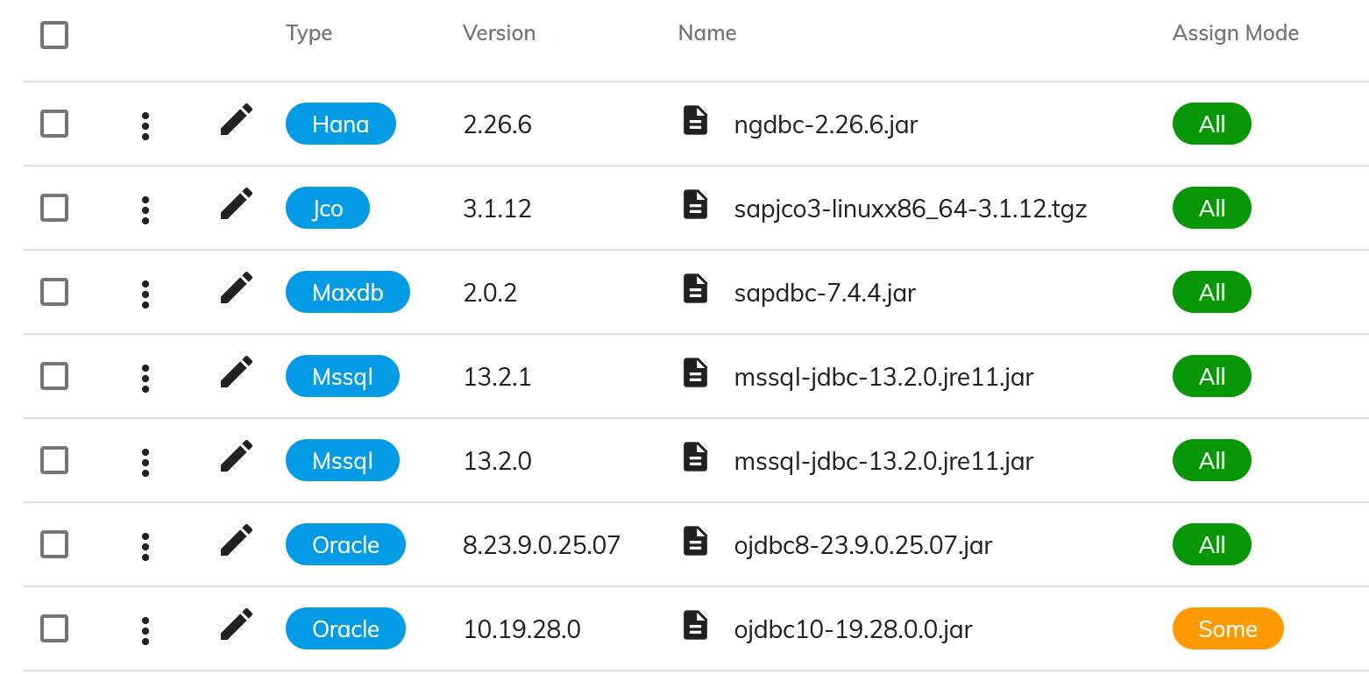

Distribution
- Once a collector pings, the cockpit will sync collector drivers with the list of registered drivers.
- By default, the highest version of each driver type will be distributed.
- Changes to the driver list will be applied to registered collectors within a minute.
- Driver removals will trigger a restart of affected collectors.
- You can assign a particular driver to a collector to use a specific (lower) version
Example:
- Assign MSSQL driver V13.2.0 to all collectors by default
- Assign MSSQL driver V12.9.1 to collector rp_prod_dc1
Note:
- Pre-existing drivers (installed manually) will no longer be used.
- You should no longer manually install drivers on collectors, they will be removed at restart.

