Elasticsearch Plugin
This plugin allows you to send alarms and metrics directly to an Elasticsearch instance
Alarm, metrics and Metadata can be indexed in separate Elasticsearch indices

Configuration
- From the plugin menu of Redpeaks cockpit, press the button + Create then select Elasticsearch in the drop-down.

Connection parameters
Parameter | Description | Mandatory
Active | Enables or disables the Elasticsearch plugin | Yes
Configuration | Choose between Standard Configuration or Cloud Configuration | Yes
Name | A unique name for the plugin instance | Yes
URL | The URL (with HTTPS for a secure connection) | Yes (if Standard Config selected)
Port | The port used to connect to Elasticsearch (Default is 9200) | Yes (if Standard Config selected)
Cloud ID | The Cloud ID used for connecting to a cloud-based Elasticsearch instance (Cloud Config) | Yes (if Cloud Config selected)
API Key | The API key for authentication (Cloud Config) | Yes (if Cloud Config selected)
Username | The username for Elasticsearch authentication | No
Password | The password for Elasticsearch authentication | No
Properties | A semicolon-separated list of additional Elasticsearch properties | No
Example:
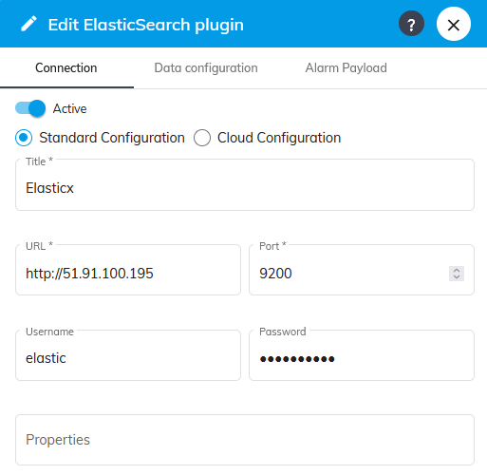

Properties
- Properties are key/value pairs separated by semicolon: setting1=value1;setting2=value2
- Common Elasticsearch properties include settings for index refresh intervals, number of replicas, etc.

Data configuration
- Open Data configuration tab to define how data is going to be sent and indexed in Elastic.
Alarms parameters
Parameter | Description | Mandatory
Send alarms | If active, alarms received by the plugin will be sent to Elasticsearch | No
Track alarms history | If active, enables tracking of alarm history | No
Alarm Index | The Elasticsearch index where alarms will be stored | Yes (if Send alarms checked)
Metrics parameters
Parameter | Description | Mandatory
Send metrics | If active, metrics received by the plugin will be sent to Elasticsearch | No
Track metrics history | If active, enables tracking of sent metrics | No
Metric Index | The Elasticsearch index where metrics will be stored | Yes (if Send metrics checked)
Metadata parameters
Parameter | Description | Mandatory
Send metadata | If active, metadata received by the plugin will be sent to Elasticsearch | No
Track metadata history | If active, enables tracking of sent metadata | No
Split metadata | If active, flattens metadata before send it | No
Metadata Index | The Elasticsearch index where metadata will be stored | Yes (if Send metadata checked)
- You can specify different indexes for alarms, metadata and metrics in Elasticsearch.
- The data will be indexed according to the configured settings, allowing for efficient search and retrieval.
Data queue
Max queue size | The maximum size of the queue holding alarms and metrics | Yes
Example:
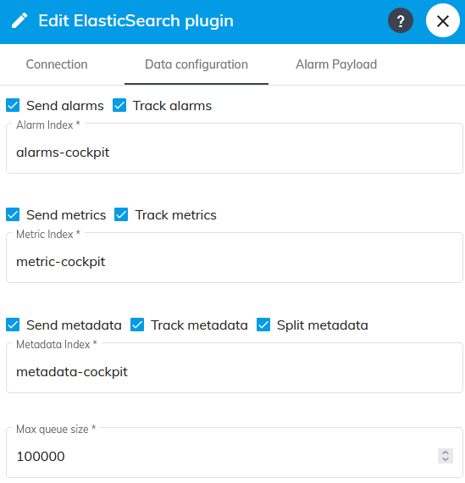

Custom alarm payload
- When Enable Custom Payload is active, you can define a custom payload template for alarms.
- This allows you to customize the data sent to Elasticsearch when an alarm is triggered.
- You can see more example on Custom alarm sender
Enable Custom Payload for Alarms | If active, allows customization of the alarm payload | No
Alarm Payload | The custom payload template for alarms | Yes (if Custom Payload is enabled)
Example:
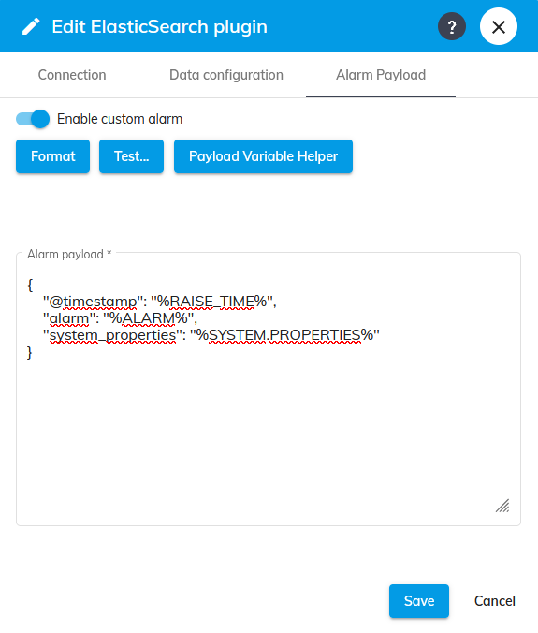

Using Custom Payload
- Formatting the Payload : Use the Format button to format your payload template.
- Testing the Payload : Use the Test Payload button to test your payload with sample data.
- Payload Variable Helper : Use the Payload Variable Helper button to insert variables into your payload template.

Available Variables
You can use variables from the following categories in your payload template:
- Alarm Variables: Information about the alarm
- Organization Variables: Information about the organization
- Group Variables: Information about the group
- System Variables: Information about the system
- Connector Variables: Information about the connector
- Properties Variables: Custom properties defined in your system
Notes:
- Ensure that all variables used in your template are correctly formatted and correspond to existing data fields
- Ensure that the Elasticsearch instance is reachable and properly configured to accept data from your application.

Troubleshooting
If you encounter issues:
- Verify the hostname and port (Standard Configuration) or the Cloud ID and API key (Cloud Configuration).
- Check Elasticsearch logs for any errors related to authentication or index operations.
- Ensure that the indices specified in the configuration exist in Elasticsearch and have the appropriate permissions set for the configured user.

