Maintenances

Purpose
Maintenances allow you to define time periods when systems will be unavailable for monitoring. During these maintenance windows, the monitoring connectors for affected systems are automatically placed in maintenance mode, preventing false alerts.
You can create three types of maintenance periods:
- 'Ad hoc' - Manually started and stopped maintenance windows with no schedule
- 'Scheduled' - One-time maintenance at a specific date and time
  - 'Not Recurrent' - One-time maintenance at a specific date and time
  - 'Recurrent' - Repeating maintenance windows (daily, weekly, or monthly patterns)
  - 'Custom CRON' - Advanced scheduling using quartz cron expressions

Maintenances UI

Main Page
The maintenance settings page displays a table of all defined maintenance periods within the tenant.
The page includes:
- A 'Create' button to define new maintenance periods
- Bulk action buttons that appear when items are selected:
  - 'Enable selection' - Enable selected maintenance periods
  - 'Disable selection' - Disable selected maintenance periods
  - 'Start selection' - Manually start selected maintenance periods
  - 'Stop selection' - Manually stop selected maintenance periods
  - 'Delete selection' - Remove selected maintenance periods
  - 'Duplicate selection' - Copy selected maintenance periods
  - 'Export selection' - Export selected maintenance data
  - 'Test selection' - Test selected maintenance configurations
- A filter field to search maintenance periods by name

Maintenance Table
The table displays the following information:
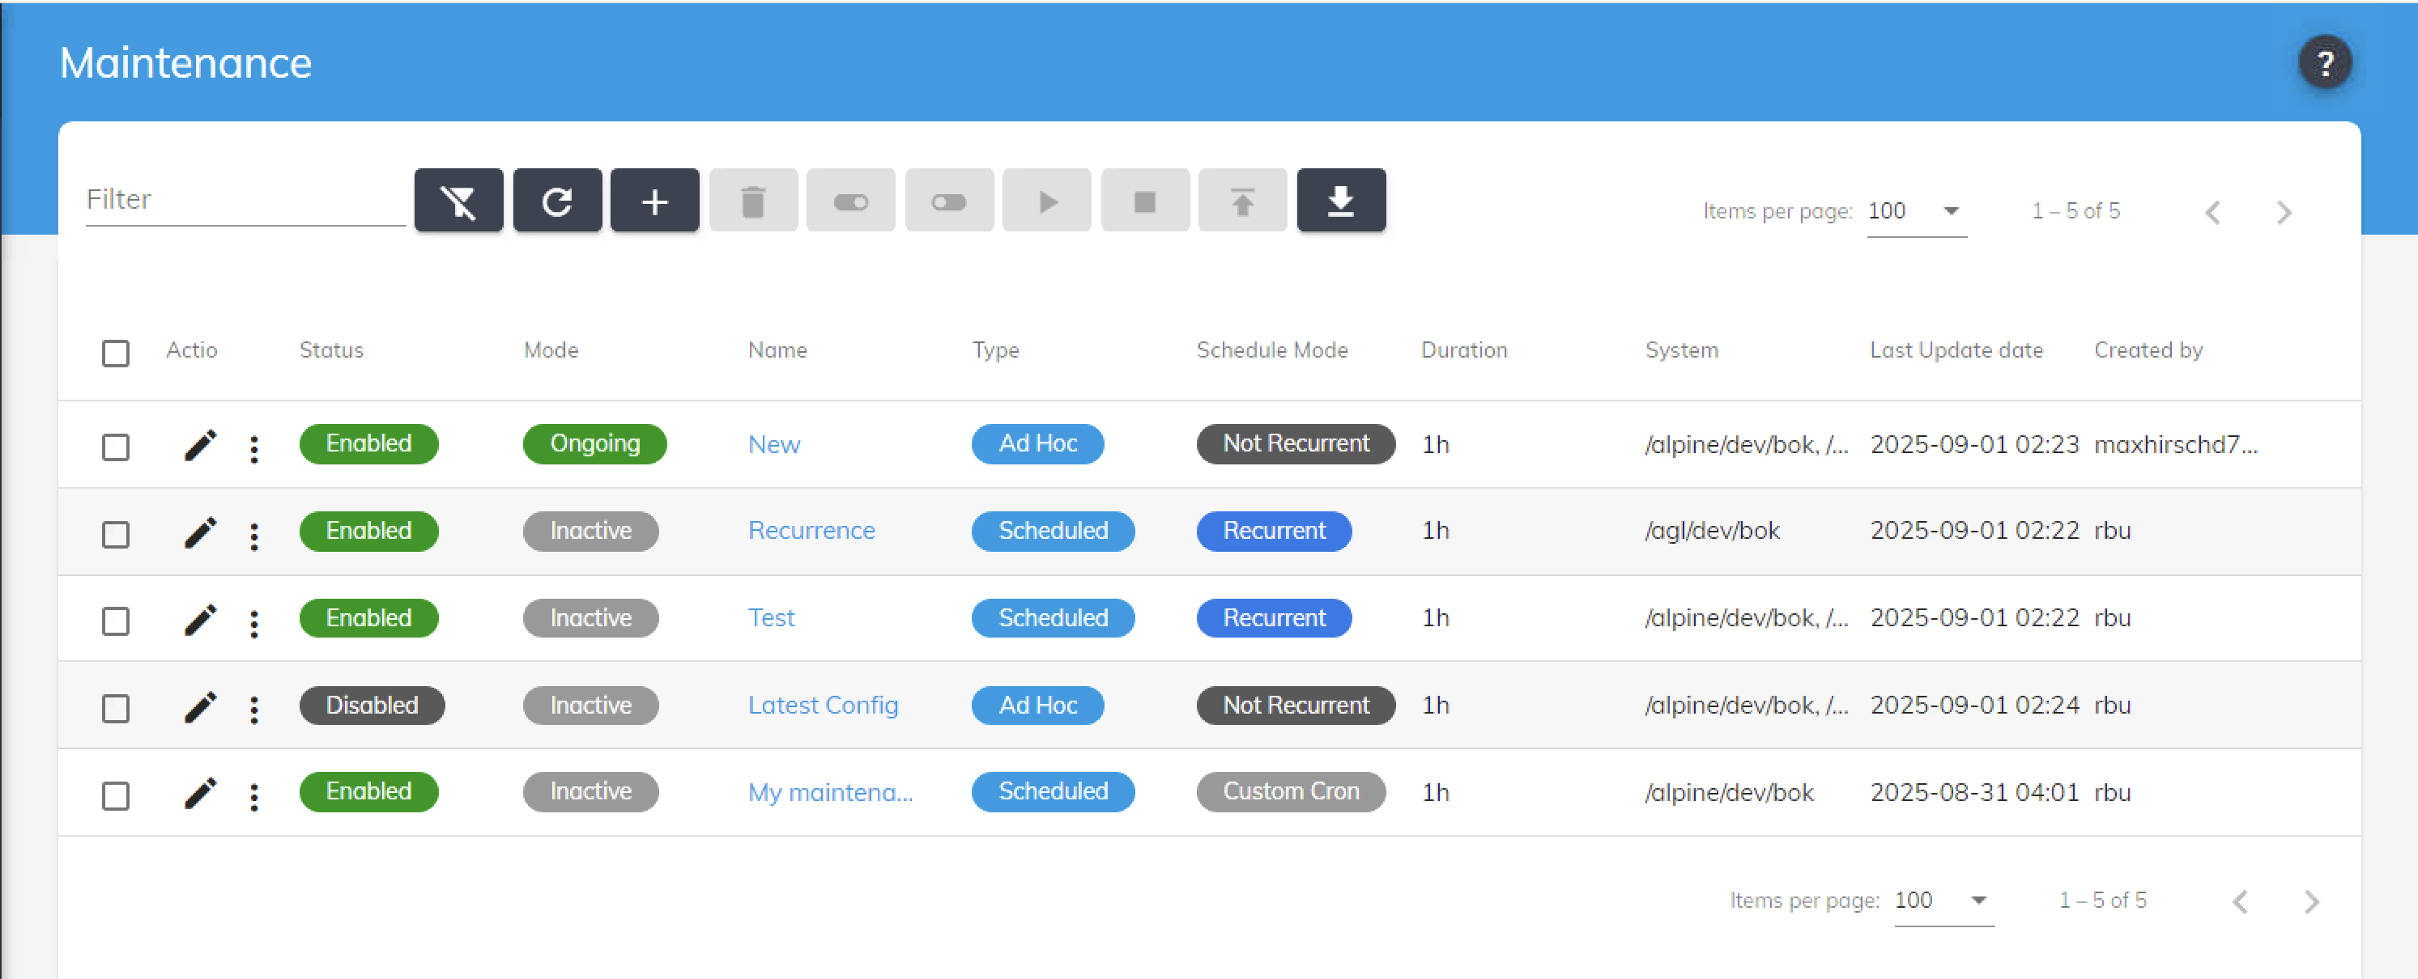Maintenance Settings Page
Column | Description
Checkbox | Select maintenance periods for bulk operations
Actions | Three-dot menu with options: Edit, Delete, Start (if inactive), Stop (if ongoing)
Status | Toggle switch showing if the maintenance is 'Enabled' or 'Disabled'
Current Mode | Badge showing 'ONGOING' (green) or 'INACTIVE' (gray)
Name | The maintenance period name
Type | 'AD_HOC', 'SCHEDULED'
Schedule Mode | Display of the schedule Mode ('Not Recurrent', 'Recurrent' or 'Custom Cron')
Duration | Time in minutes (or “Manual stop” if duration is 0)
Target Systems | Number of affected systems (hover shows list)
Timezone | Timezone if 'Recurrent' or 'Not Recurrent'
Last Updated | Timestamp and user who last modified

Create/Edit Maintenance

Basic Information
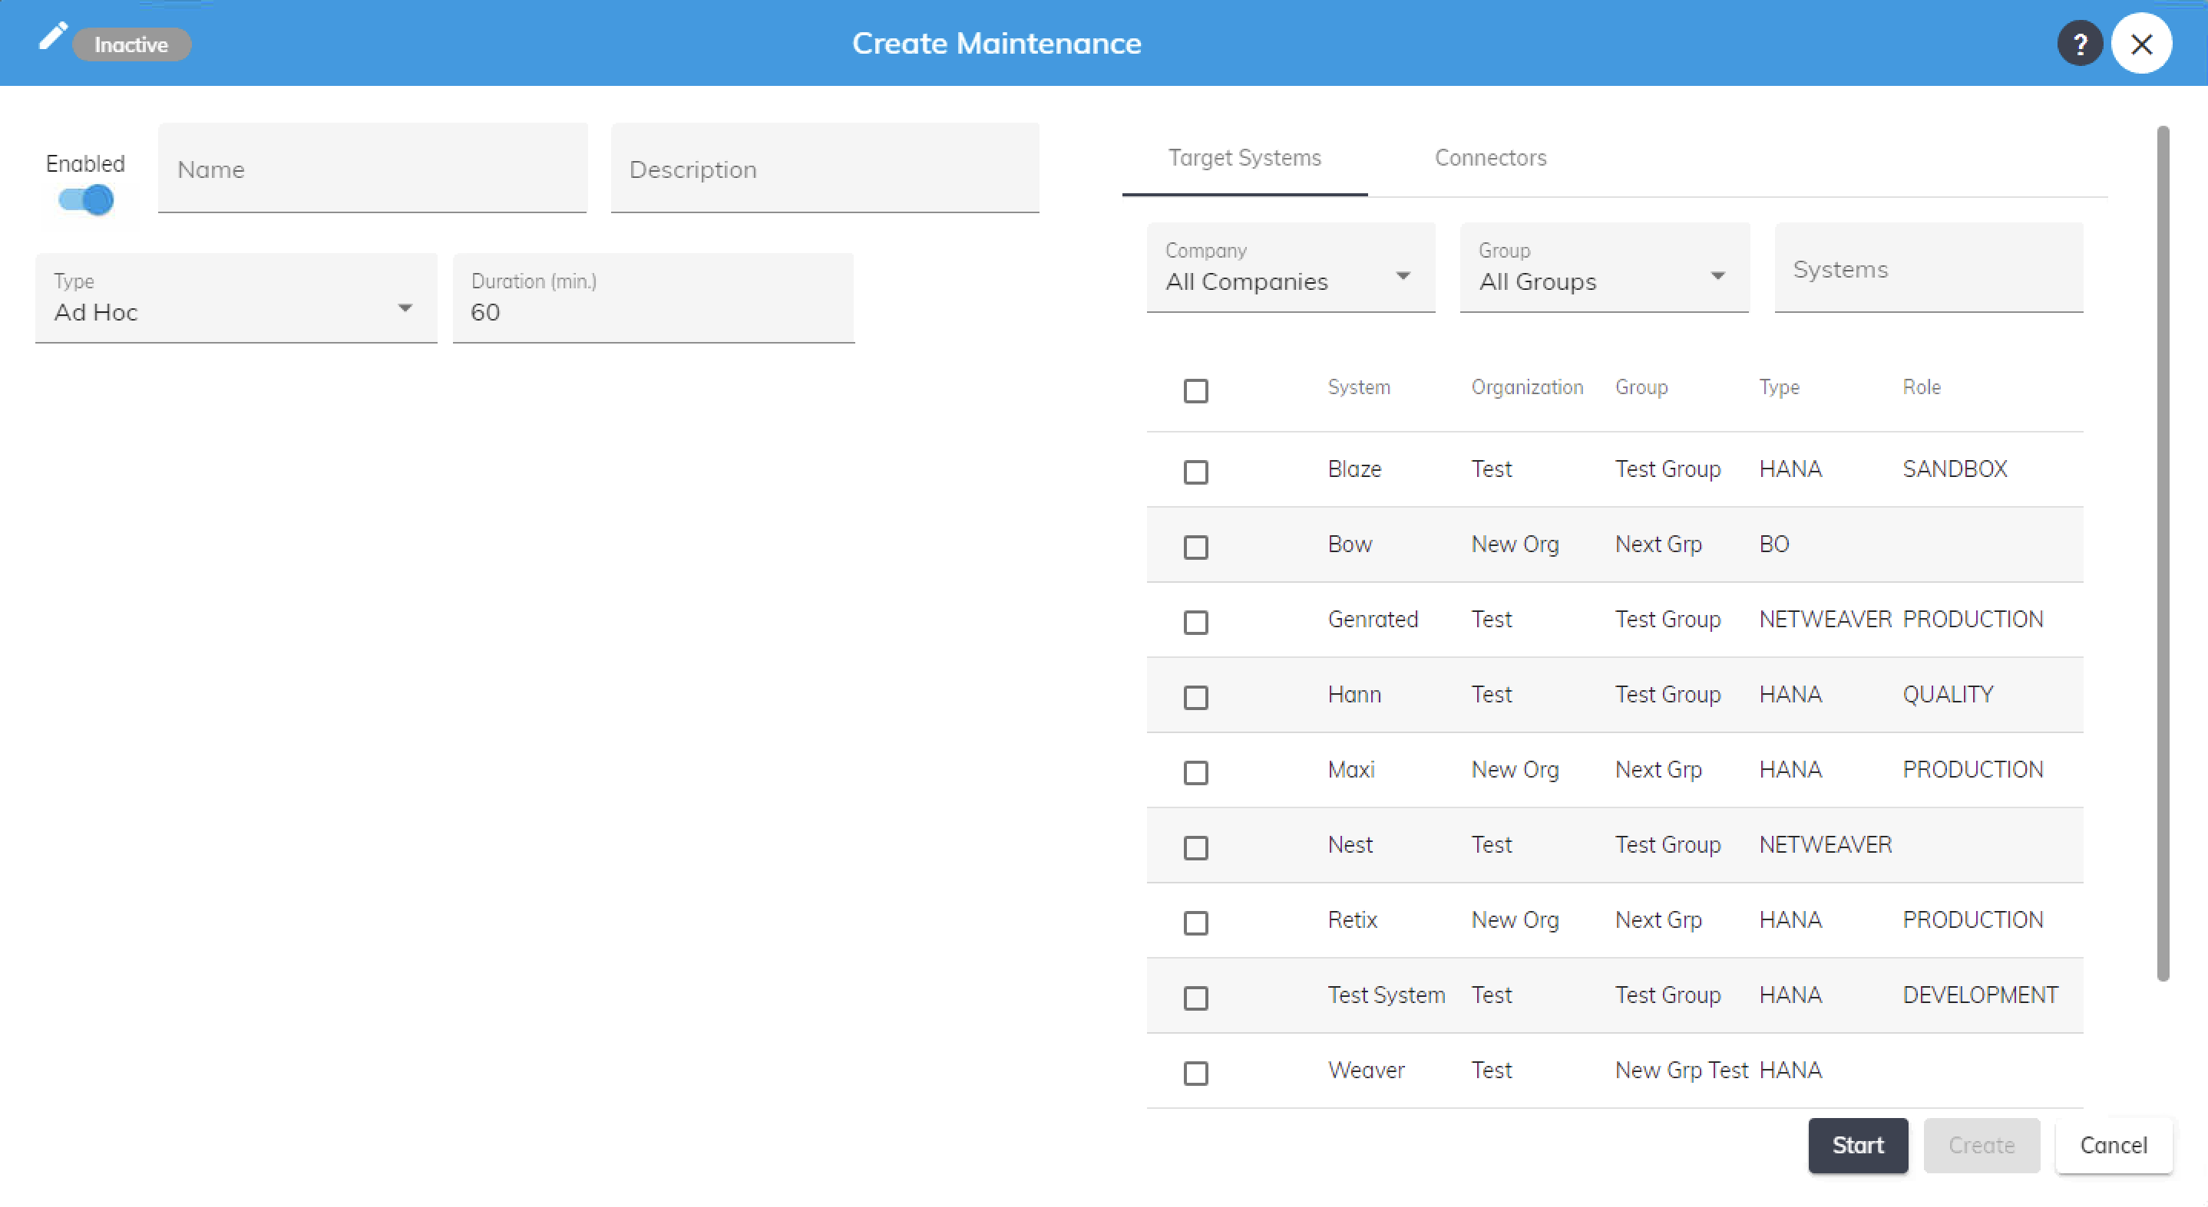 Basic Information Form
Field | Description
Name | Required text field for the maintenance identifier
Description | Optional text area for detailed maintenance information
Status | Toggle to enable or disable the maintenance period
Mode | Click Start or Stop to activate or deactivate the maintenance
Type | Dropdown menu for maintenance type (Ad hoc, Scheduled, Recurrent)
Duration | Number input field for maintenance duration in minutes
Target system or connector | Two-tab interface with tables for selecting systems and connectors

Maintenance Type
Dropdown selection:

Ad Hoc
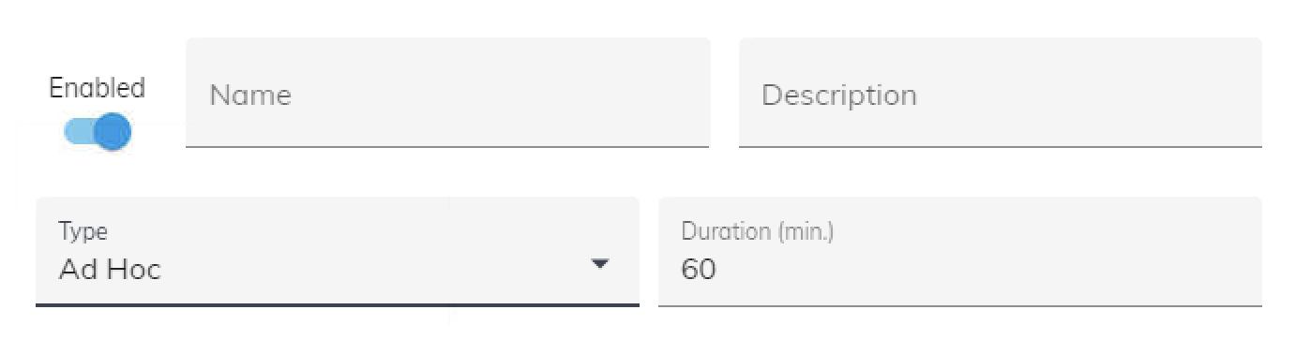 Ad Hoc Configuration
- No schedule configuration
- Maintenance must be manually started and stopped

Scheduled

Not Recurrent
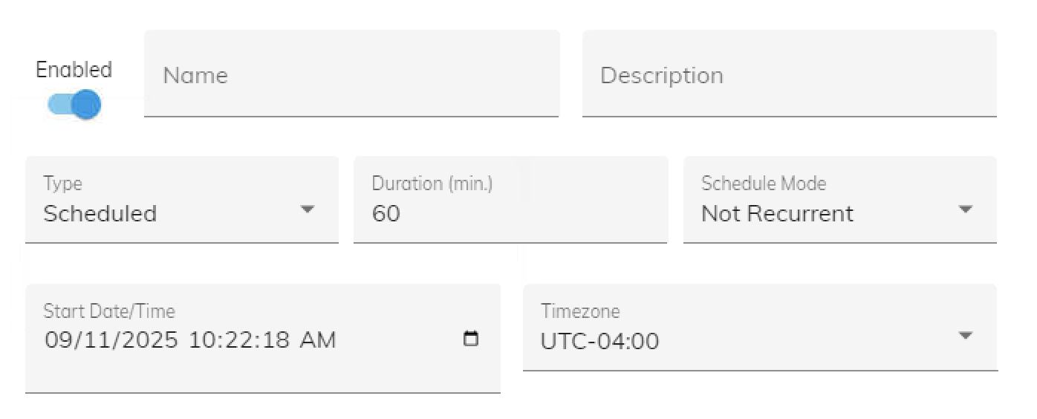 Scheduled Configuration
- One-time maintenance window
- Shows date/time picker for 'Start Date and Time'
- Shows Optional Timezone dropdown selection
- Example: “December 24, 2025 at 10:00 AM”

Recurrent
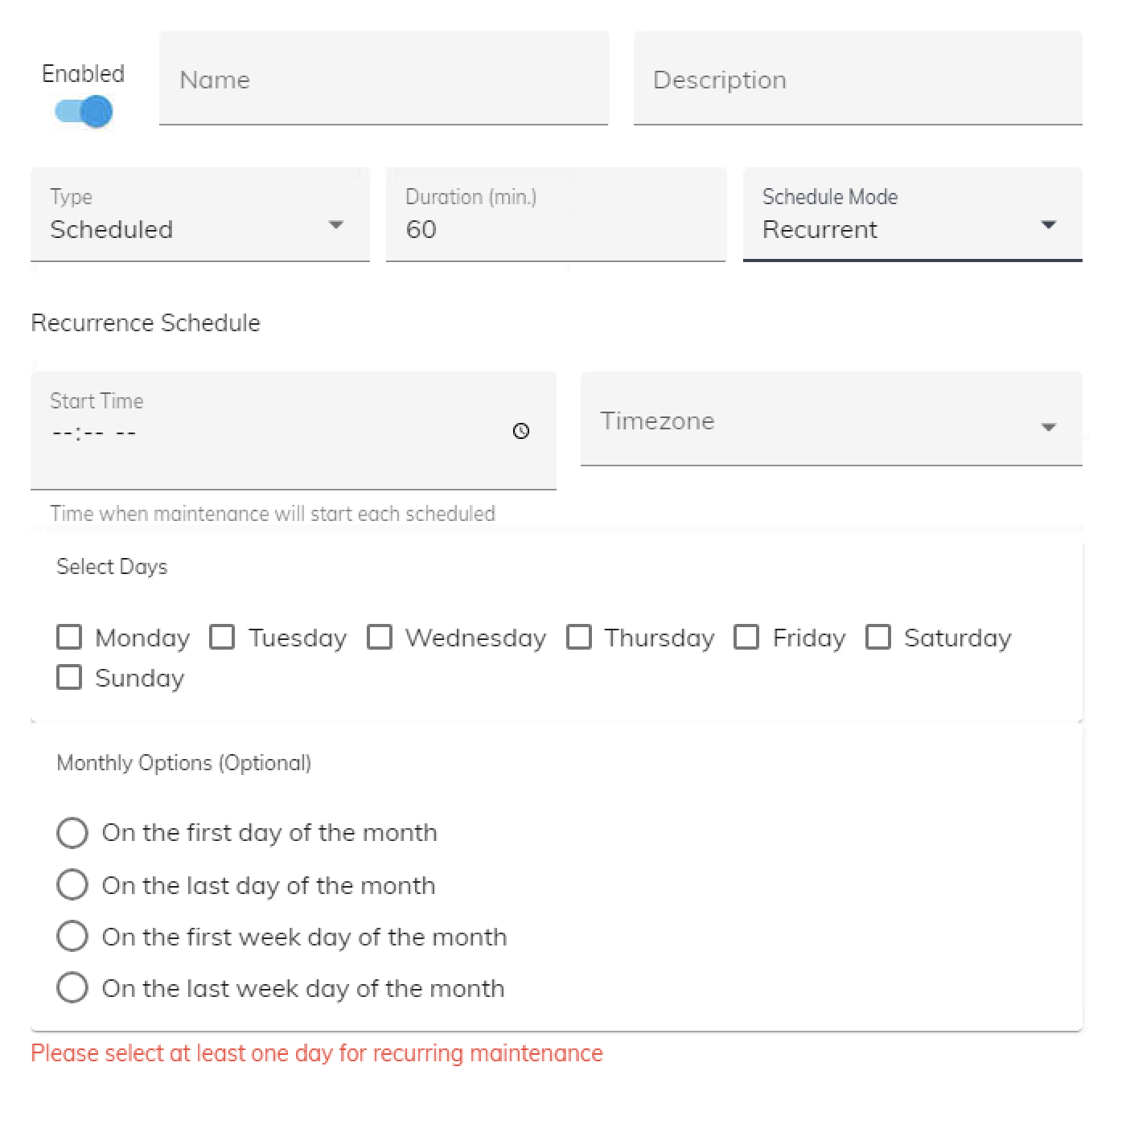 Recurrent Configuration
- Repeating maintenance windows
- Opens schedule configuration options (see Schedule Configuration below)

Duration
Field | Description
Duration (minutes) | Number input field. Enter 0 for manual stop required, otherwise maintenance auto-stops after specified minutes
Duration Display | Shows calculated time (e.g., “2 hours” for 120 minutes)

Schedule Configuration

For Recurrent Maintenance

Schedule Type Selection

Weekly Schedule
- 'Start Time' - Time picker (HH:MM format)
- 'Timezone' - Optional dropdown selection
- 'Days of Week' - Checkboxes for:
  - ☐ Monday
  - ☐ Tuesday
  - ☐ Wednesday
  - ☐ Thursday
  - ☐ Friday
  - ☐ Saturday
  - ☐ Sunday
- Example display: “Every Monday, Wednesday, Friday at 14:00”

Monthly Schedule
- 'Start Time' - Time picker (HH:MM format)
- 'Timezone' - Optional dropdown selection
- 'Day Selection' - Radio buttons:
  - ○ First day of month
  - ○ Last day of month
  - ○ First weekday of month
  - ○ Last weekday of month
- Example display: “First weekday of each month at 09:00”

Custom Cron
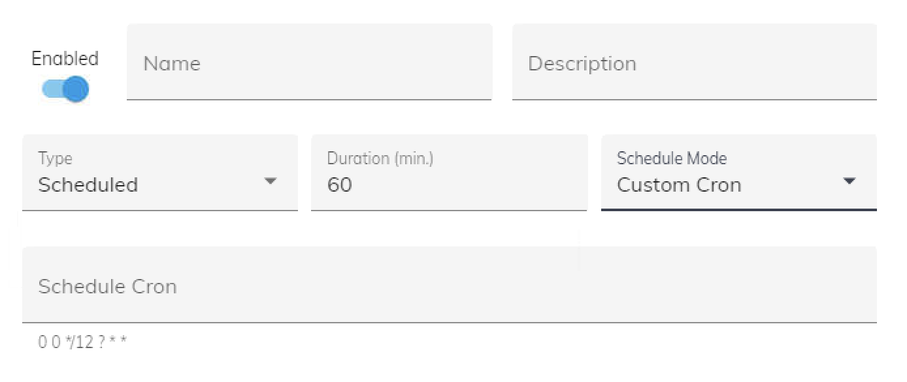 Custom Cron Configuration
- 'Cron Expression' - Text field for Quartz cron string
- 'Validation' - Red error message appears for invalid expressions
- 'Help Link' - “View cron syntax documentation”
- Example:
0 0 12 ? * SUN *
(Every Sunday at noon)

Schedule Testing
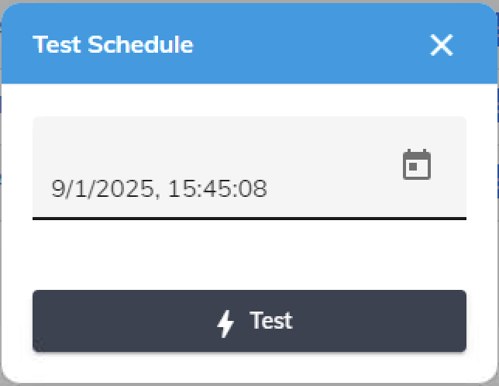Schedule Testing Panel
Test panel:
- 'Test Date/Time' - DateTime picker to select test moment
- 'Test Schedule' button - Validates if maintenance would be active
- 'Result Display':
  - ✓ Green message: “Maintenance would be ONGOING at selected time”
  - ✗ Red message: “Maintenance would be INACTIVE at selected time”
  - ⚠ Error message for invalid cron expressions

Target Systems Selection

Systems Selector
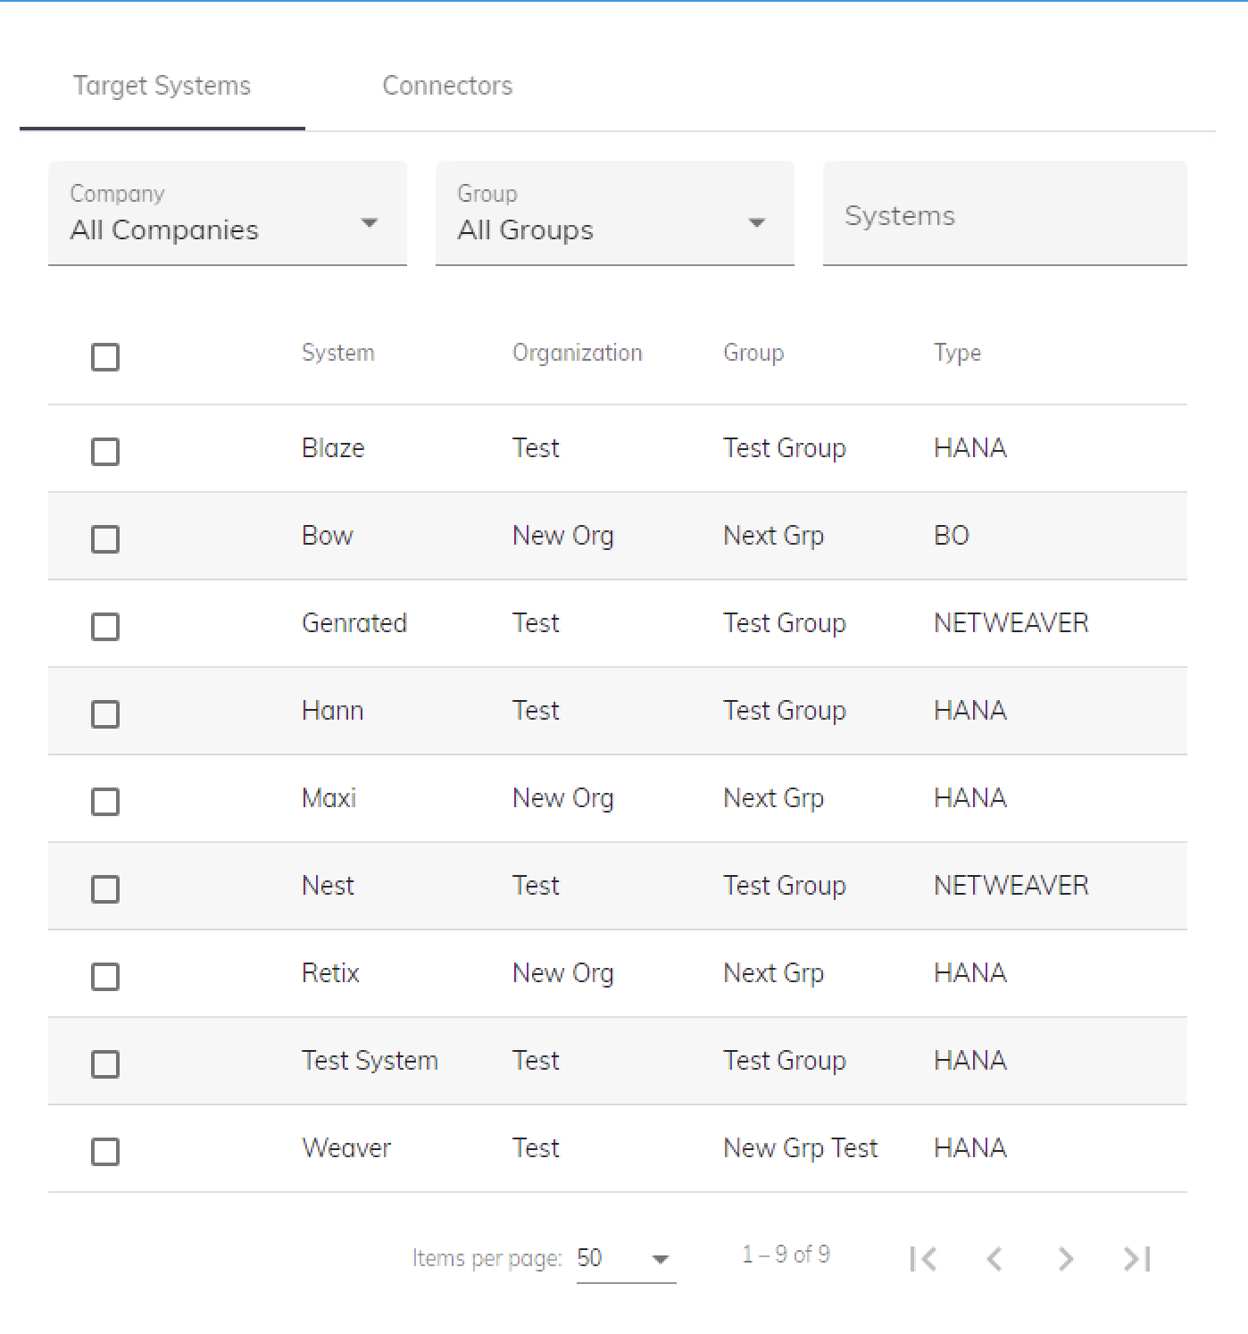Systems Selector Interface
Two-panel selector interface:

Systems (Left Tab)
- Search field to filter systems
- List showing:
  - System name
  - System organization
  - System group
  - System type
- Select all checkbox
- Shows count: “Showing X of Y systems”

Connectors (Right Tab)
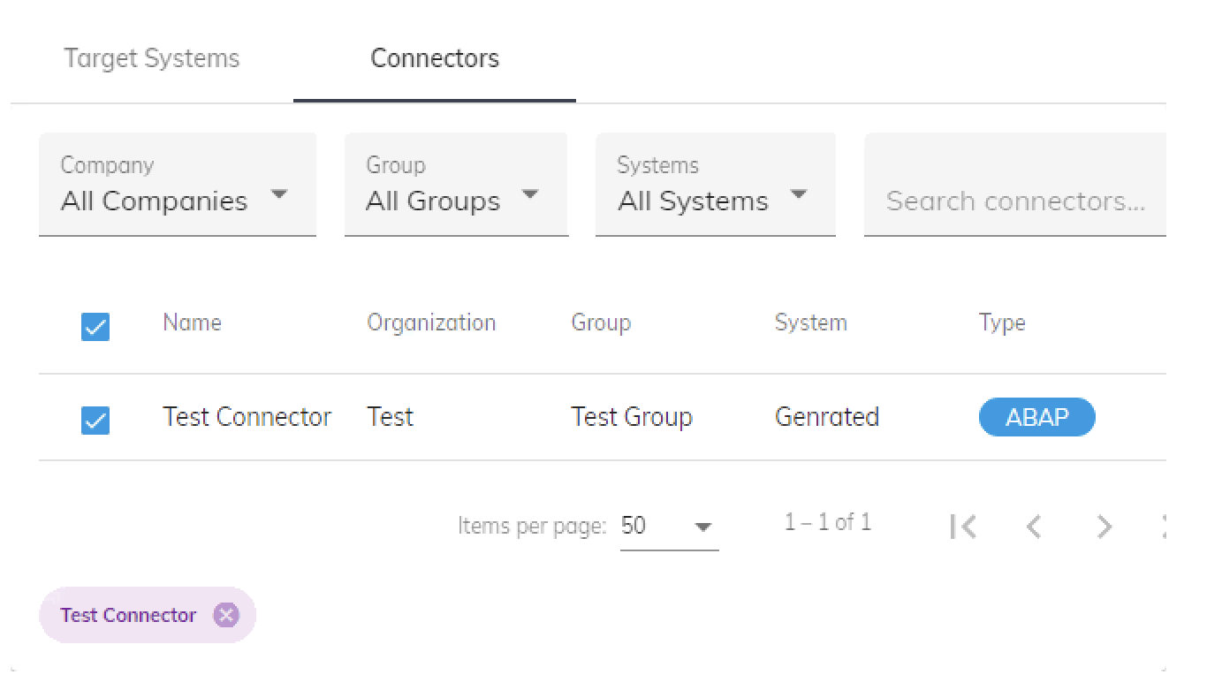
- Search field to filter connectors
- List showing:
  - Connector name
  - Connector status
  - Connector organization
  - Connector group
  - Connector system
  - Connector type
- Select all checkbox
- Shows count: “Showing X of Y systems”

Transfer Controls
- 'Add +' button - Select system
- 'x Remove' button - Unselect system
- 'Add All >>' button - Select all visible systems

Individual Actions
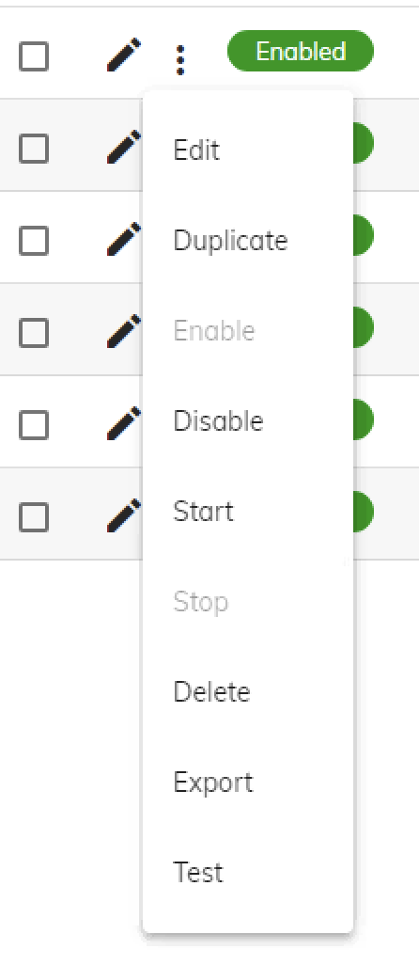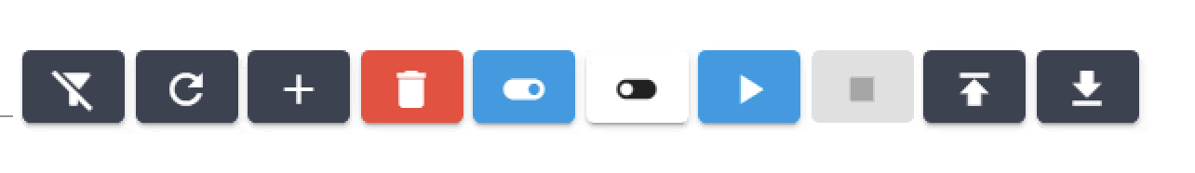
Actions available from the three-dot menu:

Enable/Disable
- Changes the maintenance status
- Disabled maintenances won't trigger automatically
- Shows confirmation: “Maintenance [name] has been enabled/disabled”

Start Maintenance
- Only available when maintenance is INACTIVE
- Immediately activates maintenance mode for all target systems
- Shows confirmation dialog:
  - Title: “Confirmation”
  - Message: “Are you sure?”
  - Buttons: [Ok] [Cancel]

Stop Maintenance
- Only available when maintenance is ONGOING
- Immediately deactivates maintenance mode for all target systems
- Shows confirmation dialog:
  - Title: “Confirmation”
  - Message: “Are you sure?”
  - Buttons: [Ok] [Cancel]

Edit
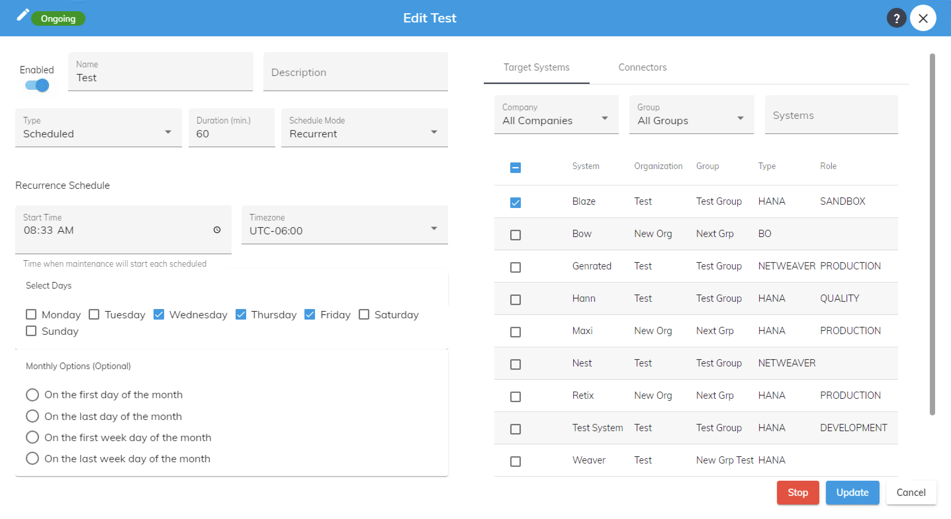Edit Maintenance Form
- Opens the maintenance configuration form
- All fields are pre-populated with current values
- Save button updates the maintenance

Delete
- Shows confirmation dialog:
  - Title: “Confirmation”
  - Message: “Are you sure?”
  - Buttons: [Ok] [Cancel]

Bulk Actions
When multiple maintenances are selected:

Bulk Enable/Disable
- Enables or disables all selected maintenance periods

Bulk Start/Stop
- Starts or stops all selected maintenance periods

Bulk Delete
- Shows confirmation dialog:
  - Title: “Confirmation”
  - Message: “Are you sure?”
  - Buttons: [Ok] [Cancel]

Status Indicators

Visual States
Status | Appearance | Description
Enabled + Inactive | Blue toggle ON, Gray “INACTIVE” badge | Maintenance is enabled but not currently running
Enabled + Ongoing | Blue toggle ON, Green “ONGOING” badge | Maintenance is enabled and currently active
Disabled + Inactive | Gray toggle OFF, Gray “INACTIVE” badge | Maintenance is disabled and not running

Form Validation
Field | Validation | Error Message
Name | Required, Unique | “Maintenance name is required” / “Name already exists”
Start Date | Future date for scheduled | “Start date must be in the future”
Duration | Non-negative number | “”
Cron Expression | Valid Quartz syntax | “Invalid cron expression: [details]”
Target Systems or Target connectors | At least one selected | “Select at least one target system or connector”
Schedule Days | At least one day for weekly | “Select at least one day of the week”

