Plugins

Purpose
Plugins define connection parameters to external API. They are used to integrate Redpeaks to third party applications and to share the generated monitoring data.
The following plugins are currently available:
- Datadog
- Elastic Search
- Email
- Custom alarm sender
- Graphite
- Kafka
- ServiceNow Cockpit
- ServiceNow Event Manager
- Jira

Plugins UI
- The plugins settings shows a table of the existing plugins within the tenant
- It allows the following actions:
  - Create/Edit a plugin (more on the links provided above).
  - Delete/bulk delete plugins.
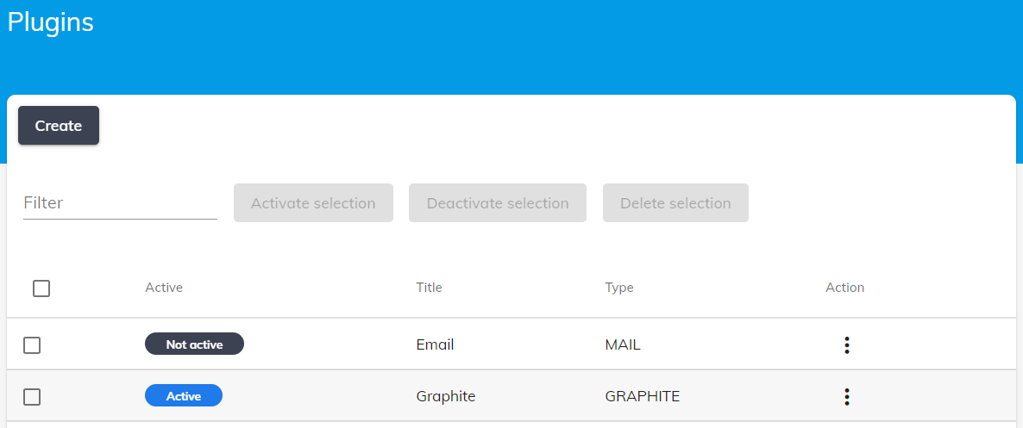

Delete/Bulk delete
- You can delete a single plugin or a group of plugins by either using the table action menu or the bulk delete button

