ServiceNow Event Management Plugin

Purpose
- With this plugin, you will be able to integrate your SAP CIs and their associated events and metrics with ServiceNow
- Once active, this plugin will collect all generated alerts and metrics and regularly post them to ServiceNow.
- If alarm rules are active, only alarms passing the filters will be processed.
- Configuration items data will be sent to your ServiceNow instance directly
- Events and metrics will go through a mid server

Requirements
- Your ServiceNow instance must have the Event management module from ITOM enabled.
- You need to have a mid-server, alerts and events will transit from it.

Create/Edit
- Press Create or select Edit in the table action menu to open the ServiceNow Event Manager plugin editor
Parameter | Description
Active | Plugin state
Name | The plugin name
User | The ServiceNow user
Password | The associated password
Config API URL | The URL for the configuration API
Events API URL | The URL for the events API
Metrics API URL | The URL for the metrics API
Chunk size | The max number of events/metrics to send per request

Default API URI
- ServiceNow API might evolve in time and this plugin allows to edit the associated URLs if any change happens in ServiceNow
- Those are the default API URL to be used:
  - Configuration API: https://[YOUR_ITOM_INSTANCE].service-now.com/api/now/identifyreconcile
  - Events API: http://[YOUR_MIDSERVER:PORT]/api/mid/em/inbound_event?Transform=jsonv2
  - Metrics API: http://[YOUR_MIDSERVER:PORT]/api/mid/sa/metrics
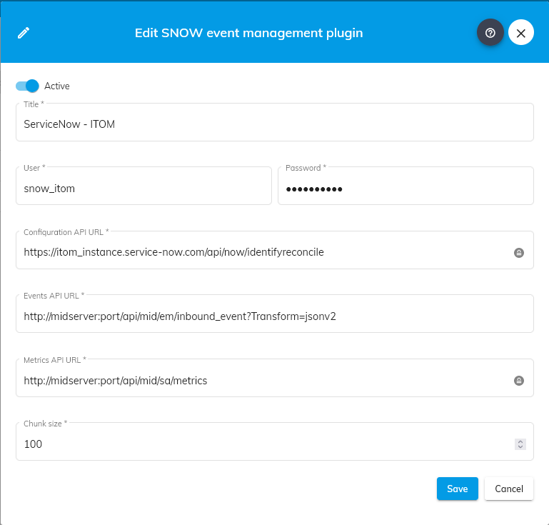

MID server configuration
- The MID server must be configured to use the same user credentials as the ServiceNow instance user used to push the SAP CIs
- You need to add 2 extensions for alerts and metrics endpoints:
  - EventManagement extension
  - Operational intelligence metrics


