Teams

Purpose
- Teams can be defined to associate users together.
- Their main purpose is to simplify user roles and authorizations by defining them to a team of users instead of case by case basis.
- This facilitates the users onboarding as they will be granted the same privileges as their team.
- It also provides better isolation of users from with which no interaction is foreseen or allowed

Teams UI
- The team menu will display the list of existing teams
- It allows the following actions:
  - Create/Edit a team
  - Delete/bulk delete team
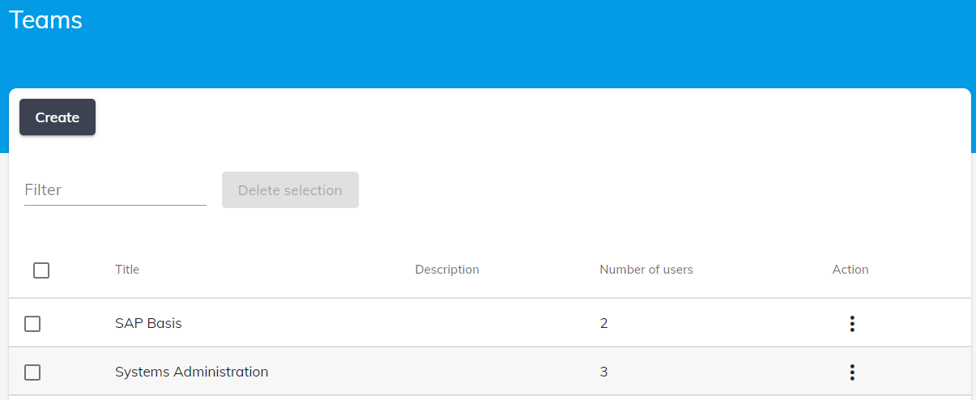

Create/Edit
- Press Create or select Edit in the table action menu to open the team editor
- Set teams parameters
  - Title
  - Description
  - Users
  - Authorization Profiles
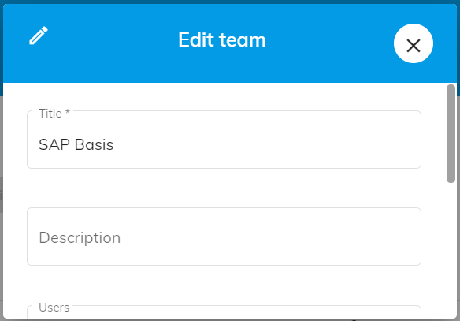

Delete/Bulk delete
- You can delete a single team or a group of teams by either using the table action menu or the deleteselection button
 Teams with users assigned to them cannot be deleted

 Using teams to manage authorizations will greatly facilitate the process to onboard users or to change access levels at scale.

