Users
Users settings menu helps to create and manage users.

Purpose
- The users settings shows a table of the existing users within the tenant
- It allows the following actions:
  - Create/Edit a user
  - Delete/bulk delete users
  - Invite users
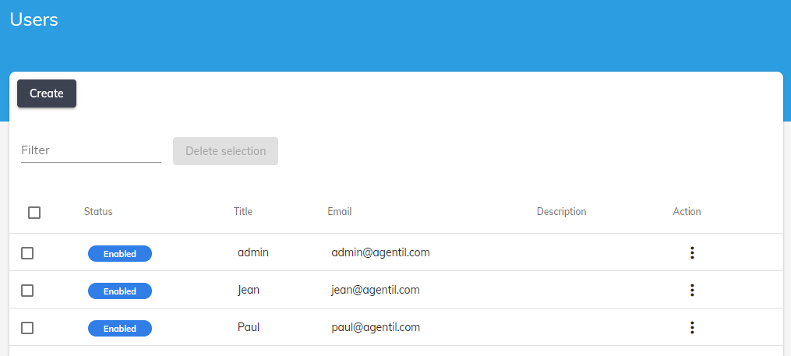

Create/Edit
- Press Create or select Edit in the table action menu to open the user editor
- Set the users parameters
  - Enabled
  - Name
  - Email
  - Description
  - Password
  - Select the Authorization Profiles to associate with the user
 User name and password must be unique across all tenants.
It must also follow a strong password policy, with at least:
- 8 characters
- 1 special character
- 1 upper case
- 1 lower case
- 1 numeric
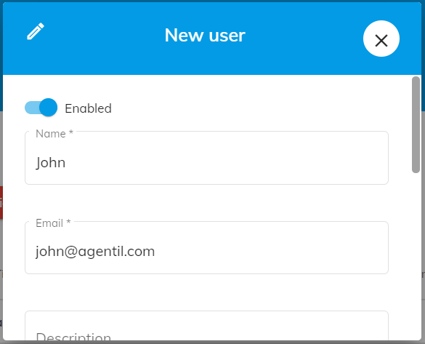

Delete/Bulk delete
- You can delete a single user or a group of users by either using the table action menu or the delete selection button

Invite users
- You can invite users by providing a list of email addresses.
- Each user will receive a subscription link by email allowing to create his account
- You can directly define the team or the authorizations that will be automatically associated to each invited user
- If a user doesn't receive the invite email, you can still retraive the invite link from the table and send it to him


