Dashboards
Redpeaks Cockpit offers pre-configured dashboards for efficient organization and analysis of system data.
Our dashboard editor provides users with the capability to design and share custom dashboards
tailored to their specific needs. This feature enables users to delve into
collected data and generate personalized insights seamlessly.

Overview
The dashboard view primarily consists of the following components:
- Dashboard Table: This table displays existing dashboards and provides sorting functionality for easy navigation.
- Dashboard Controls: Users can utilize dashboard controls to perform actions such as creating, deleting, importing, etc.
- Dashboard Viewer: Allows users to view and interact with the selected dashboard.
- Dashboard editor: Allows user to create or edit dashboards
- Time Selector: A time selector tool is provided to define the period for data selection, enabling users to specify the desired timeframe for analysis.

Dashboards table and controls

Table display
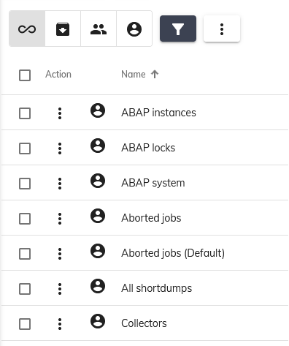
- Use the display toggle button to hide or show the table, allowing more space for the viewer.
- The expand button enlarges the table to display additional information.
- Utilize the filter buttons and fields to filter and sort dashboards.

Table Controls
The following controls are available from the table:
- Clone: Duplicate a dashboard.
- Delete: Remove one or multiple dashboards.
- Export: Export one or multiple dashboards.
- Import: Import dashboards.

Export dashboards
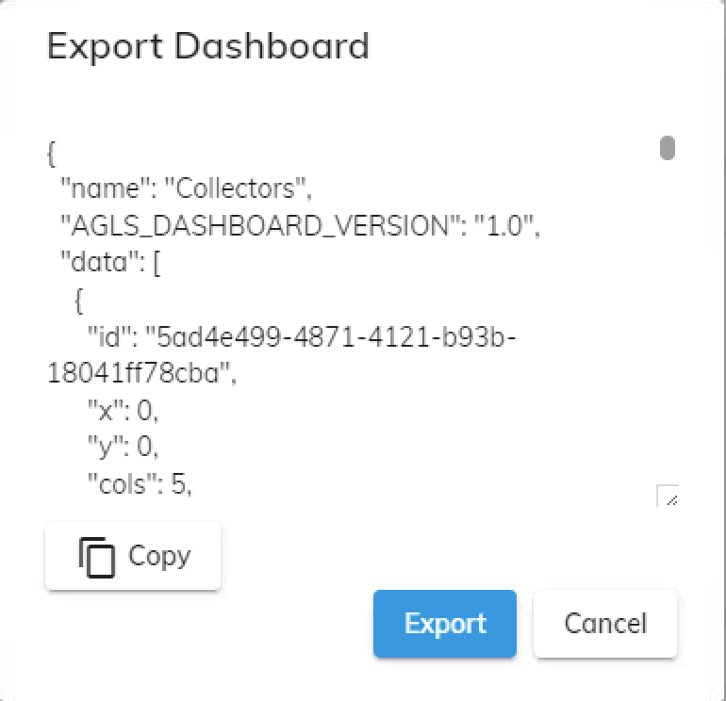
- Click 'More' -> 'Export' to open the export modal.
- Optionally, you can copy the JSON data to the clipboard or download the exported file.
- The Export option enables you to effortlessly share dashboard data.

Import dashboards
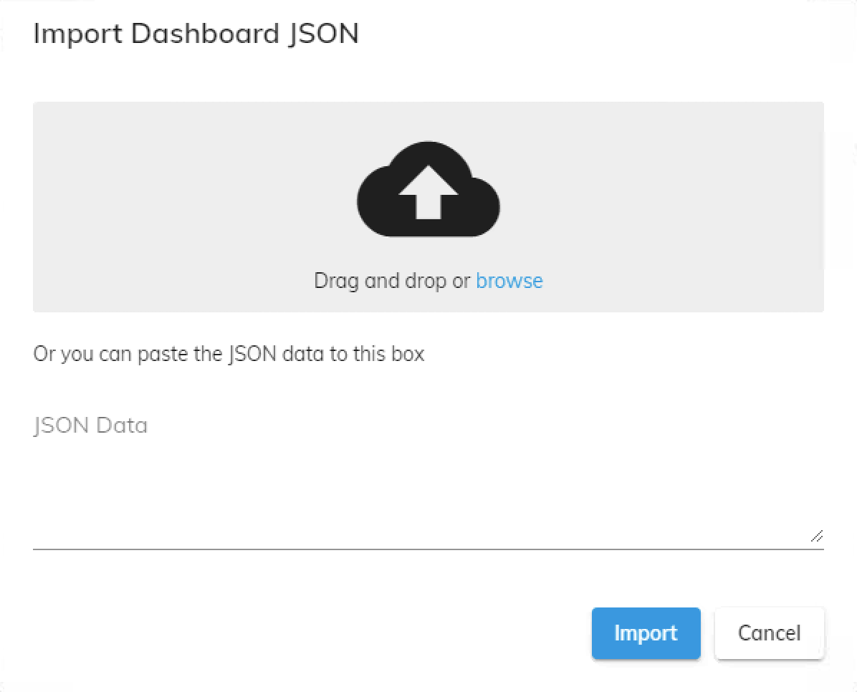
- To access edit mode, click the 'Edit' button on the desired dashboard.
- Then, click 'More' -> 'Import' to open the import modal.
- You can either paste copied dashboard data or upload a JSON file containing dashboard data.
- The import option allows you to quickly import dashboard configurations with ease.

Dashboard viewer
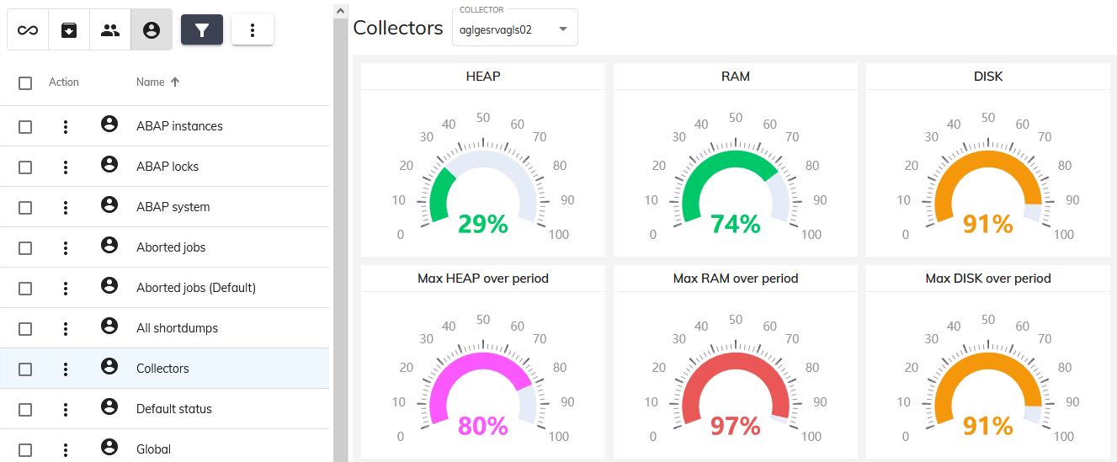
- Simply select a dashboard to have it displayed
- Use the period selector to change the time span of the dashboard
- Look at the dashboard viewer details for more information

Dashboard editor
- The dashboard view allows to edit dashboards for which you have the permission
- Look at the dashboard editor details for more information

Period selector
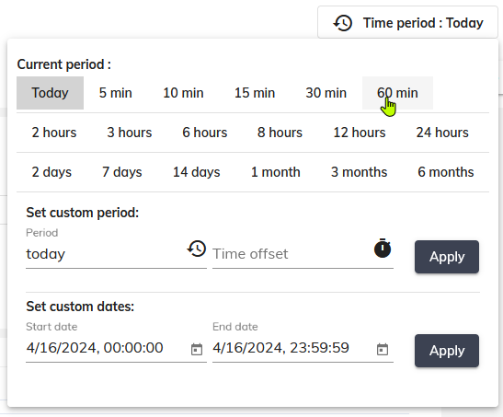
- The period picker allows to select the period of time to use to display device data
- The period picker enables you to choose the timeframe for displaying device data.
- You have the option to select from predefined periods or define a custom period using either the custom period form or the date picker.
- The custom period form and date picker allow you to specify a timeframe relative to the current time.
- For instance, selecting a period of “24h” with an offset of “7d” will display data from the past 24 hours starting from 7 days ago.
Time units to use in custom period form:
Unit | Description
sec | seconds
min | minutes
hours | hours
days | days
week | week
year | year
- Examples:
  - 10 min: 24 minuites
  - 24 sec: 30 seconds

