Pro.Monitor logs

Purpose
- Change the log level
- Download the files today’s and agents

Change the log level
- From the top right, click on the setting icon
- Select the admin configuration sub-menu
- Click on tabs logs
- Select your log level : ERROR, INFO or DEBUG
- Set the time and click on Extend
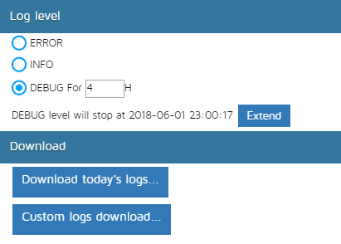

Download logs
- You can download the logs from any server or agent
- The menu will order logs from servers in the first table and logs from workers in the second
  - Server logs: All about communication with users, scheduling of monitoring tasks, plugins.
  - Worker logs: All about the real monitoring tasks, connection to systems and analyse of data
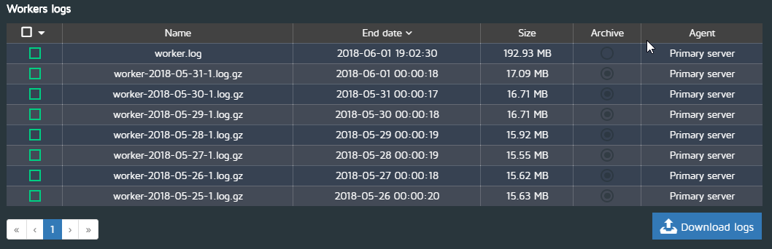

Download today logs files
- Click on Download today’s logs
- The list will display only log files generated in the current day
- Select the ones you need and hit download

Download custom logs files
- Click on Custom logs download
- The list will display all available log files
- Select the ones you need and hit download

