Monitoring profiles

Monitoring profiles
- The ready-to-monitor configuration of all monitors is defined in the profiles
- To monitor a system, simply assign profiles to its connectors
- Default profiles are provided to facilitate the setup of the monitoring, you can visualize them via the menu PROFILES -> Select default profiles
- These profiles contains monitors with a default configuration
- To visualize the content of a profile, simply select one in the PROFILES section, this will display its current monitors
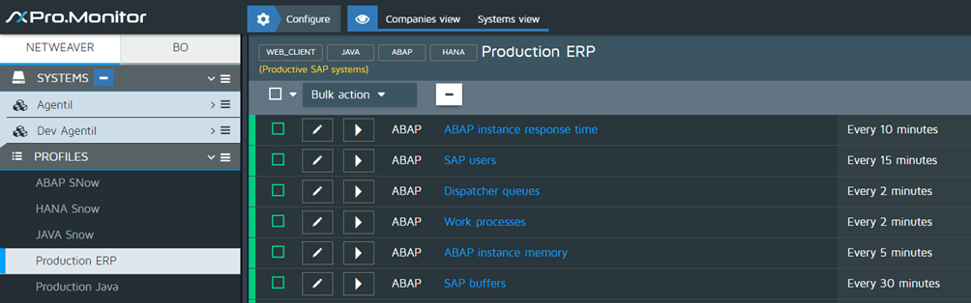
- Use the assign button to associate a profile to one or several connectors.
- This will open a screen where you will be able to move connectors from right to left and vice versa.
- The ones on the left will use the profile
- Notice that you can also create your own profiles and then define exactly which monitors you want to activate
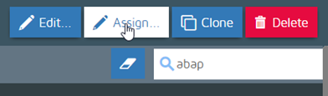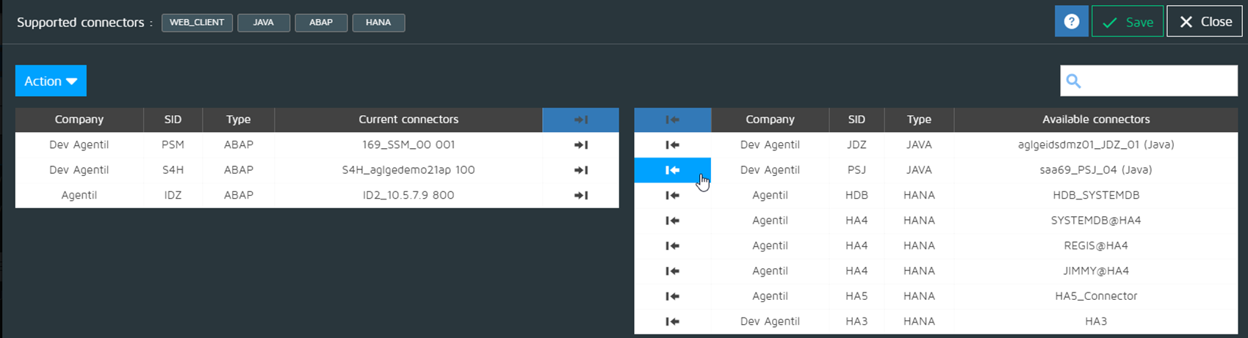

Profile customization
- From a profile, you can press the EDIT button to open the list of available monitors (see image below - step 4 -)
- On the right side are displayed the available monitors and on the left, the ones already used in the profile.
- Simply move the monitors left and right to add and remove monitors.
- Warning: If you remove a monitor from a profile, you will loose its customization, and it won’t be used against the assigned systems.

Step 4

