ServiceNow Event Manager

Purpose
- The Cockpit plugin gives the possibility to send metrics, alarms and metadata to the ServiceNow platform
- Once active, this plugin will collect all generated alerts and metrics and regularly post them to ServiceNow.
- It is possible to define several ServiceNow plugins, for example if a secondary collector is in place.
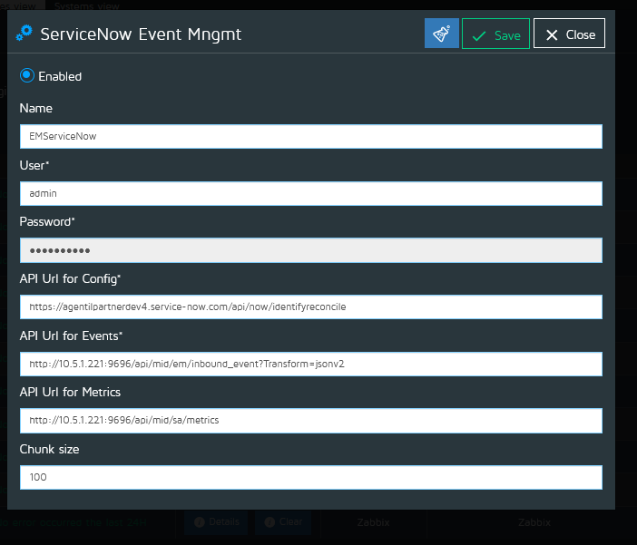

Configuration
- From the plugin menu, select “ServiceNow Event Management” type and click on “Add” to create a new plugin, this will open plugin configuration screen
- Fill the plugin settings form:
  - Enabled: To enable or disable the plugin
  - Name: The plugin name
  - User/Password: Credentials to access the host
  - API Url for Config: : Webservice used to send configuration example : https://agentilpartnerdev4.service-now.com/api/now/identifyreconcile
  - API Url for Events: : Webservice used to send events, example : http://10.5.1.221:9696/api/mid/em/inbound_event?Transform=jsonv2
  - API Url for Metrics: : Webservice used to send metrics, example : http://10.5.1.221:9696/api/mid/sa/metrics
  - Chunk size: The maximum number of alerts or metrics waiting in the output buffer. Used to limit the memory usage if events are created faster than consumed

