6. Sybase Connector

Purpose
- With a Sybase connector, you can directly connect to a Sybase Database.
- It will give access to all components that can be monitored trough Pro.Monitor Sybase monitors
- To create a Sybase connector, there are two steps:
  - Create a user profile in SAP and register it in Pro.Monitor (Pro.Monitor SAP User)
  - Create and set connector parameters
- Pro.Monitor Sybase connector uses JDBC to connect to the Database and SQL queries to inquire the database

Creating a SAP user profile
- At first step, create a SAP user is the SAP system
  - Find an step-by-step example creating a SAP user with Read access on a table in Sybase under SAPSR3DB schema at the bottom of this page
- SAP user profiles can be reached via Systems->SAP users
- Create a new profile using the “Add” button
- Once created, the user profile can be selected in the connector form
- Note: A SAP User is by default associated with only one Group (Company). You can explicitly set a SAP User to be cross companies.
The effect is that it will be selectable from connectors of any company.
- The corresponding user must be created in SAP along with the appropriate authorizations.
- Use SU01 and PFCG transaction to do so. You can download the authorization profile in Admin->Admin configurartion->Upload/Download

Creating the connector
- Select the system in the Systems tree and select “Add connector” in its contextual menu, then select “Sybase” type.
- Sybase connector input form will allow you configure it (see image below)
  - Title : This label will help you to identify the connector
  - Database host: the hostname or IP address of the System Database server
  - Database Port: the port to access the Database
  - User: the SAP user profile to use for the connection
  - For specific settings “Use SSH tunnel” and “Custom timeout” see below section “Setting specific configuration”
- Press Save & Test to save the profile and check the connection is working
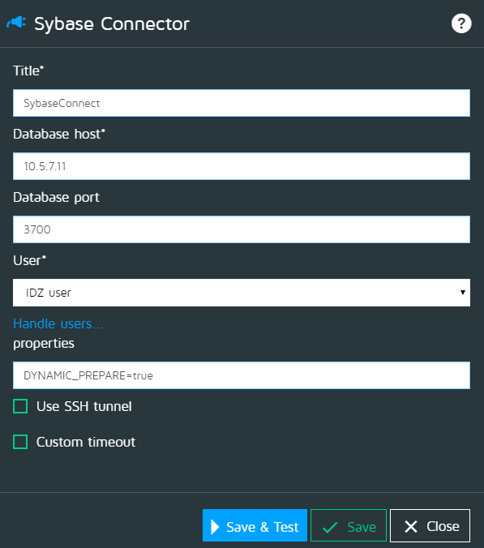

Setting specific configuration
- If you are using a SSH tunnel option
  - SSH host : the hostname or IP address of the System Database server
  - SSH port : the port to access the Database
  - SSH User : the SAP user profile to use for the connection
- If you checked the “Custom timeout” option :
  - Max invalid time (s) : after this value (in seconds) is reached, Pro.Monitor will stop attempting to connect to the System
  - Max response time (s) : it represents the maximum number of seconds Pro.Monitor have to wait before interrupting the connection to the SAP system server
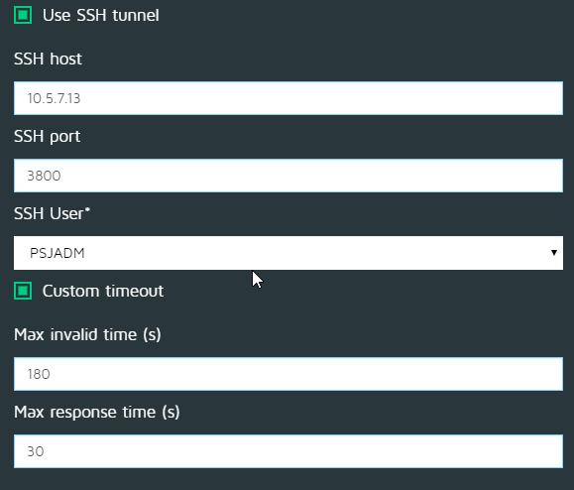

Creating a SAP user with Read access on table in Sybase under SAPSR3DB schema
- Create a new role “test_role” as below
  - use master -> go
  - create role test_role -> go
- Create a new login user “testuser” to access your database SAPSR3DB
  - sp_addlogin testuser, testuser, SAPSR3DB -> go
  - use SAPSR3DB -> go
  - sp_adduser testuser , testuser -> go
  - New user added.
- Grant SELECT (READ) permission to the new role
  - create table t1 (a int) -> go
  - insert into t1 values (1) -> go
  - 1 row affected
  - grant SELECT on t1 to test_role -> go
- Grant the role to the required login user
  - use master -> go
  - grant role test_role to testuser -> go
  - sp_modifylogin testuser, “add default role”, test_role -> go
- Connect using “testuser” and access the table
  - $ isql -Utestuser -SASE157 -Ptestuser
  - select * from SAPSR3DB..t1 -> go

