Change Tracking

Purpose
Pro.Monitor keeps trace of all relevant changes that has been made (updating a profil data, a system data, etc.) as well as significant user activities, such as deleting a system, downloading a configuration snapshot, etc. Administrators are able to see all those changes clicking on the “Change tracking” thumb. The Changes tracking table will be displayed (see image 1). It is possible to filter by Company, System, Type, Family and Object name using their related dropdown lists or type a text on the text field (magnifying glass icon) to find the text. Clicking on the “eye” blue icon, will open a window containing a list of all fileds that have been changed as well as their before and after change values (see image 2).

image 1
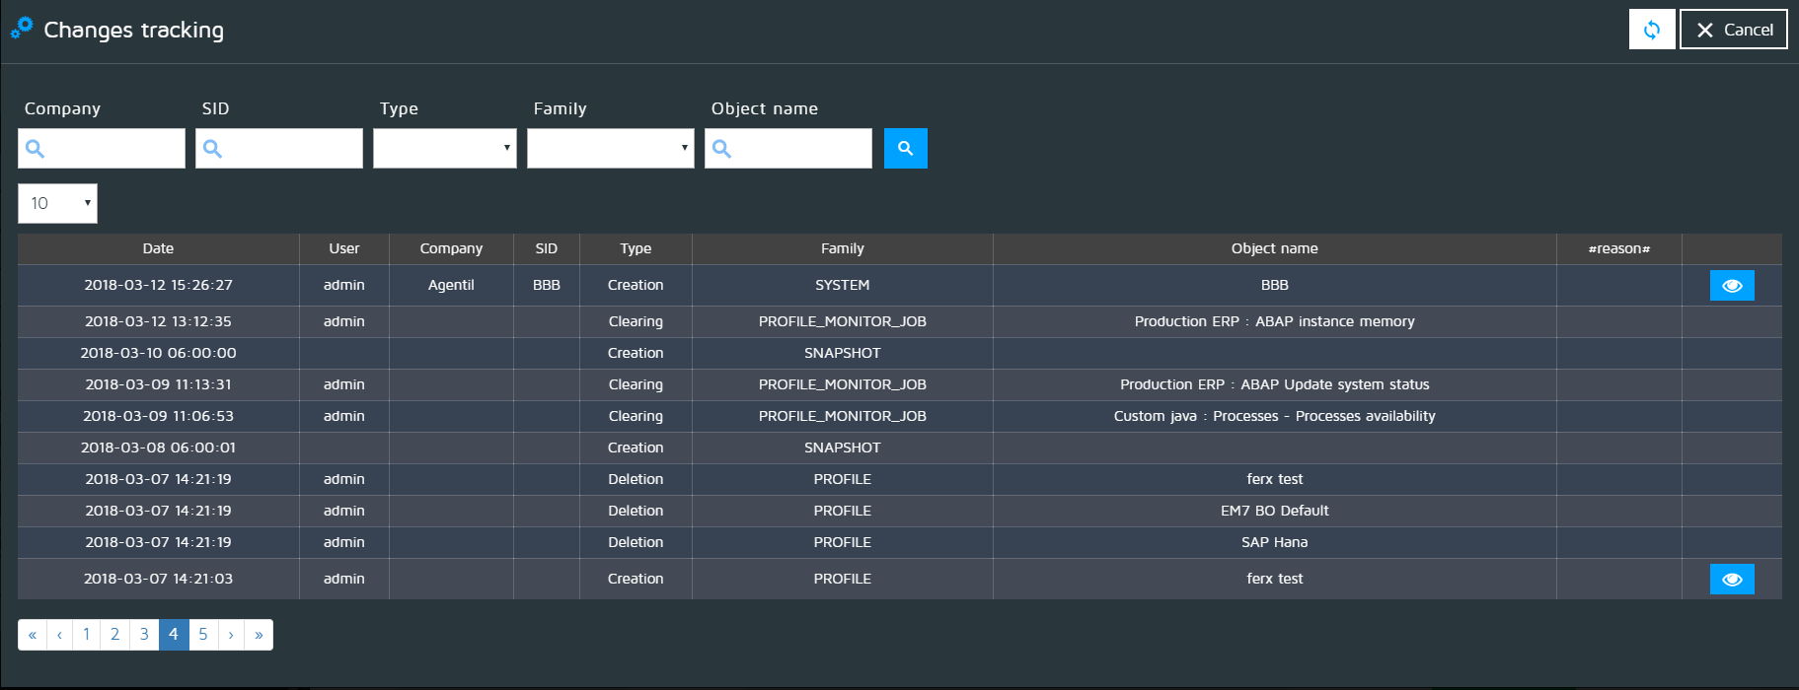

image 2


