Snapshots

Overview
A snapshot is a backup of the entire configuration, written into an exportable flat file
It contains:
- Monitoring settings (Systems, connectors, user profiles, monitors, profiles, etc...)
- Admin settings
- User settings
- Plugins
It excludes:
- Generated reports
- Monitor metadata and historical information
- Logs
- Statistics

Administration
The snapshot section of the admin menu allows to do the following:
- Configure backup plan
- Import and apply snapshot
- Create and export snapshot

Backup plan
- The backup plan will define how often a backup of the configuration will be performed.
- The backup operation consists of taking a snapshot of the configuration, which is stored on Pro.Monitor server.
- To configure the backup, set its recurrence using the backup plan formular below.
- If Smart backup is active, the snapshot will be created only if a configuration change occurred since the last backup
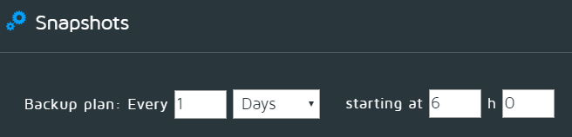

Import snapshots
- Use the upload button to select a snapshot file on your local system and upload it to Pro.Monitor
- It will be displayed in the table of available snapshots. From this table you will see snapshot date, comment and if it was added manually or generated automatically.
- Select your snapshot and press Apply, it will replace the entire configuration by the one set in the snapshot
Note: Pro.Monitor has been designed to 100% backward compatible with any version of snapshots
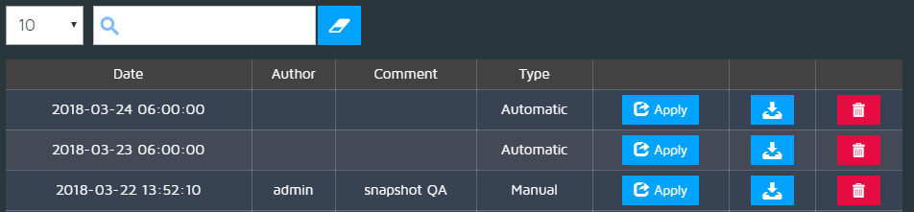
Caution: To apply a snapshot will remove any existing configuration, if you want to be able to recover it, take a snapshot before.

Take/Export snapshots
- Press the Take snapshot button to manually create a snapshot of the configuration
- The snapshot will be displayed in the table.
- Press the Download button to copy the file on your local system.
- This file can then be used to export the snapshot to another Pro.Monitor instance or to restore its configuration.


