General configuration process
- Define the systems to monitor via the creation of companies, systems and connectors
- Define how to monitor the systems by creating monitoring profiles
- Assign profiles to systems to define how they will be monitored
- The same profile can be associated to several systems, allowing to centralize the monitoring configuration

1. Define WHAT to monitor: the systems
- Systems are organized within companies and are monitored via connectors

Create companies
- Connectors are grouped within companies and systems
- Start by creating companies manually via the Systems->Companies menu
- Companies can be used to represent organizational units
- The companies menu helps to create, update or delete companies
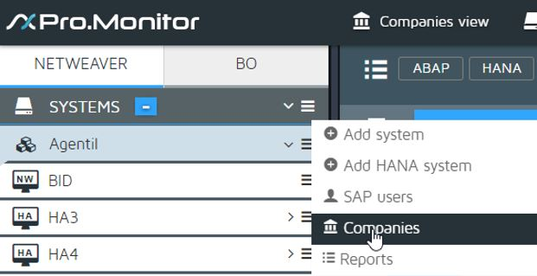

Create systems
- A system represents an SAP system, per SAP terminology
- You can add systems from the Profiles or company menu
- Select the type of system you want to create
- Systems are identified by a trigram, the SID
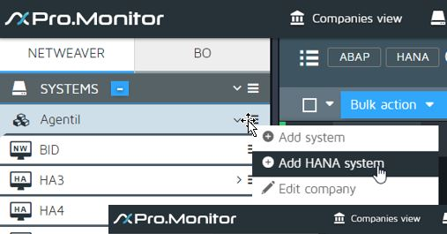

Create connectors
- Connectors can be manually created for NetWeaver and BusinessObjects systems
- Connectors for HANA systems are created automatically based on settings defined in the system profile. One connector per tenant will be created.
- To create a connector, open the menu of the target system and select Add connector
- A connector form will open, allowing to setup the connector parameters
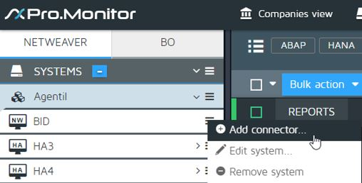

2. Define HOW to monitor: the profiles
- Get a profile from the monitoring library or create and populate your own
- Customize the monitors of the profile

Monitoring profile definition
- The configuration of the monitoring is defined in the profiles
- To monitor a system, simply assign profiles to its connectors
- Default profiles are provided to facilitate the setup of the monitoring, you can visualize them via the menu PROFILES->Select default profiles
- These profiles contains monitors with a default configuration
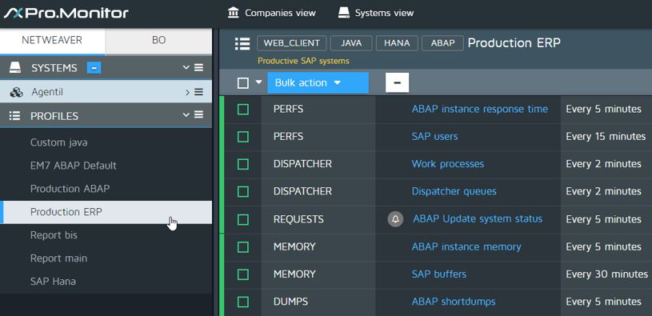
- To visualize the content of a profile, simply select one in the PROFILES section, this will display its current monitors (1)
- Use the assign button to associate a profile to one or several connectors. This will open a screen where you will be able to move connectors from right to left and vice versa. The ones on the left will use the profile
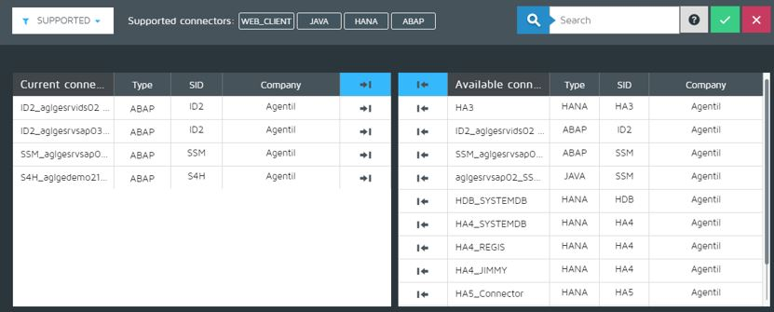
- You can also create empty profiles and define exactly which monitors you want to activate

Profile Customization
- From a profile, you can press the EDIT button to open the list of available monitors
- On the right side are displayed the available monitors and on the left, the ones already used in the profile.
- Simply move the monitors left and right to add and remove monitors.
- Warning: If you remove a monitor from a profile, you will loose its customization, and it won’t be used against the assigned systems.
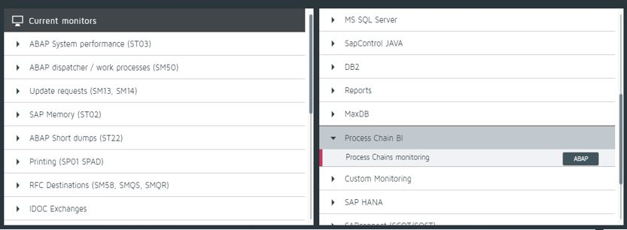

Configure the monitors
- Once you have selected the monitors of a profile, you can customize them.
- Monitors will perform the actual monitoring, by fetching and analyzing data from the systems, and then generating alarms, metrics and reports.
- The configuration screen of each monitor gives the possibility to define exactly how a monitor should react, and what kind of metadata it should produce.
- The customization of a monitor is local to a profile and will not be influenced by customizations done in other profiles.
- To customize a monitor, press its EDIT button.
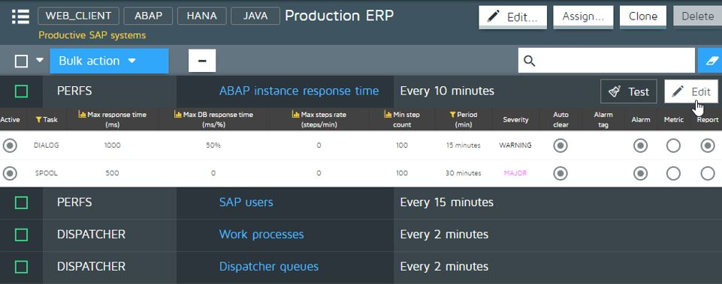
- All monitors will have customizable parameters specific to each type, but they will also share a set common settings (2):
  - State: If active (green led), the monitor will be executed.
  - Schedule: Defines how often a monitor will be executed. Press Edit schedules to create new schedules
  - Timeout: Define the execution time allocated to a monitor before triggering a timeout.
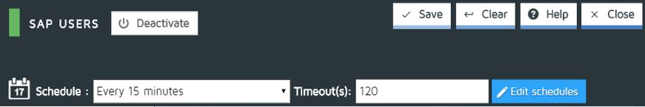
- From the top right side of the screen, you have the following actions (2):
  - Activate/Deactivate: Modify the state of the monitor
  - Save the monitor
  - Clear the monitor: Will remove customized parameters and fall back to its default configuration
  - Help: Displays documentation about how to use and configure the monitor
  - Close: Closes the configuration screen

Surveillance table
- Most monitors can be customized via a surveillance table.
- You can create several rules and set parameters like filters, thresholds, severities, periods, etc…
- Each surveillance table will be specific to a type of monitor and will reflect the relevant settings necessary to configure the monitor. Use the Help button of each monitor to get more detailed information
- However, some parameters are often common to many monitors and will be briefly described here (3):
  - Severity: The severity of the generated alert
  - Auto clear: If an alarm condition is not valid anymore, send a signal to clear the generated alarm
  - Alarm tag: Used to associate a tag to an alarm message.
  - Alarm, Metric: If active, sends respectively an alarm or a metric
  - Report: If active, the line of surveillance will be used to highlight problems in the reports
- Rules can be managed with the Add, Remove or Clone buttons


