LDAP

Purpose
- Pro.Monitor can use a LDAP for handle the users Pro.Monitor.
- The first time connection to Pro.Monitor with LDAP send a request authorization.
- The admin must accept the request for allow the access (a notification will be visible)

Configuration
- URL : URL LDAP server
- Example : ldap://nameServer.domainName/dc=DC1,dc=DC2
- Base : Group LDAP
- Example : OU=Users,OU=AGL
- Filter :
- Example : sAMAccountName={0}
- Manage DN : User LDAP connection
- Manager password : Password LDAP connection

Ask an authorization access
- Connect to Pro.Monitor with LDAP account
- Click on Ask for Authorization
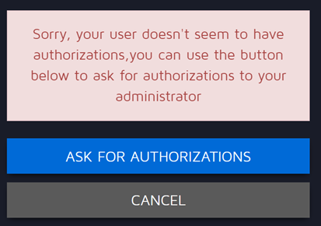
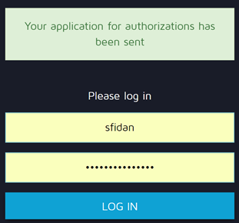

Accept LDAP user authorization
- Connect to Pro.Monitor with admin
- Go in Pro.Monitor user interface
  - Click on setting icon
  - Click on Pro.Monitor user sub menu
- Accept the user in tab Authorization applications


