Pro.Monitor Users

Managing users
- Pro.Monitor provides a default Administrator super user (username : admin, password : admin).
- Administrator super user credentials can be changed when installing the application using the wizard.
- Only Pro.Monitor users having administrator rights can manage and grant rights to other Pro.Monitor users.
- To access Pro.Monitor users feature : Go to Administrator settings (gear icon at top-right corner of the screen) and click on ProMonitor users
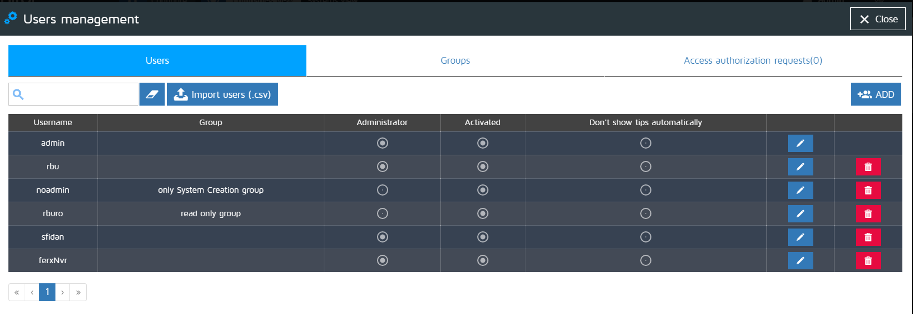
- Quick search input field : enter a text to search among Username and Group table columns
- Import users button : allows to import Pro.Monitor users previously saved in a .csv file format
- Add button : opens the Pro.Monitor users creation window
- Click on a given Pro.Monitor Delete icon to delete the corresponding user
- Click on a given Pro.Monitor Edit icon to edit/modify the corresponding user data

Creating users
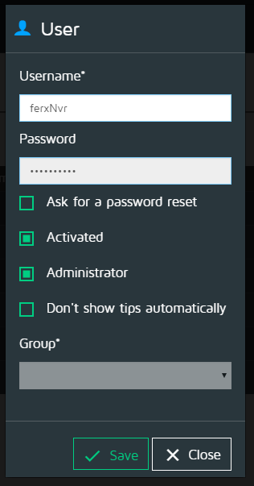
- check “Ask for a password reset” if the new user has to reset his password at first login, the application will automatically take care of this operation
- check / uncheck the “Activated” option to grant/deny access to the application
- check “Administrator” if the new user need to have Adminstrator full rights
- check / uncheck “Don't show tips automatically” to allow user to display “tips” (bulb icon) throughout tha application
- Group : select a group so the user will inherit group's rights and restrictions (see Pro.Monitor Groups section)

Pro.Monitor Groups

Managing groups
- Only Pro.Monitor users having administrator rights can manage and grant rights other Pro.Monitor users.
- To access Pro.Monitor Groups function : Go to Administrator settings (gear icon at top-right corner of the screen) click on ProMonitor users, click on Groups
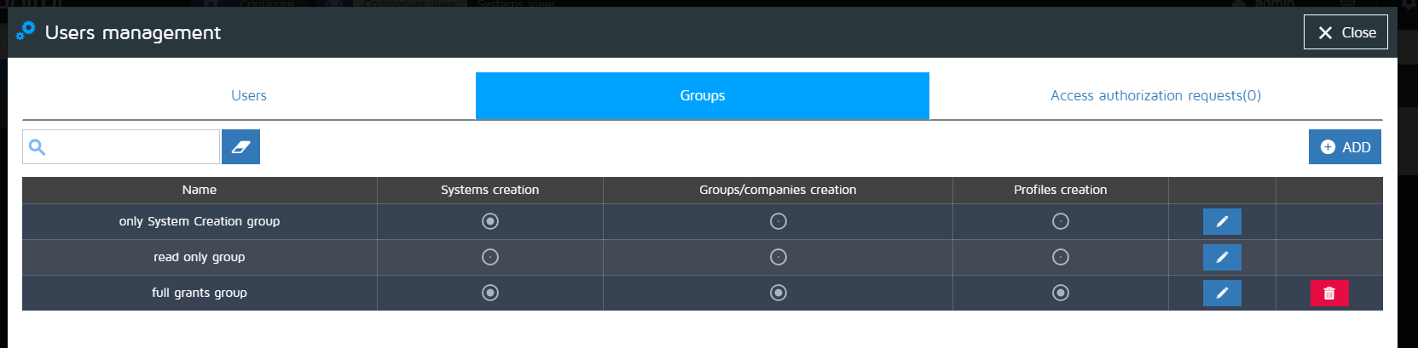
- Quick search input field : enter a text to search on Name table column
- Add button : opens the Pro.Monitor group creation window
- Click on a given Pro.Monitor Delete icon to delete the corresponding group
- Click on a given Pro.Monitor Edit icon to edit/modify the corresponding group data

Creating groups
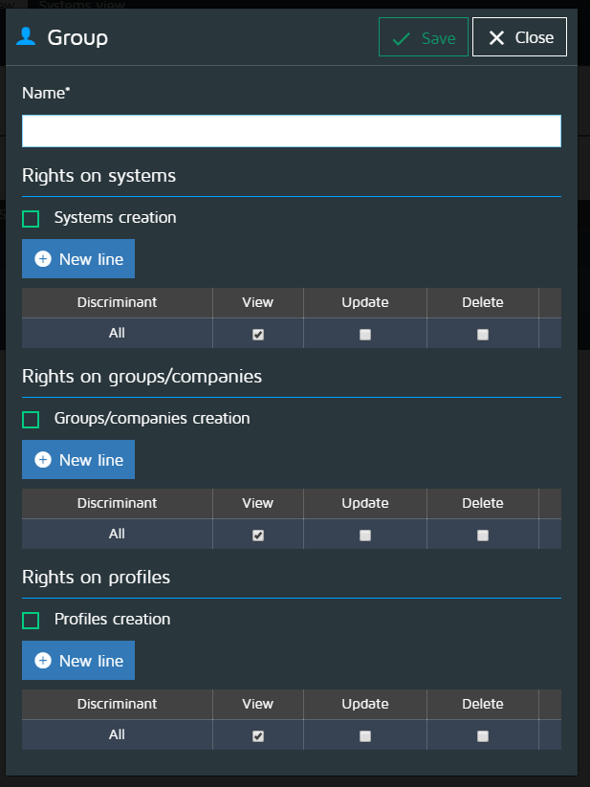
- The adminstrator can set full operation rights (View, Update, Delete) on Systems, Groups and Companies as well as Profiles by checking the corresponding checkbox (i.e. “Systems creation” checkbox, see image below)
- Pro.Monitor can manage specific users rights on every single element (Systems, Groups and Companies, Profiles). Click on “New line” button, check on the operations that will be allowed and then check the elements on which the operations above mentioned will be applied.

Pro.Monitor users access authorizations
- Pro.Monitor gives the possibility to acess the application in two different ways :
  - using an Administrator managed Pro.Monitor user credentials and rights
  - via LDAP (to access this function, go to : Administrator settings -> Admin Configuration -> LDAP/AD)
- If LDAP authentication mode is active and a non authorized user attempts to access the application - entering valid credentials - a message will be sent to the user login page and the option of sending an access authorization request will be given (see image below)
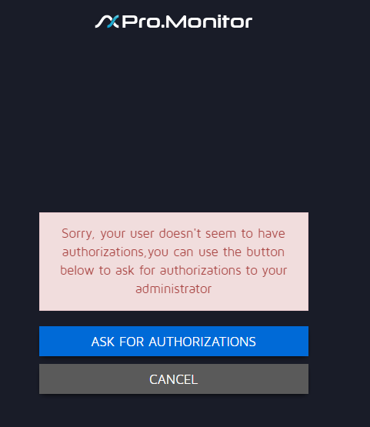

Managing Pro.Monitor users access authorizations
- If a user has sent an access authorization request (see above section), the administrator will be notified at log-in (notification message).
- To manage Access authorization requests go to : Administrator settings (gear icon at top-right corner of the screen), click on ProMonitor users, click on access authorization requests tab.
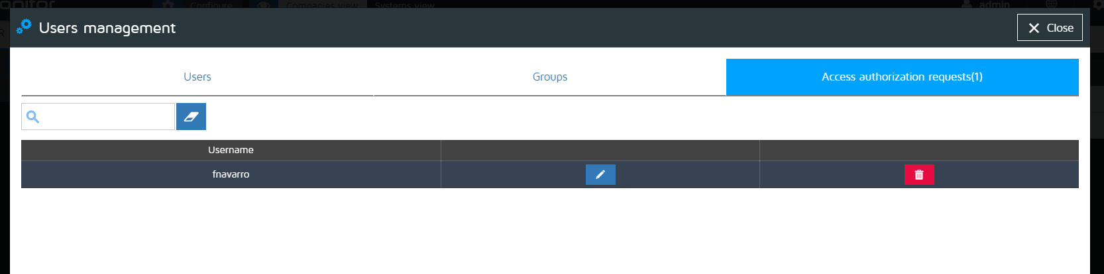
- Click on a given access request Delete icon to delete the corresponding request
- Click on a given access request Edit icon to activate, grant administrator rights, assign a group and validate the access request (clicking on Save button).


