1. Configure
Top left corner of ProMonitor main page you will find the button Configure:
- This feature has been designed as a shortcut toolkit.
- The user can directly create and manage main ProMonitor entities such as companies, systems, users, profiles, SLD profiles and reports.
- Click on the plus icon to create a new component, or choose the gear to open the component manager.
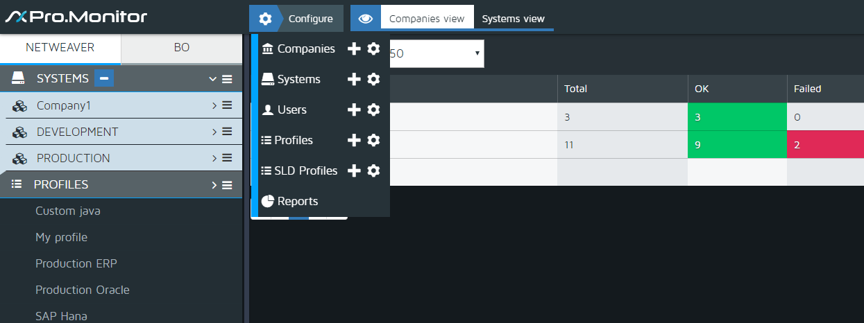

Component Manager
- Click on a small gear icon (managing icon) to open a window on manage mode
- All elements will be displayed. The user the possibility to create, edit, update, delete, etc any element present on the list (see systems managing window in the example here below).
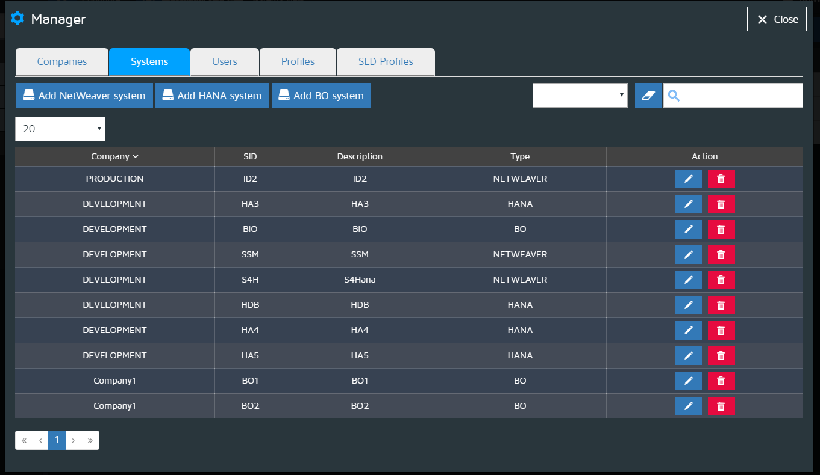
- To create an element, click on a small plus icon (create icon) of a given ProMonitor entity (see SAP users creation window in the example here below).
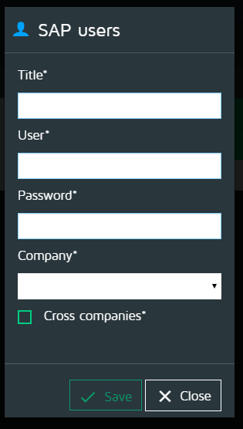

Reports
- Click on Reports to display a screen having all reports generated by ProMonitor grouped by companies.
- Click on a View icon to open the report on a new browser tab.
- Click on a Download icon to download the report under a html page form.
- To delete a report, check any checkbox (left of every row) to select a report and then click on “Delete selected files”.
- Top left checkbox allows to check/uncheck all checkboxes at once.


