LDAP

Purpose
- Pro.Monitor can use a LDAP for handle the users Pro.Monitor.
- The first time connection to Pro.Monitor with LDAP send a request authorization.
- The admin must accept the request for allow the access (a notification will be visible)

Pro.monitor versions prior to 6.7
- Notice that a new input field, “Logon attribute” has been added in Pro.Monitor version 6.7
- The default value for this field is : sAMAccountName
- If you had set a given value in the field “Filter” in versions prior to 6.7 and you make un upgrade to 6.7 :
  - Please enter that value in the new field “Logon attribute”
- Notice that, starting from Pro.Monitor version 6.7, the defaul value of field “Filter” is : (objectclass=person)

Configuration
- Active : Check this option to activate or deactivate LDAP credentials authentication
- URL : URL LDAP server
  - Example : ldap://nameServer.domainName/dc=DC1,dc=DC2
- Base : Group LDAP
  - Example :OU=Users,OU=AGL
- Filter :
  - Example : (&(objectClass=person)(!(objectClass=computer))(!(sAMAccountName=a-*))(!(sAMAccountName=ext-*))(!(sAMAccountName=svc-*))(!(sAMAccountName=s_*)))
  - Notice that the value of this field MUST BE ENCLOSED IN BRACKETS
- Logon attribute :
  - Example : sAMAccountName
- Manage DN : LDAP connection user
- Manager password : LDAP connection user's password
- Once the fields above explained are set, it is possible to test
- About Test results :
  - It will indicate if the connection has been successful or not
  - Will display all Organizational Unhits (OU) that have been found
  - Will show all users found
  - In the left input field, you can make a quick search entering the OU you want to find
  - In the right input field, you can make a quick search entering the user logon attribute value you want to find
  - You can also enter a Username and Password, click on Test button to check if a particular user is well authenticated.
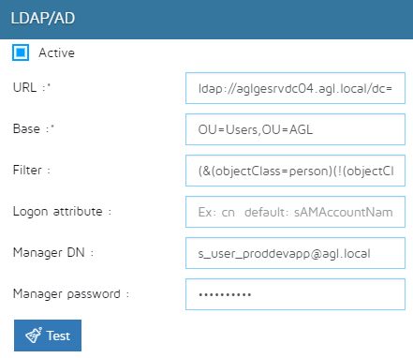

Ask an authorization access
- Connect to Pro.Monitor with LDAP account
- Click on Ask for Authorization
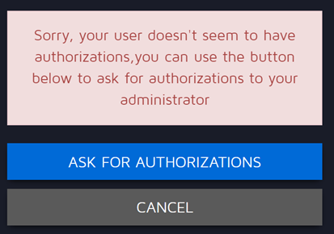
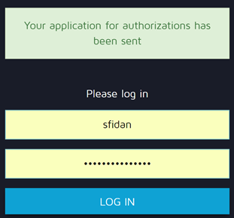

Accept LDAP user authorization
- Connect to Pro.Monitor with admin
- Go in Pro.Monitor user interface
  - Click on setting icon
  - Click on Pro.Monitor user sub menu
- Accept the user in tab Authorization applications


