System

Purpose
- Pro.Monior allows administrators to fully configure a system with an specific functionality : System.
- This feature is subdivided in the following sections (see image below) :

Worker settings
In this section, administrators can configure :
- How many parallel tasks a monitoring process will execute :
  - This setting will determine how many single taks (monitors) Pro.Monitor is able to execute at the same time
  - Notive that this setting is tight to the number of microprocessors (cores) of the machine on which Pro.Monitor has been installed
- The allocation (in GB) of the monitoring processes memory :
  - This value concerns the maximum amount of memory that can be allocated to an entire monitoring batch (to be seen as a container of monitors)
- Monitoring processes' timeout (in minutes)
- The possibility to compress or not monitoring results. Notice that compressing results will demand a certain CPU process time
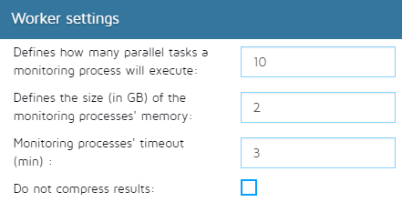

Retention settings
Under this section, administrators are able to :
- Activate monitors result retention:
  - To store monitor execution results.
  - This function is useful to track generated alarms and metrics, long run times or aborted results
- Store statistics only:
  - Keep only track of monitor execution status (won't store alarms/metrics/results).
  - This will store much less data in the DB.
- Set the minimum number of seconds a given job (Pro.Monitor Monitor) executes its task before storing the job result.
  - This setting is particularly useful when Administrator need to track monitors that have taken a long time to execute.
- Set the number of days that Pro.Monitor will keep in memory the monitoring data
- Set the number of days that Pro.Monitor will store in memory monitor tests information
- Configure the number of days Pro.Monitor log files will be kept in memory - at disposal for downloading -
- Launch a “clean up procedure” that will immediately delete all retention data prior to the settings above explained
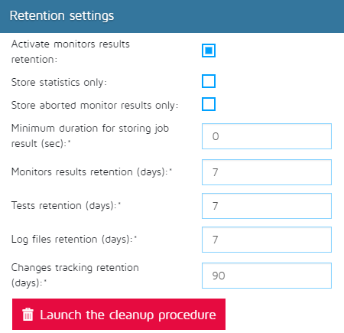

Change tracking settings
- Whenever a Pro.Monitor user performs an action that will provoke a significant change in the system, administrators can give the possibility or not - checking on “Optional” - to a user to enter a note concerning the reason for that action, or make this feature mandatory - checking on “Mandatory” -. Check “Deactivated” option to immediately deactivate this function.
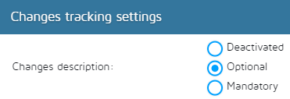

Timeout settings
In this section, administrators will be able to :
- Set the timeout value (in seconds) for a report to be generated
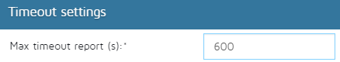

Flapping settings
Under this section, the administrator can determine :
- When a given system is to be considered as a “flapping system” trough the following parameters :
  - Period : It represents the time lapse (in hours) to be taken into account
  - Threshold : It represents the system flaps threshold, once this value is overreached (within the Period parameter value), the system will be considered as “flapping system”


