Zabbix Plugin

Purpose
The Zabbix plugin gives the possibility to collect metrics, alarms and metadata in Zabbix plateform. Once active, this plugin will collect all generated alerts, metrics and metadata and store them waiting for the probe to collect them To limit memory usage the number of element temporally stored is limited

Configuration
Some configuration needs to be done in Pro.Monitor.

Pro.Monitor
From the plugin menu, select type Zabbyx and create the plugin, this will open plugin configuration screen
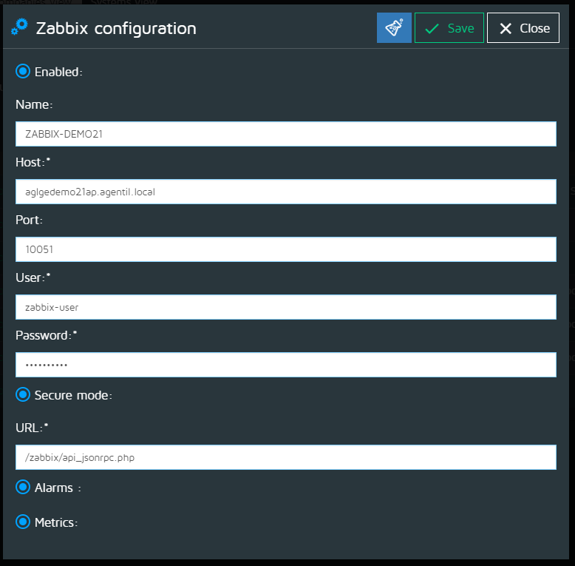
Fill the plugin settings form:
- Enabled : To enable or disable the plugin
- Name : The name of the plugin to display in the list of plugins
- HOST : Host where is installed your Zabbyx instance
- Port : Port connexion Zabbyx
- URL : Webservice URL to sent all alarms and metrics
- Alarms : To enable or disable the send alarms
- Metrics : To enable or disable the send metrics

