Procedures
Defines procedures which can be helpful for troubleshooting problems with the application

Find Java install folder
- You will need sometimes to use java tools located in java bin folder, which is not always in the PATH.
- To find the exact Java bin folder, execute the below command
# ls -l /etc/alternatives/java
> /etc/alternatives/java -> /usr/lib/jvm/java-17-openjdk-17.0.0.0.35-1.rolling.el7.x86_64/bin/java

Find application PID
- Java tools often require to provide process PID
- It can be discovered by running the below command:
# systemctl status promonitor
- The PID is displayed next to the application startup command (22502 in below example)
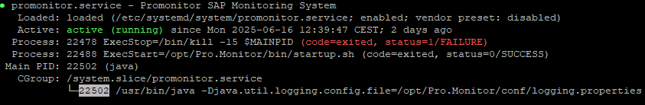
- If multiple PIDs are displayed, run it multiple times, the right one is the one which persists and never changes.

Heap dump
Heap dump creates a file allowing to inspect memory usage of the application
This is helpful for investigating problems such as memory leaks
- Get the application PID and run following command
[JAVA BIN PATH]/jmap -dump:live,format=b,file=heapdump.hprof [PID]
- Attach the dump file to a ticket. This will help investigating
Note:
- If jmaps returns an error such as well-known file /tmp/.java_pid22502 is not secure: file should be owned by the current user (which is 0) but is owned by 994
- Try running it by prefixing the command with sudo -u promonitor, such as
sudo -u promonitor [JAVA BIN PATH]/jmap -dump:live,format=b,file=heapdump.hprof [PID]

Stack trace
Stack traces helps understanding what the application is doing at a given time.
This helps investigating performance issues, such as slow startup
- Get the application PID and run following command
[JAVA BIN PATH]/jstack PID > stacktrace.log
- Attach stacktrace.log to a ticket

