HTTPS settings

Use HTTPS Only
- Activate HTTPS only checkbox to automatically redirect HTTP requests to HTTPS
- WARNING: In such configuration, remote agents will not be able to connect if you don't add the server certificate into their truststore (unless using a certificate coming from a trusted authority)

Change HTTPS port
- Redpeaks HTTPS port number is set to 8443 by default
- If you are running on Linux:
  - Set the new HTTPS port in HTTPS redirection port field
  - Using port 443 is not always possible: ports below 1024 require elevated privileges
  - Example routing rule: iptables -t nat -A PREROUTING -p tcp --dport 443 -j REDIRECT --to-ports 8443
  - Restart the Redpeaks service from the Maintenance menu
- If you are running on Windows:
  - Set the new HTTPS port in HTTPS redirection port field.
  - Run: [REDPEAKS_HOME]\\bin\\pro_monitorw.exe
  - Open the Java tab
  - Change the -Dhttp.port.ssl value to the new port number
  - Restart the promonitor service
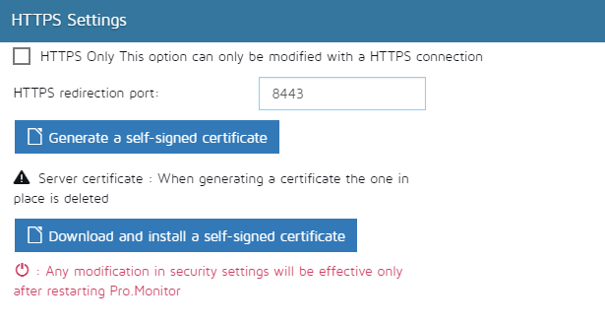

Certificates

Disclaimer
- The default certificate embedded with the server will not work in Multi-instance mode: agents will refuse the connection because the certificate is not bound to the server IP address
- You must generate a self-signed certificate bound to the correct IP or hostname
- All generated certificates are stored in: [REDPEAKS_HOME]/certificates/.keystore

Generating a certificate
- The default certificate uses localhost as Common Name (CN)
- To connect to the server using HTTPS and a hostname, you must install or generate a proper certificate
Generating a Self-signed certificate
- Click Generate a self-signed certificate
- Enter the hostname or IP
- Save the certificate
Generating a Certificate manually
- Follow the procedure here
Certificates from a trusted authority
- Follow the procedure below

Downloading and installing a self-signed certificate
- To establish a secure connection with a system using a self-signed certificate, you must trust the certificate
- Once trusted, you must connect using the Common Name (CN) of the certificate
- This applies to:
  - REST API connector
  - Secure LDAP
  - Secure plugin
  - Secure primary server (agents)
  - Secure SAPControl or portal
Import certificate from remote sites:
- Click Download and install a self-signed certificate
- Enter the URL as hostname:port (443 by default)
- Enter the certificate's CN (visible in browser certificate details)

Installing a certificate manually
- Copy the certificate file (.cer) into [REDPEAKS_HOME]/certificates/
- Import it:
keytool -import -trustcacerts -keystore [REDPEAKS_HOME]/certificates/.keystore -storepass agentilKeyStore \
-noprompt -alias yourAliasName -file [REDPEAKS_HOME]/certificates/certificate.cer

Import keystore into the Redpeaks keystore
- Import an external PKCS12 keystore:
keytool -importkeystore -srckeystore yourKeyStore.p12 -srcstoretype PKCS12 -srcstorepass agentilKeyStore \
-destkeystore [REDPEAKS_HOME]/certificates/.keystore -deststoretype JKS -deststorepass agentilKeyStore
NOTE:
- Redpeaks keystore (server keys) and truststore (trusted certificates) are stored in the same file [REDPEAKS_HOME]/certificates/.keystore

Building a Full PKCS12 Certificate Bundle (P12)
In some cases, you have:
- a private key file (server.key)
- a server certificate (server.crt or server.cer)
- one or more CA / intermediate certificates (root.cer, intermediate.cer)
The recommended way to provide a complete chain to Redpeaks is to build a PKCS12 (.p12) file containing
- private key
- server certificate
- intermediate and root certificates (full chain)

Ensure certificates are in PEM format
- Open your .cer files
  - If you see -----BEGIN CERTIFICATE-----, they are already in PEM format
  - If the file is binary, convert from DER to PEM
openssl x509 -inform DER -in intermediate.cer -out intermediate.crt
openssl x509 -inform DER -in root.cer -out root.crt

Build the chain file
- Concatenate intermediate and root certificates (in this order)
cat intermediate.crt root.crt > chain.pem

Create PKCS12 with full chain
- Create a PKCS12 file containing:
  - the private key
  - the server certificate
  - the full chain
Example:
openssl pkcs12 -export -inkey server.key -in server.crt -certfile chain.pem -name pro_monitor -out fullcert.p12
You will be asked for an export password: use “agentilKeyStore” if you want to import it directly with default Redpeaks keystore password

Import P12 into Redpeaks keystore
- Import the newly created fullcert.p12 into Redpeaks keystore:
keytool -importkeystore -srckeystore fullcert.p12 -srcstoretype PKCS12 \
-srcstorepass agentilKeyStore -destkeystore [PRO_MONITOR_HOME]/certificates/.keystore -deststoretype JKS -deststorepass agentilKeyStore
- After this, the alias used (“pro_monitor” in the example) should contain:
  - Entry type: PrivateKeyEntry
  - Certificate chain length: 2 or 3 (server + intermediate (+ root))

Troubleshooting
- See Troubleshooting certificate issues

