Mail Gateway
Redpeaks must be configured to send reports and alerts by email, three authentication types are available:
Type | Description
SMTP | Standard login with username and password
SMTP Office 365 (OAuth2) | Office 365 SMTP using modern login (OAuth2)
Exchange Online (Graph API) | Uses Microsoft Graph API (recommended for Microsoft 365)

SMTP Authentication
Use this mode for internal or basic mail servers
Field | Description
Server | Name or IP address of the mail server (example: smtpcompanycom)
Port | Port number (25, 465 or 587)
Secure TLS connection | Enable if your mail server needs TLS or STARTTLS
From | Email address used to send the message (example: noreply@companycom)
Need authentication | Enable if the server requires login
Username | SMTP account username
Password | SMTP account password
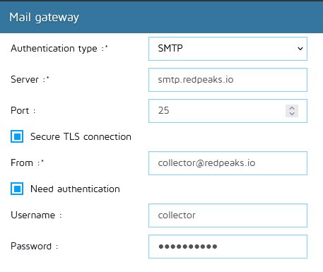

Azure AD / Microsoft 365 Prerequisites (for OAuth2 modes)
Both SMTP Office 365 (OAuth2) and Exchange Online (Graph API) need an app in Microsoft Entra ID (previously Azure Active Directory)

1 Create the application
Step | Action
1 | Open Azure Portal
2 | Go to Microsoft Entra ID
3 | Click App registrations → New registration
4 | Name it (for example: Redpeaks Mail Gateway)
5 | Select Accounts in this organizational directory only (Single tenant)
6 | Leave Redirect URI empty
7 | Click Register
On the app Overview page, note:
- Application (client) ID → used as Client ID
- Directory (tenant) ID → used as Tenant ID

2 Tenant ID
The Tenant ID is your company’s unique Microsoft 365 / Entra ID identifier
Where to find it | Location in Azure Portal
Option 1 | Microsoft Entra ID → Overview → Tenant ID
Option 2 | App registrations → Redpeaks Mail Gateway → Overview → Directory (tenant) ID
Copy this value into the Tenant ID field in Redpeaks

3 Add API Permissions
Mode | Permissions to Add
SMTP Office 365 (OAuth2) | Office 365 Exchange Online → Application permissions → SMTPSend
Exchange Online (Graph API) | Microsoft Graph → Application permissions → MailSend
After adding permissions, click Grant admin consent for [your tenant] and confirm

4 Create a Client Secret
Step | Action
1 | Go to Certificates & secrets
2 | Under Client secrets, click New client secret
3 | Add a short name (example: Redpeaks) and select an expiration time
4 | Click Add
5 | Copy the Value immediately - this is your Client Secret for Redpeaks

5 Should you change the OAuth scope?
Normally, you do not change this field Redpeaks automatically uses the correct default scope:
Mode | Default Scope
SMTP Office 365 (OAuth2) | https://outlook.office365.com/.default
Exchange Online (Graph API) | https://graph.microsoft.com/.default
Only change it in special cases:
- If your Microsoft 365 tenant is hosted in another region or national cloud:
  - US Gov: https://graphmicrosoftus/default
  - Germany: https://graphmicrosoftde/default
- If your IT or Redpeaks support tells you to use a custom resource
When using a custom scope:
- It must match the permissions granted in Azure
- You can add several scopes separated by spaces

SMTP Office 365 (OAuth2)
Used to send emails through Office 365 SMTP with OAuth2 login
Field | Description
From | Email address used to send the message (must exist in Exchange Online)
Tenant ID | Paste the Directory (tenant) ID from Azure
Client ID | Paste the Application (client) ID from Azure
Client Secret | Paste the secret Value created in Certificates & secrets
OAuth Scope | Leave empty (default: https://outlook.office365.com/.default)
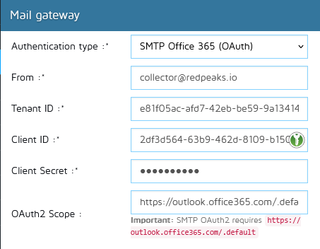

Exchange Online / Microsoft 365 (Graph API)
Used to send emails through Microsoft Graph API (recommended)
Field | Description
From | Email address used to send the message (Exchange Online mailbox)
Tenant ID | Paste the Tenant ID from Azure
Client ID | Paste the Application (client) ID from Azure
Client Secret | Paste the secret Value created in Certificates & secrets
OAuth Scope | Leave empty (default: https://graph.microsoft.com/.default)
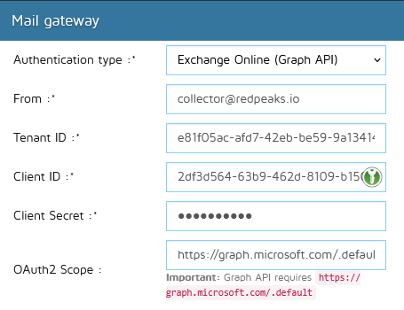

Validation
Step | What to Do
1 | Save the Mail Gateway settings in Redpeaks
2 | Use the Test email button to check the configuration
3 | If the test fails, check:
• | Tenant ID, Client ID and Client Secret values
• | Permissions (SMTPSend or MailSend) and admin consent
• | The From address exists and can send messages

