Security

Purpose
- The Security section allows administrators to configure user authentication and password management to ensure the safety and protection of the system.
- This feature includes settings like login attempts, password complexity, password length, and password expiration (see image below).
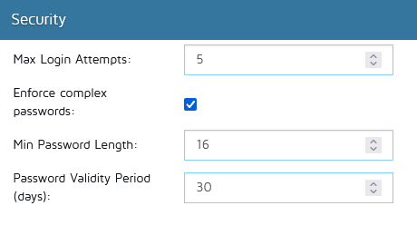

Security settings
In this section, administrators can configure:
- Max Login Attempts:
  - This setting controls the number of allowed failed login attempts before the system temporarily locks the user’s account.
  - By default, the number is set to 5, meaning users will be locked out after 5 failed login attempts.
  - You can increase or decrease this number depending on your organization's security requirements.
- Enforce Password Complexity:
  - When this setting is enabled, users are required to create passwords that meet certain complexity standards, including uppercase and lowercase letters, numbers, and special characters.
  - This setting is enabled by default.
  - To disable password complexity enforcement, uncheck the option (this might reduce the strength of user passwords and increase security risks).
- Min Password Length:
  - This option allows administrators to set the minimum number of characters required for a password.
  - The default is 8 characters.
  - You can modify this value according to your security needs (longer passwords are generally more secure).
- Password Validity Period (days):
  - This setting enforces a password expiration policy, the specified number of days, users will be prompted to update their passwords.
  - By default, this period is set to -1 days, this is disabled by default.
  - You can adjust this period by entering a new value (shorter periods enforce more frequent password updates, but may lead to increased support requests for forgotten passwords).

Important Notes
- It is strongly recommended to edit these settings to enhance system security and protect against unauthorized access.

