Agents
- The agent menu can be opened from the settings menu.
- Agents are remote instances of Redpeaks used as a proxies, for accessing systems within isolated environments.
- Agents connect to a primary Redpeaks instance for central configuration management.
- To assign workload to agent, you must associate them with groups via the Associations tab
- You can visualize, configure and update agents via 3 sub-tabs:
  - Agent configuration: Manage settings and update agents
  - Agent stats: Visualize agent status and statistics
  - Associations: To associate the groups to monitor per agent

About Agent life cycle
- When an agent registers for the first time in Redpeaks, it has a PENDING state. It will not execute any task.
- An administrator will then ACCEPT the agent via the dedicated button
- Few seconds later, the agent will appear in the list of accepted agents
- When an agent is ON with a status ONLINE, it is ready to execute monitoring tasks.
- Monitoring workload will be evenly distributed across agents, according to their associations (see agents groups).
- You can temporarily deactivate an agent by selecting it and using ACTION menu to press Deactivate. No more tasks will be executed.
- You can delete an accepted agent. It will go back in the list of pending agents, until switched off.
- If an accepted agent stops to poll the primary server, it will be detected after few minutes. Its state will switch to OFFLINE and its current workload will be rescheduled on other available agents.
Note: A Primary server will always have a local agent. If no other remote agents are registered with the server, this local agent will automatically be used to process monitoring workload.

Agent configuration
The agent configuration tab shows information about agent status and connectivity. You can change agent settings and perform actions with the Control and Update menus.
Agents can be in following states:
- ONLINE: The agent is ready to process workload
- OFFLINE: The agent is not connected to the central server and will not process workload
- RESTARTING: The agent is currently restarting and will come back generally in one minute or two.
- UNLICENSED: If you are using a “per agent” license, this means that the agent is not covered by the license and will not process workload.
- UPDATING: The agent is currently being updated
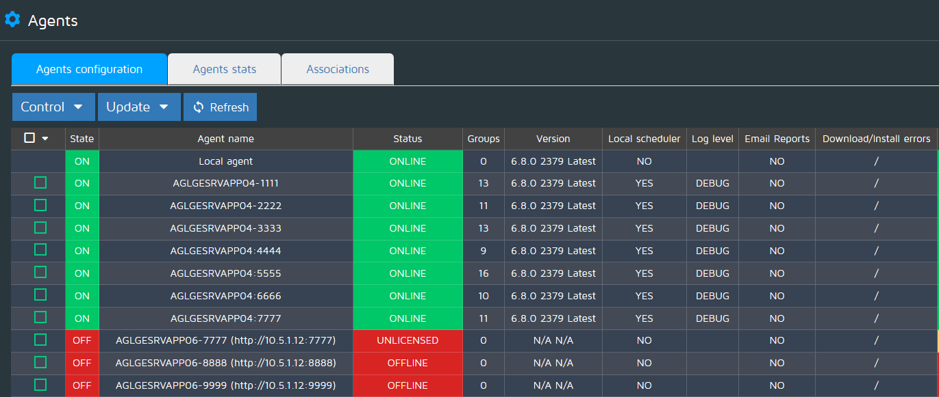
Columns :
- Selector : Check/uncheck a given agent, then use the Action button to Activate/Deactivate the agent
- State : ON/OFF (Activated/Deactivated)
- Agent name : The name that the agent has chosen as identifier
- Status : will be ONLINE if the agent Redpeaks instance is running, OFFLINE if the instance is stopped
- Groups : Number of Groups currently monitored by the agent
- Version : Redpeaks version installed on the agent instance
- Local scheduler : State of local scheduler settings
- Log level : The current log level of the agent
- Email reports : The current report sending settings
- Drivers : JCO and HANA : Informs the Administrator if necessary drivers for monitoring are installed on agent machine
Following settings or actions can be controlled for each agent via the Control drop down:
- State: Activate / Deactivate. If deactivated, the agent will not process workload.
- Log level: You can configure the log level individualy for each agent.
- Local scheduler: If enabled, the agent will no longer depend on the central server availability to monitor the systems
- Email reports: If enabled and if the agent has SMTP profile set, it will be used to send the reports. Otherwise reports will be sent from central server.
- Restart: Remotely restart the agent
Following actions can be done via the Update drop down
- Upload JCO/HANA drivers: Those drivers are requiered to monitor NetWeaver and HANA systems, can can remotely upload those drivers on freshely installed agents.
- Upgrade: If the central server has a newer version than agent, you can start agent update

Agent upgrade
The agent remote upgrade allows to upgrade the software version of multiple agents without connecting or having access to each agent OS.
Once upgrade is started, the agent will go in following states:
- READY: Waiting for agent to acknowlege the upgrade
- DOWNLOADING: The agent downloads update package from primary (~ 120 MB)
- COOLING DOWN: If agent was busy, it waits for current workload to finish (2 to 5 minutes)
- INSTALLING: The agent installs the update
- RESTARTING: The agent restarts after upgrade is finished
The time for the whole upgrade process mainly depends on agent's remaining workload and downlink bandwidth.
It usually takes less than 5 minutes.
Once the update is started, the whole process is automatic and the updated agent will register and process awaiting workload.

Local scheduler
When this setting is active, the agent will be able to generate its workload and process it without any connection to the central server.
This provides more resilience, specialy if the agent has its own plugins configured. Even if temporarily disconnected from central server, the agent will still monitor its associated groups and send alarms, metrics or reports to the third parties via its plugins.
When configuration changes on the central server, the agent will refresh its local configuration to stay up to date.

Pending Agents table
- Represents the list of pending remote agents waiting to be accepted.
- Click on Accept button to validate the agent, it will then be displayed on the Agents table (see above)

Agent stats
The agent statistics table shows detailed information about each agent:
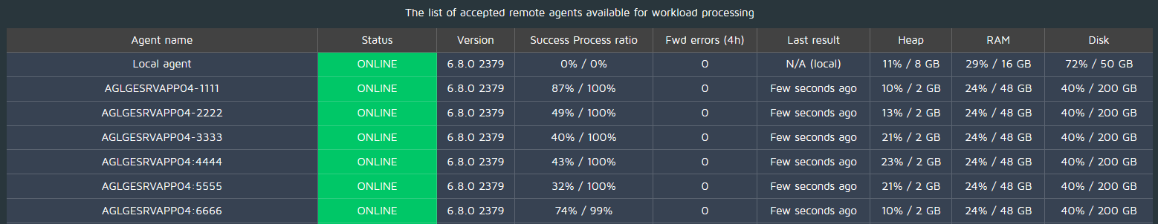
Columns:
- Agent name : The name that the agent has chosen as identifier
- Status : Current agent status
- Version : Redpeaks version installed on the agent
- Success / Process ratio : Indicates if the agent can consume its workload correctly
  - Success shows the ratio of monitors failing during execution. Ratio decreases when connectivity with systems is broken, when a monitor fails to process system data or when there is authozation issues by example.
  - Process shows the ratio of executed monitors vs total workload. Must be close to 100%. If less than 90%, the agent is probably overloaded. and its capacities must be increased (CPU).
- Forward errors : The number of connection failure during the attempt of sending monitoring results from agent to server. Must stay close to 0. If regularly over 0, check agent logs for an explanation of the error.
- Last results : Last time the agent sent some results. If over 3 minutes, this probably indicates some connectivity issues.
- Heap : Current heap usage of the agent. Must be stable in time and below 90%. By default, agents start with 2 GB of heap. Agent with a high workload (>100 systems) can be configured to use more memory.
- RAM : Agent RAM consumption rate / RAM allocated
- Disk : Agent hard disk memory used / hard disk size
NOTE: Click on any agent to see more details: (Last poll time, average results send time, DB size, etc...)

Associations
From the associations tab you can assign groups to agents, defining which agent will process the workload generated for the systems belonging to each group.
Two sub tabs are available:
- Per agent: You can select an agent and associate it with several groups at once
- Per group: You can select a group and associate it with several agents at once.
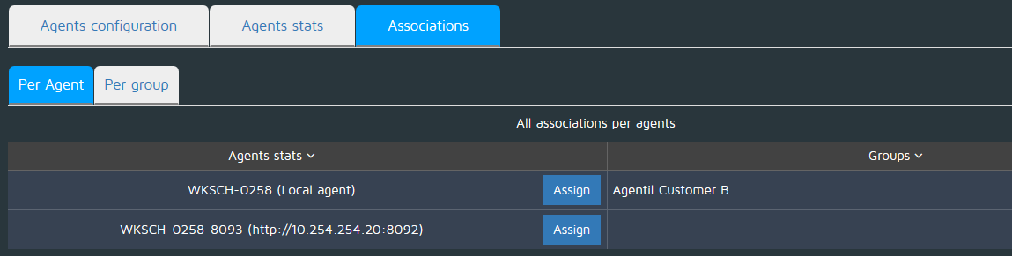
IMPORTANT NOTES:
- When you assign multiple agents to one group, its workload will be evenly distributed accross all agents. In that case, those agents cannot be set as “Local scheduler” and it is recommended to use similar specs for their servers.
- If no remote agents are associated with the server (Standalone installation), it is not necessary to assign groups to the local agent. But if you do so, be aware that unassigned groups won't be monitored.
- If a group is not assigned to any agent, all its systems won't be monitored and a warning popup will be displayed

