Snapshots

Overview
A snapshot is a backup of the configuration, written into an exportable JSON file
It contains:
- Monitoring settings (Companies, Systems, Connectors, SAP users, Monitors, monitoring Profiles, etc...)
- Administrator settings
- Redpeaks Users settings
- Plugins
It excludes:
- Generated reports
- Monitor metadata and historical information
- Logs
- Statistics

Administration
The snapshot section of the admin menu allows to do the following:
- Configure backup plan
  - Define when the automatic backup will be done
- Upload and apply snapshot:
  - Replace existing configuration by the one in the snapshot
- Create and export snapshot:
  - Create a snapshot file containing the backup of the current configuration
- Import configuration:
  - Merge some part of a snapshot in the current configuration

Backup plan
- The backup plan will define how often a backup of the configuration will be performed.
- The backup operation consists of taking a snapshot of the configuration, which is stored on Redpeaks server.
- To configure the backup, set its recurrence using the backup plan formular below.
- If Smart backup is active, the snapshot will be created only if a configuration change occurred since the last backup

Upload snapshots
- Use the upload button to select a snapshot file on your local system and upload it to Redpeaks
- It will be displayed in the table of available snapshots. From this table you will see snapshot date, comment and if it was added manually or generated automatically.
- Select your snapshot and press Apply, it will replace the entire configuration by the one set in the snapshot
Note: Redpeaks has been designed to 100% backward compatible with any version of snapshots
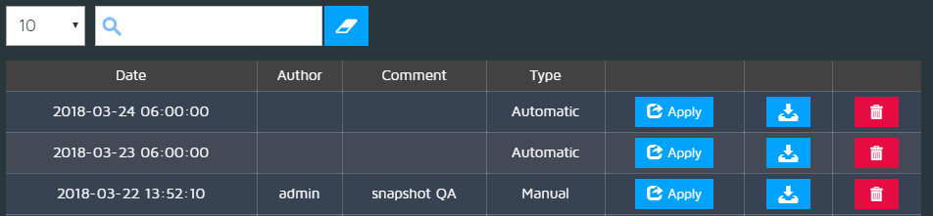
Caution: To apply a snapshot will remove any existing configuration, if you want to be able to recover it, take a snapshot before.

Take/Export snapshots
- Press the Take snapshot button to manually create a snapshot of the configuration
- The snapshot will be displayed in the table.
- Press the Download button to copy the file on your local system.
- This file can then be used to export the snapshot to another Redpeaks instance or to restore its configuration.
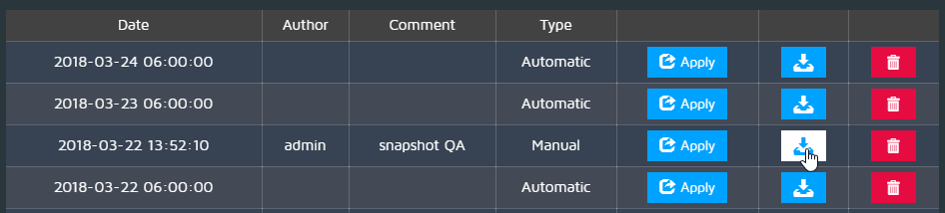

Import a configuration
- This features allows to import groups and configuration from an existing snapshot.
- Unlike Import snapshot, this will MERGE selected components into the current configuration, and not replace everything
- This is a convenient way for exporting some configuration from one Redpeaks instance to another.

Example
- You have a Redpeaks instance called in this example Redpeaks instance A
- It has in its database some companies, systems, connectors and monitoring profiles as in the image below.
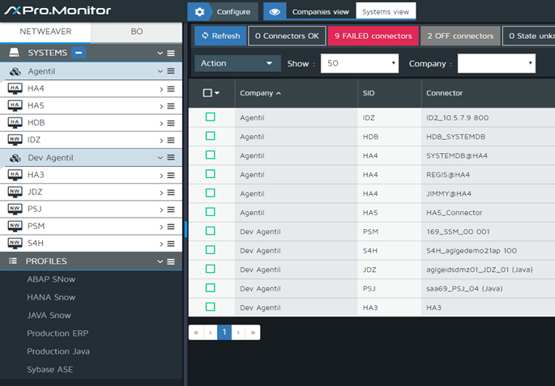
- You would like to merge to Redpeaks instance A another Redpeaks instance (called in this example Redpeaks instance B).
- Redpeaks instance B has the following configuration :
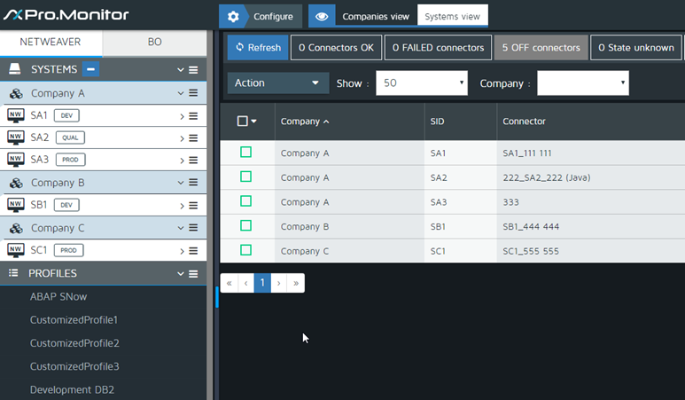
- On Redpeaks instance A : Click on “Import a Configuration” button.
- Select the ProMonitor snapshot file containing the configuration of Redpeaks instance B to be imported.
- The following screen will be then displayed :
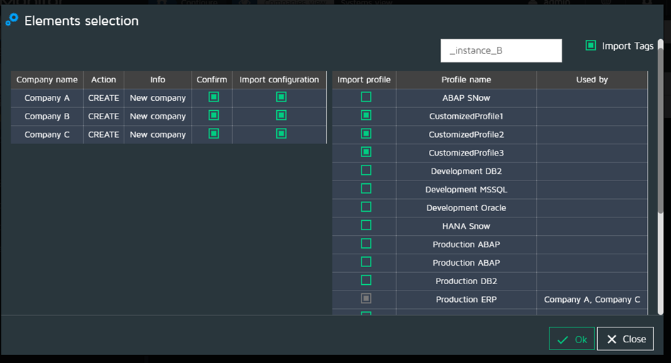
- Companies and Profiles present in the snapshot file to be imported (Redpeaks instance B) are displayed in two different tables
- Companies table (left) :
  - Check on “Confirm” column to import the company
  - Check on “Confirm” column to import also the corresponding company configuration
  - Notice that checking on “Import Configuration” will automatically select all profiles affected by that specific configuration (if any)
- Profiles table (right):
  - Check on the monitoring profiles that you want to import
  - At the top of the screen, you can enter a profile suffix
  - The profiles suffix will be displayed in Redpeaks instance A after merged
  - The colum “Used by” will display all company names that are using a given profile
- Check on Import tags if you want to merge also the Tags
- The application will then display a screen with all imported elements information (see image below).
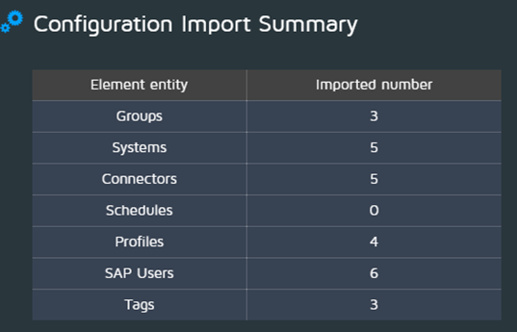
- More about Companies table :
  - Action : Informs the user about the action to be taken. There are three possible values :
    - Copy :
      - If a given company name to be imported is already present in Redpeaks instance A, the application will suggest to copy that company.
      - At the end of the company name it will added a numerical suffix.
  - Create : The application will insert the company into the ProMonitor database.
  - Ignore : The company already exists in the ProMonitor database and has the same Id.
As shown in the image here below, the result of the Import Configuration operation will be a merge of data from ProMonitor instance A and ProMonitor instance B


