Redpeaks Users

Managing users
- Redpeaks provides a default Administrator super user (username : admin, password : admin).
- Administrator super user credentials can be changed when installing the application using the wizard.
- Only Redpeaks users having administrator rights can manage and grant rights to other Redpeaks users.
- To access Redpeaks users feature : Administrator settings --> Users and Authorizations --> Users
- Find detailed information about Permissions and Authorizations here : Authorizations & Permissions
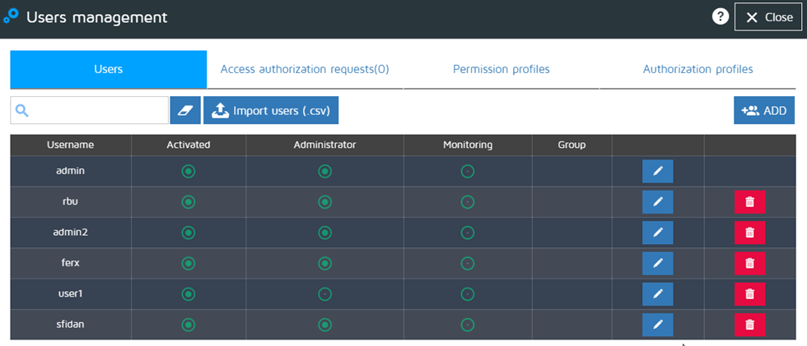
- Quick search input field : enter a text to search among Username and Group table columns
- Import users button : allows to import Redpeaks users previously saved in a .csv file format

Creating users
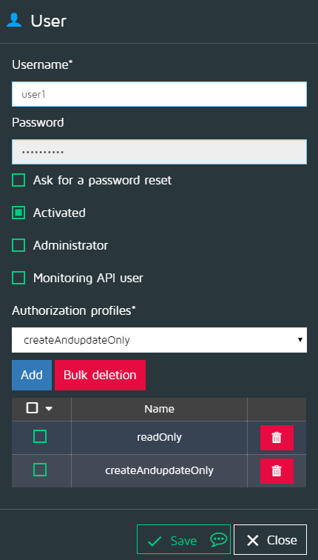
- check “Ask for a password reset” if the new user has to reset his password at first login, the application will automatically take care of this operation
- check / uncheck the “Activated” option to grant/deny access to the application
- check “Administrator” if the new user need to have Adminstrator full rights
- check “Monitoring API user”
- Authorization profiles : Administrators can assign one or more Authorizations Profiles to a user.
  - select an Authorization profile
  - click on “Add”
  - repeat previous steps to add more Authorizations profiles
  - it is possible to unassign any Authorization profile by clicking the delete icon corresponding to the Authorization profile to be deleted
  - if you need to delete few Authorization profiles at once, use “all / none” checked feature or check single Authorization profiles to be deleted, then click on “Bulk deletion”

Redpeaks users access authorizations
- Redpeaks gives the possibility to acess the application in two different ways :
  - using an Administrator managed Redpeaks user credentials and rights
  - via LDAP (to access this function, go to : Administrator settings -> Admin Configuration -> LDAP/AD)
- If LDAP authentication mode is active and a non authorized user attempts to access the application - entering valid credentials - a message will be sent to the user login page and the option of sending an access authorization request will be given (see image below)
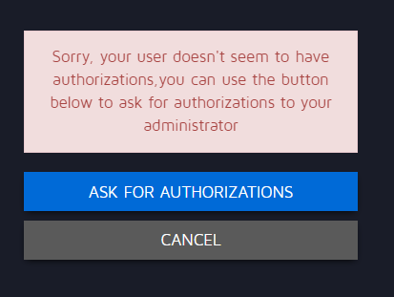

Managing Redpeaks users access authorizations
- If a user has sent an access authorization request (see above section), the administrator will be notified at log-in (notification message).
- To manage Access authorization requests go to : Administrator settings -> Users -> Access authorization requests.
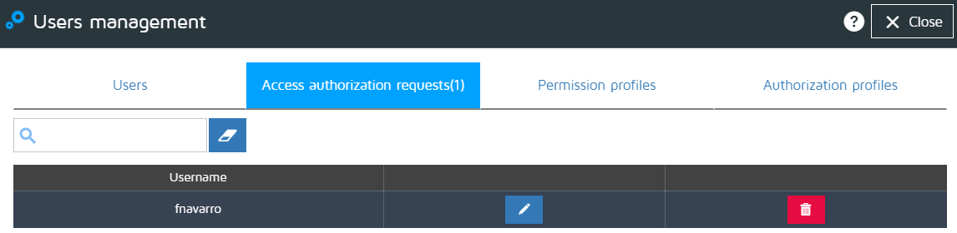
- Click on a given access request Edit icon to activate, grant administrator rights, validate the access request.


